**CS3332 – Software Engineering I**

**Developing A Library Management Software of**

**Ha Noi University of Science and Technology (HUST)**

|  |  |  |  |
| --- | --- | --- | --- |
| **Group 1** | | | |
| **Group Members** | **No.** | **Name** | **ID** |
| 1 | Ta Duc Duy | 1624634 |
| 2 | Tran Hai Minh | 1642853 |
| 3 | Le Duc Tuyen | 1624790 |
| 4 | Truong Thanh Hung | 1624817 |
| 5 | Vu Duy Hao | 1628402 |
| **Lecturer** | Dr. Du Dinh Vien | | |

*- Ha Noi, August 23rd, 2024 -*

Contents

1 General Description of Project 1

1.1 Introduction to the Ta Quang Buu Library 1

1.2 Drivers for Building Software 1

1.3 Objectives 2

1.4 Project Scopes 2

1.5 Team Members' Contribution 3

2 Software Requirements Specifications 4

2.1 Functional Requirements 4

2.1.1 Functional Requirements for Hust Student 4

2.1.2 Functional Requirements for Librarian 4

2.2 Non-Functional Requirements 5

2.4 Overall Use Case Diagram 6

2.6 List of Actors 9

2.7 List of Use Cases 9

2.8 Bussiness Rules 10

2.9 Use Case Specification 10

2.9.1 Register new account 10

2.9.2 Log in 12

2.9.3 Reset password 13

2.9.4 Change password 14

2.9.5 Log out 16

2.9.6 View profile 16

2.9.7 Edit profile details 17

2.9.8 View notifications 19

2.9.9 Ask for borrowing book 20

2.9.10 View all personal requests 21

2.9.11 Seach personal requests 22

2.9.12 Cancel personal requests 23

2.9.13 Add new book 25

2.9.14 Remove book 26

2.9.15 Update book details 27

2.9.16 Search book 29

2.9.17 Add reader 30

2.9.18 Remove reader 32

2.9.19 Update reader 33

2.9.20 Search reader 34

2.9.21 Ban reader 35

2.9.22 Unban reader 36

2.9.23 View history of borrowing and returning book 37

2.9.24 Issue book 39

2.9.25 View requests to borrow book 40

2.9.26 Seach requests to borrow book 41

2.9.27 Return book 42

2.9.28 View reports and statistics 44

3 Software Design and Implementation 46

3.1 System Architecture 46

3.1.1 MVC Model 46

3.1.2 Repository Pattern 46

3.1.3 Singleton Pattern 47

3.2 Activity Diagram 48

3.2.1 Activity Diagram for Register new account 48

3.2.2 Activity Diagram for Log in 49

3.2.3 Activity Diagram for Reset password 50

3.2.4 Activity Diagram for Change password 51

3.2.5 Activity Diagram for Log out 52

3.2.6 Activity Diagram for View profile 53

3.2.7 Activity Diagram for Edit profile details 54

3.2.8 Activity Diagram for View notifications 55

3.2.9 Activity Diagram for Ask for borrowing book 56

3.2.10 Activity Diagram for View all personal requests 57

3.2.11 Activity Diagram for Search personal requests 58

3.2.12 Activity Diagram for Cancel personal requests 59

3.2.13 Activity Diagram for Add new book 60

3.2.14 Activity Diagram for Remove book 61

3.2.15 Activity Diagram for Update book details 62

3.2.16 Activity Diagram for Search book 63

3.2.17 Activity Diagram for Add reader 64

3.2.18 Activity Diagram for Remove reader 65

3.2.19 Activity Diagram for Update reader 66

3.2.20 Activity Diagram for Search reader 67

3.2.21 Activity Diagram for Ban reader 68

3.2.22 Activity Diagram for Unban reader 69

3.2.23 Activity Diagram for View history of borrowing and returning book 70

3.2.24 Activity Diagram for Issue book 71

3.2.25 Activity Diagram for View requests to borrow book from reader 72

3.2.26 Activity Diagram for Search requests to borrow book from reader 73

3.2.27 Activity Diagram for Return book 74

3.2.28 Activity Diagram for View reports and statistics 75

3.3 Sequence Diagram 76

3.3.1 Sequence Diagram for Create new account (Sign Up) 76

3.3.2 Sequence Diagram for Login 77

3.3.3 Sequence Diagram for Reset Password 78

3.3.4 Sequence Diagram for Log Out 78

3.3.5 Sequence Diagram for View Profile Details 79

3.3.6 Sequence Diagram for Edit Profile Details 79

3.3.7 Sequence Diagram for Borrow Book 80

3.3.8 Sequence Diagram for View Personal Request 80

3.3.9 Sequence Diagram for Search Personal Request 81

3.3.10 Sequence Diagram for Cancel Personal Request 81

3.3.11 Sequence Diagram for Add Book 82

3.3.12 Sequence Diagram for Search Book 83

3.3.13 Sequence Diagram for Update Book Details 84

3.3.14 Sequence Diagram for Add Reader 85

3.3.15 Sequence Diagram for Remove Reader 85

3.3.16 Sequence Diagram for Update Reader Details 86

3.3.17 Sequence Diagram for Search Reader 87

3.3.18 Sequence Diagram for Ban/Unban Reader 87

3.3.19 Sequence Diagram for (Student) View History of Borrowing and Returning Book 88

3.3.20 Sequence Diagram for (Librarian) View History of Borrowing and Returning Book 88

3.3.21 Sequence Diagram for View Personal Request 89

3.3.22 Sequence Diagram for View Statistic 89

3.4 Database Design 90

3.4.1 users 90

3.4.2 readers 91

3.4.3 books 91

3.4.4 categories 91

3.4.5 authors 92

3.4.6 borrow 92

3.6 Package Diagram 93

4 Software Testing 94

4.1 Overall Description 94

4.1.1 Testing Levels 94

4.1.2 Test Plan 94

4.1.3 Test Scope 94

4.1.4 Test item 94

4.1.5 Testing Risk Register 95

4.1.6 Test Approach (Strategy) 96

4.1.7 Management and Metrics 97

4.1.8 Test Estimation 97

4.1.9 Test Deliverables 98

4.2 User Guides 111

4.2.1 Deliverables Package 111

4.2.2 Software Requirements 111

4.2.3 Installation Guide 111

5 Evaluation and Results 116

5.1 Evaluation of Library Management Software 116

5.1.1 Easy of Use 116

5.1.2 Effectiveness 116

5.1.3 Flexibility 116

5.2 Results of Implementing Library Management Software 116

5.2.1 Improved Management Efficiency 116

5.2.2 Reporting and Performance Analysis 116

5.3 Summary 117

6 References 118

**Table of Tables**

Table 1. Members' Contribution 3

Table 2. List of Actors 9

Table 3. List of Use Cases 10

Table 4. List of Business Rules 10

**Table of Figures**

Figure 1. Overall Use Case Diagram 6

Figure 2. Use Case Diagram for Hust Student 7

Figure 3. Use Case Diagram for Librarian 7

Figure 4. Activity Diagram for UC-01 48

Figure 5. Activity Diagram for UC-02 49

Figure 6. Activity Diagram for UC-03 50

Figure 7. Activity Diagram for UC-04 51

Figure 8. Activity Diagram for UC-05 52

Figure 9. Activity Diagram for UC-06 53

Figure 10. Activity Diagram for UC-06 54

Figure 11. Activity Diagram for UC-08 55

Figure 12. Activity Diagram for UC-09 56

Figure 13. Activity Diagram for UC-10 57

Figure 14. Activity Diagram for UC-11 58

Figure 15. Activity Diagram for UC-12 59

Figure 16. Activity Diagram for UC-13 60

Figure 17. Activity Diagram for UC-14 61

Figure 18. Activity Diagram for UC-15 62

Figure 19. Activity Diagram for UC-16 63

Figure 20. Activity Diagram for UC-17 64

Figure 21. Activity Diagram for UC-18 65

Figure 22. Activity Diagram for UC-19 66

Figure 23. Activity Diagram for UC-20 67

Figure 24. Activity Diagram for UC-21 68

Figure 25. Activity Diagram for UC-22 69

Figure 26. Activity Diagram for UC-23 70

Figure 27. Activity Diagram for UC-24 71

Figure 28. Activity Diagram for UC-25 72

Figure 29. Activity Diagram for UC-26 73

Figure 30. Activity Diagram for UC-27 74

Figure 31. Activity Diagram for UC-28 75

Figure 32. Sequence Diagram for Create New Account (Sign Up) 76

Figure 33. Sequence Diagram for Log in 77

Figure 34. Sequence Diagram for Reset Password 78

Figure 35. Sequence Diagram for Log Out 78

Figure 36. Sequence Diagram for View Profile Details 79

Figure 37. Sequence Diagram for Update Profile Details 79

Figure 38. Sequence Diagram for Borrow Book 80

Figure 39. Sequence Diagram for View Personal Request 80

Figure 40. Sequence Diagram for Seach Personal Request 81

Figure 41. Sequence Diagram for Cancel Personal Request 81

Figure 42. Sequence Diagram for Add Book 82

Figure 43. Sequence Diagram for Search Book 83

Figure 44. Sequence Diagram for Update Book Details 84

Figure 45. Sequence Diagram for Add Reader 85

Figure 46. Sequence Diagram for Remove Reader 85

Figure 47. Sequence Diagram for Update Reader Details 86

Figure 48. Sequence Diagram for Search Reader 87

Figure 49. Sequence Diagram for Ban/Unban Reader 87

Figure 50. Sequence Diagram for (Student) View History of Borrowing and Returning Book 88

Figure 51. Sequence Diagram for (Librarian) View History of Borrowing and Returning Book 88

Figure 52. Sequence Diagram for View Personal Request 89

Figure 53. Sequence Diagram for View Statistic 89

Figure 54. Database Diagram 90

Figure 55. Package Diagram 93

**Preface**

With the rapid growth of information technology and communication industries worldwide and in our country, it has greatly pushed the process of digitalization in the country. Many software and IT applications have been applied effectively in real life. This makes our tasks get done quickly, efficiently, and saves time. Especially in management, computer management software has helped people manage scientifically, accurately, and save costs. We no longer need large storage spaces for books, documents, etc. In general, computers have replaced much of human labor.

I, along with my team, aim to bring technological advances to the Vietnamese people. Specifically, we, as HUSTers, would like to leverage these technological advances to bring convenience and professionalism to our university, Hanoi University of Science and Technology (HUST).

It is not difficult to realize that Ta Quang Buu Library is a symbol of HUST University and plays a major role in every aspect of the university. Therefore, if we apply technology to this library, helping it provide more meaningful services, we will create significant social value. This is the reason why my team and I have selected the topic “**Developing a Library Management Software for HUST.**”Due to the limited time to carry out the project and my lack of deep management experience, there may be some mistakes and shortcomings in the content presented. We sincerely hope to receive the support and feedback from teachers and friends to improve our project.

We also would like to express our sincere gratitude to our teacher, Dr. Du Dinh Vien, who directly and kindly guided and helped us complete this final project of our major.

# General Description of Project

## Introduction to the Ta Quang Buu Library

The Ta Quang Buu Library is the primary academic library of Hanoi University of Science and Technology, serving thousands of students, faculty, and researchers. It is a vital resource center, offering a vast collection of books, journals, digital resources, and research materials across various academic disciplines. The library plays a crucial role in supporting the university's educational and research missions by providing access to a wide range of information resources and fostering a culture of learning and inquiry.

As the university grows and the demand for library services increases, managing the library's operations using traditional methods has become increasingly challenging. The need for an efficient and modern system to manage the library's resources, streamline operations, and enhance user experience has become evident, prompting the development of the Library Management System.

## Drivers for Building Software

The decision to develop this software is driven by several key factors that highlight the need for a modern and efficient library management system. Firstly, the increasing number of students and faculty at HUST has led to a growing demand for library services. The traditional methods of managing the library’s vast collection of resources are becoming insufficient, resulting in longer wait times, difficulties in locating materials, and challenges in managing user records. By developing a comprehensive software solution, we aim to address these challenges by streamlining library operations, thereby improving the overall efficiency and user experience.

Secondly, the integration of digital resources into the library is essential in the modern educational landscape. As more academic resources become available online, the need for a system that can seamlessly manage both physical and digital collections is more pressing than ever. The proposed library management software will enable the Ta Quang Buu Library to efficiently manage digital resources, making them more accessible to students and faculty. This integration will not only enhance the library's service offerings but also align with HUST’s broader goals of digital transformation.

Another significant driver for developing this software is the need to enhance the accuracy and reliability of library data management. Currently, the manual processes involved in cataloging, tracking, and updating library records are prone to errors. These errors can lead to mismanagement of resources, lost materials, and inaccurate reporting. The new software will automate these processes, reducing the likelihood of human error and ensuring that the library’s data is always up-to-date and accurate. This will, in turn, enable better decision-making and resource allocation within the library.

Furthermore, the development of this software is motivated by the desire to foster a more engaging and interactive user experience. By incorporating features such as online book reservations, automated notifications, and personalized user accounts, the software will make it easier for students and faculty to interact with the library. This will encourage more frequent use of the library’s resources and contribute to a more vibrant academic community at HUST.

In summary, the development of library management software for the Ta Quang Buu Library is driven by the need to improve operational efficiency, integrate digital resources, enhance data accuracy, and provide a better user experience. By addressing these key drivers, the software will not only meet the current needs of the library but also position it to adapt to future challenges and opportunities. This project represents a significant step towards modernizing the library and ensuring that it continues to play a vital role in supporting the academic and research activities of HUST.

## Objectives

The primary objective of the Library Management System project is to create a comprehensive software solution that automates and improves the management of library resources at the Ta Quang Buu Library. The system aims to simplify and streamline the processes of tracking users, issuing, returning, and tracking library materials. By implementing the Library Management System, the library seeks to enhance its operational efficiency, provide better services to users, and integrate digital and physical resources more effectively.

## Project Scopes

The project aims to build a Library Management System, which only serves for two types of users:

* Hust Student: the student is working at Ha Noi University of Science and Technology (HUST)
* Liranrian: the librarian is working at Ta Quang Buu Library

Additionally, the project will focus on studying the core business process of Ta Quang Buu Library, including

* Managing borrowing/returning book
* Managing readers
* Managing books

## Team Members' Contribution

|  |  |  |  |
| --- | --- | --- | --- |
| **No.** | **Full Name** | **Role** | **Contributed Task** |
| 1 | Ta Duc Duy | Leader | Collect input requirements, write the report |
| 2 | Tran Hai Minh | Coder | Implement use cases: **UC-09, UC-10, UC-11, UC-12, UC-23, UC-24, UC-25, UC-26, UC-27, UC-28** |
| 3 | Le Duc Tuyen | Tester | Design test cases |
| 4 | Truong Thanh Hung | Coder | Implement use cases: **UC-13, UC-14, UC-15, UC-16, UC-17, UC-18, UC-19, UC-20, UC-21, UC-22, UC-23** |
| 5 | Vu Duy Hao | Coder | Implement use cases: **UC-01, UC-02, UC-03, UC-04, UC-05, UC-06, UC-07, UC-08** |

Table . Members' Contribution

# Software Requirements Specifications

## Functional Requirements

### Functional Requirements for Hust Student

The students, who are working at Ha Noi University of Science and Technology (Hust), can use the following features.

* Register new account
* Log in
* Reset password
* Change password
* Log out
* View profile
* Edit profile details
* Search book
* Ask for borrowing book
* View history of borrowing and returning book
* View all personal request
* Cancel personal requests
* Search personal requests
* View notifications

### Functional Requirements for Librarian

The librarians, who are working at Ta Quang Buu Library, can use the following features.

* Log in
* Reset password
* Change password
* Log out
* View profile
* Edit profile details
* Add new book
* Remove book
* Update book details
* Search book
* Add reader
* Remove reader
* Update reader
* Search reader
* Ban reader
* Unban reader
* View history of borrowing and returning book
* Issue book
* View all requests to borrow book from reader
* Search requests to borrow book from reader
* Return book
* View reports and statistics

## Non-Functional Requirements

* The application must have a user-friendly interface
* The application must be easy to use for the users.
* The application must have high security
* The application must be easy to maintain

## Overall Use Case Diagram

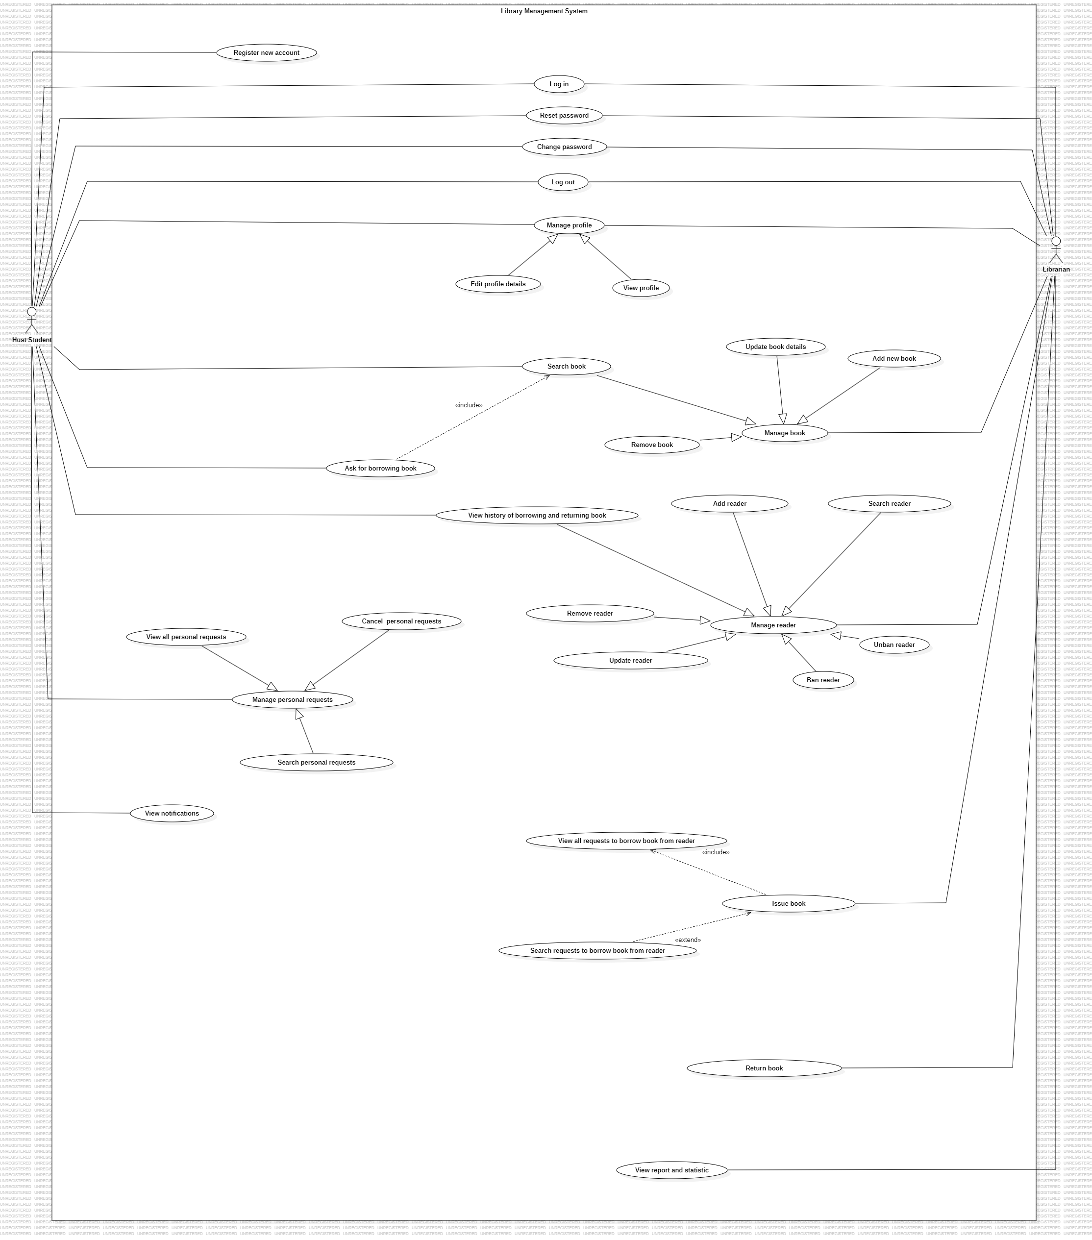

Figure . Overall Use Case Diagram

Figure . Use Case Diagram for Hust Student

Figure . Use Case Diagram for Librarian

## List of Actors

|  |  |  |
| --- | --- | --- |
| **No.** | **Actor** | **Description** |
| 1 | Hust Student | They are students who are learning at Ha Noi University of Science and Technology (HUST) |
| 2 | Librarian | They are librarians who are working at Ta Quang Buu Library |

Table . List of Actors

## List of Use Cases

|  |  |  |
| --- | --- | --- |
| **ID** | **Use Case** | **Actor(s)** |
| **UC-01** | Register new account | Hust Student |
| **UC-02** | Log in | Hust Student, Librarian |
| **UC-03** | Reset password | Hust Student, Librarian |
| **UC-04** | Change password | Hust Student, Librarian |
| **UC-05** | Log out | Hust Student, Librarian |
| **UC-06** | View profile | Hust Student, Librarian |
| **UC-07** | Edit profile details | Hust Student, Librarian |
| **UC-08** | View notifications | Hust Student |
| **UC-09** | Ask for borrowing book | Hust Student |
| **UC-10** | View all personal requests | Hust Student |
| **UC-11** | Search personal requests | Hust Student |
| **UC-12** | Cancel personal requests | Hust Student |
| **UC-13** | Add new book | Librarian |
| **UC-14** | Remove book | Librarian |
| **UC-15** | Update book details | Librarian |
| **UC-16** | Search book | Hust Student, Librarian |
| **UC-17** | Add reader | Librarian |
| **UC-18** | Remove reader | Librarian |
| **UC-19** | Update reader | Librarian |
| **UC-20** | Search reader | Librarian |
| **UC-21** | Ban reader | Librarian |
| **UC-22** | Unban reader | Librarian |
| **UC-23** | View history of borrowing and returning book | Hust Student, Librarian |
| **UC-24** | Issue book | Librarian |
| **UC-25** | View requests to borrow book from reader | Librarian |
| **UC-26** | Search requests to borrow book from reader | Librarian |
| **UC-27** | Return book | Librarian |
| **UC-28** | View reports and statistics | Librarian |

Table . List of Use Cases

## Bussiness Rules

|  |  |
| --- | --- |
| **ID** | **Description** |
| BR-01 | Using a maximum of 30 characters for the Name of user |
| BR-02 | Using a maximum of 30 characters for Email |
| BR-03 | Using a maximum of 11 digits (0-9) for Phone Number |
| BR-04 | Using a maximum of 100 characters for the Address |
| BR-05 | Using a maximum of 100 characters for Username |
| BR-06 | Using a maximum of 100 characters for Password |
| BR-07 | The new password (sent in Gmail) contains 8 characters long |
| BR-08 | The maximum length of the new password is 1000 characters |
| BR-09 | Using a maximum of 100 characters for the book’s title |
| BR-10 | Using a maximum of 30 characters for the book’s category |
| BR-11 | Using a maximum of 30 characters for the book’s author |

Table . List of Business Rules

## Use Case Specification

### Register new account

|  |  |
| --- | --- |
| **Use Case Specification** | |
| **Use Case No.:** | UC-01 |
| **Use Case Name:** | Register new account |
| **Created By:** | Ta Duc Duy |
| **Date:** | July 28th , 2024 |
| **Actors:** | Hust Student |
| **Summary:** | This feature applies only for Hust Student, but not for Librarian. This feature allows the user to create a new account. |
| **Trigger:** | The user clicks on “Create new account” |
| **Preconditions:** | 1. The user does not have a registered account before |
| **Post–conditions:** | 1. **Success:** The user creates a new account successfully. 2. **Failure:** The system displays an error message if the user provides incompleted or incorrect information. |
| **Main Success Scenario/Main Flow/Normal Flow/Main Path:**   |  |  |  | | --- | --- | --- | | **Step.** | **Actor Action** | **System Response** | | 1 | The user clicks on “Create new account” in the homepage | The system displays the form, as below  - Username  - Password  - Re-password  - Fullname  - Phone Number  - Email  - Address  - Birth | | 2 | The user fills out the given form |  | | 3 | The user submits the form by clicking on “Sign up” | The system validates the submitted form.  **[Exception 1]**  **[Exception 2]**  **[Exception 3]** | | 4 |  | The system displays the message “Sign up successfully” | | |
| **Alternative Flows:**   |  |  |  | | --- | --- | --- | | **No.** | **Actor Action** | **System Response** | | 1 | **N/A** |  | | |
| **Exceptions:**   |  |  |  | | --- | --- | --- | | **No.** | **Actor Action** | **System Response** | | 1 | The user enters an existing Username | The system displays the message “Username already existed”, and then prompts the user to re-enter the form. | | 2 | The user enters an existing Email | The system displays the message “Email already existed”, and then prompts the user to re-enter the form. | | 3 | The user enters an existing Phone Number | The system displays the message “Phone Number already existed”, and then prompts the user to re-enter the form. | | |
| **Business Rules:** | * **BR-01** * **BR-02** * **BR-03** * **BR-04** * **BR-05** * **BR-06** |

### Log in

|  |  |
| --- | --- |
| **Use Case Specification** | |
| **Use Case No.:** | UC-02 |
| **Use Case Name:** | Log in |
| **Created By:** | Tạ Đức Duy |
| **Date:** | July 28th , 2024 |
| **Actors:** | Hust Student, Librarian |
| **Summary:** | This use case allows 2 types of users (Hust Student, Librarian) to log in to the library management system. The system verifies the user's credentials and grants access to the system's resources based on the user's role and permissions. |
| **Trigger:** | The user clicks on “Log in” |
| **Preconditions:** | The user has already registered an account. |
| **Post–conditions:** | 1. The user is authenticated 2. The user can now perform actions according to their role. 3. History of log-in is recorded. |
| **Main Success Scenario/Main Flow/Normal Flow/Main Path:**   |  |  |  | | --- | --- | --- | | **Step.** | **Actor Action** | **System Response** | | 1 | The user clicks on “Log in” on the homepage | The system asks the user to fill out the following form  - Role (Hust Student/ Librarian)  - Username  - Password | | 2 | The user fills out the given form |  | | 3 | The user clicks on “Log in” | The system verifies the user account in the database. Upon successful authentication, the system directs the user to their respective dashboard based on their role.  **[Exception 1]** | | |
| **Alternative Flows:**   |  |  |  | | --- | --- | --- | | **No.** | **Actor Action** | **System Response** | | 1 | N/A |  | | |
| **Exceptions:**   |  |  |  | | --- | --- | --- | | **No.** | **Actor Action** | **System Response** | | 1 | The user enters an incorrect username or password. | The system displays an error message indicating the credentials are invalid and prompts the user to try again. | | |
| **Business Rules:** | * **BR-05** * **BR-06** |

### Reset password

|  |  |
| --- | --- |
| **Use Case Specification** | |
| **Use Case No.:** | UC-03 |
| **Use Case Name:** | Reset password |
| **Created By:** | Ta Duc Duy |
| **Date:** | July 28th , 2024 |
| **Actors:** | Hust Student, Librarian |
| **Summary:** | This use case allows a user who has forgotten their password or wishes to change it to reset their password in the library management system. The user can choose to reset their password by verifying their identity through the registered email address. |
| **Trigger:** | The user clicks on “Forgot password” |
| **Preconditions:** | 1. The user must have an active account in the library management system. 2. The system must have the user's email address and verified. |
| **Post–conditions:** | 1. **Success:** The user’s password is successfully reset, and they can log in with the new password. 2. **Failure:** The system displays an error message if the password reset process cannot be completed (e.g., verification failure, system error). |
| **Main Success Scenario/Main Flow/Normal Flow/Main Path:**   |  |  |  | | --- | --- | --- | | **Step.** | **Actor Action** | **System Response** | | 1 | The user selects the "Forgot Password" or "Reset Password" option on the login page. | The system prompts the user to enter the registered email. | | 2 | The user enters the email | The system verifies this email  **[Exception 1]** | | 3 |  | The system sends a new 8-characters-long password to this email | | 4 | The user check the registered email and uses the new password sent into this email to login again. |  | | |
| **Alternative Flows:**   |  |  |  | | --- | --- | --- | | **No.** | **Actor Action** | **System Response** | | 1 | **N/A** |  | | |
| **Exceptions:**   |  |  |  | | --- | --- | --- | | **No.** | **Actor Action** | **System Response** | | 1 | The user enters an invalid or incorrect email address. | The system displays an error message and prompts the user to enter valid email. | | |
| **Business Rules:** | * **BR-07** |

### Change password

|  |  |
| --- | --- |
| **Use Case Specification** | |
| **Use Case No.:** | UC-04 |
| **Use Case Name:** | Change password |
| **Created By:** | Ta Duc Duy |
| **Date:** | July 28th, 2024 |
| **Actors:** | Hust Student, Librarian |
| **Summary:** | This use case allows a user to change their password in the library management system for security purposes. |
| **Trigger:** | The user clicks on “Change password” in the “System” section. |
| **Preconditions:** | 1. The user must be logged into the system |
| **Post–conditions:** | 1. **Success:** The user's password is successfully updated, and they can log in with the new password. 2. **Failure:** The system displays an error if the change fails (e.g., incorrect current password, new password doesn't meet requirements). |
| **Main Success Scenario/Main Flow/Normal Flow/Main Path:**   |  |  |  | | --- | --- | --- | | **Step.** | **Actor Action** | **System Response** | | 1 | The user clicks on “Change password” in the “System” section. | The system shows the following editable form - Enter current password  - Enter newpassword  - Re-enter newpassword | | 2 | The user fills out the given form |  | | 3 | The user clicks on “OK” | The system verifies the submitted form.  **[Exception 1]**  **[Exception 2]**  **[Exception 3]** | | 4 |  | The system updates the password and displays a confirmation message. | | |
| **Alternative Flows:**   |  |  |  | | --- | --- | --- | | **No.** | **Actor Action** | **System Response** | | 1 | N/A |  | | |
| **Exceptions:**   |  |  |  | | --- | --- | --- | | **No.** | **Actor Action** | **System Response** | | 1 | The user enters an incorrect current password. | The user shows message “Incorrect current password” | | 2 | The new password doesn't meet the security requirements (e.g., too short, not complex enough). | The user is prompted to enter a valid password. | | 3 | Entering a new password and Re-entering a new password doesn’t match | The user shows the error message and prompts the user to re-enter the field “Re-entering new password” | | |
| **Business Rules:** | * **BR-08** |

### Log out

|  |  |
| --- | --- |
| **Use Case Specification** | |
| **Use Case No.:** | UC-05 |
| **Use Case Name:** | Log out |
| **Created By:** | Ta Duc Duy |
| **Date:** | July 28th, 2024 |
| **Actors:** | Hust Student, Librarian |
| **Summary:** | This use case describes the process by which a user securely logs out of the library management system, ending their session. |
| **Trigger:** | The user indicates that they want to log out of the system. |
| **Preconditions:** | 1. The user must be logged into the system. |
| **Post–conditions:** | 1. **Success:** The user's session is terminated, and they are redirected to the login page or a confirmation page indicating they have logged out. |
| **Main Success Scenario/Main Flow/Normal Flow/Main Path:**   |  |  |  | | --- | --- | --- | | **Step.** | **Actor Action** | **System Response** | | 1 | The user selects the "Log Out" option from the “System” section | The system redirects the user to the login page or displays a log-out confirmation page. | | |
| **Alternative Flows:**   |  |  |  | | --- | --- | --- | | **No.** | **Actor Action** | **System Response** | | 1 | N/A |  | | |
| **Exceptions:**   |  |  |  | | --- | --- | --- | | **No.** | **Actor Action** | **System Response** | | 1 | N/A |  | | |
| **Business Rules:** | **N/A** |

### View profile

|  |  |
| --- | --- |
| **Use Case Specification** | |
| **Use Case No.:** | UC-06 |
| **Use Case Name:** | View profile |
| **Created By:** | Ta Duc Duy |
| **Date:** | July 28th, 2024 |
| **Actors:** | Hust Student, Librarian |
| **Summary:** | This use case allows a user to view their personal profile details, such as name, email, phone number, etc. |
| **Trigger:** | The user chooses to view their profile information by selecting the "Infomation" option on the homepage. |
| **Preconditions:** | 1. The user must be logged in to the library management system. |
| **Post–conditions:** | 1. **Success:** The user successfully views their profile information. |
| **Main Success Scenario/Main Flow/Normal Flow/Main Path:**   |  |  |  | | --- | --- | --- | | **Step.** | **Actor Action** | **System Response** | | 1 | The user chooses to view their profile information by selecting the "Infomation" option on the homepage. | The system retrieves the user’s profile information from the database. Then the system displays the user’s profile details, including  - Full name  - ID  - Birth  - Address  - Registered email  - Registered phone number | | |
| **Alternative Flows:**   |  |  |  | | --- | --- | --- | | **No.** | **Actor Action** | **System Response** | | 1 | N/A |  | | |
| **Exceptions:**   |  |  |  | | --- | --- | --- | | **No.** | **Actor Action** | **System Response** | | 1 | N/A |  | | |
| **Business Rules:** | **N/A** |

### Edit profile details

|  |  |
| --- | --- |
| **Use Case Specification** | |
| **Use Case No.:** | UC-07 |
| **Use Case Name:** | Edit profile details |
| **Created By:** | Ta Duc Duy |
| **Date:** | July 28th, 2024 |
| **Actors:** | Hust Student, Librarian |
| **Summary:** | This use case allows the user to update their personal profile details, such as name, email, phone number, and other relevant information in the library management system. |
| **Trigger:** | The user clicks on “Information” and he/she wants to edit the personal profile details. |
| **Preconditions:** | 1. The user has logged in successfully. |
| **Post–conditions:** | 1. **Success:** User’s profile details are updated and saved in the system. 2. **Failure:** The system displays an error message if the profile details cannot be updated (e.g., due to missing required fields or system error). |
| **Main Success Scenario/Main Flow/Normal Flow/Main Path:**   |  |  |  | | --- | --- | --- | | **Step.** | **Actor Action** | **System Response** | | 1 | The user clicks on “Information” in the homepage | The system displays the current user information under the **uneditable** form, as belows  - Reader ID (un-editable)  - Full Name (un-editable)  - Address (un-editable)  - Email (un-editable)  - Phone Number (un-editable)  - Birth (un-editable) | | 2 | The user clicks on “Update information” | The system shows current user information under **editable form**, as follows  - Reader ID (un-editable)  - Full Name (editable)  - Address (editable)  - Email (editable)  - Phone Number (editable)  - Birth (editable) | | 3 | The user edits necessary fields in the form |  | | 4 | The user submits the form by clicking on “Save” | The system validates the input and updates the profile information in the database.  **[Exception 1]** | | |
| **Alternative Flows:**   |  |  |  | | --- | --- | --- | | **No.** | **Actor Action** | **System Response** | | 1 | N/A |  | | |
| **Exceptions:**   |  |  |  | | --- | --- | --- | | **No.** | **Actor Action** | **System Response** | | 1 | If input validation fails (e.g., incorrect email format) | The system displays an error message, and then asks the user to correct the input and resubmit. | | |
| **Business Rules:** | * **BR-01** * **BR-02** * **BR-03** * **BR-04** * **BR-05** * **BR-06** |

### View notifications

|  |  |
| --- | --- |
| **Use Case Specification** | |
| **Use Case No.:** | UC-08 |
| **Use Case Name:** | View notifications |
| **Created By:** | Ta Duc Duy |
| **Date:** | July 28th, 2024 |
| **Actors:** | Hust Student |
| **Summary:** | This use case allows a user to view notifications related to their account activities, such as due date reminders, reservation confirmations, or system updates. |
| **Trigger:** | After immediately the user logged in to the system. |
| **Preconditions:** | 1. User must be logged in. |
| **Post–conditions:** | 1. **Success:** The user views notifications |
| **Main Success Scenario/Main Flow/Normal Flow/Main Path:**   |  |  |  | | --- | --- | --- | | **Step.** | **Actor Action** | **System Response** | | 1 | After the user successfully logs in to the system | The system displays necessary notifications | | |
| **Alternative Flows:**   |  |  |  | | --- | --- | --- | | **No.** | **Actor Action** | **System Response** | | 1 | N/A |  | | |
| **Exceptions:**   |  |  |  | | --- | --- | --- | | **No.** | **Actor Action** | **System Response** | | 1 | N/A |  | | |
| **Business Rules:** | N/A |

### Ask for borrowing book

|  |  |
| --- | --- |
| **Use Case Specification** | |
| **Use Case No.:** | UC-09 |
| **Use Case Name:** | Ask for borrowing book |
| **Created By:** | Ta Duc Duy |
| **Date:** | July 28th, 2024 |
| **Actors:** | Hust Student |
| **Summary:** | This use case allows a user to send a request to borrow books to the librarian |
| **Trigger:** | The user clicks on “Available book” (search book function) and he/she wants to send a request to borrow some books |
| **Preconditions:** | 1. The user must be logged in and verified as Hust Student |
| **Post–conditions:** | 1. **Success:** The borrowing request is successfully sent and awaits approval by the librarian. |
| **Main Success Scenario/Main Flow/Normal Flow/Main Path:**   |  |  |  | | --- | --- | --- | | **Step.** | **Actor Action** | **System Response** | | 1 | The user clicks on “Available book” section | The system shows all **available** books | | 2 |  | The system shows the search feature | | 3 | The user searches for the desired books. | The system shows related books that are available to borrow. | | 4 | The user selects a desired book | The system asks the user to enter the date to return this book. | | 5 | The user enters the date to return the book |  | | 6 | The user clicks on “Request borrow” | The system displays the confirmation message “Your request is sent”  **[Exception 1]** | | |
| **Alternative Flows:**   |  |  |  | | --- | --- | --- | | **No.** | **Actor Action** | **System Response** | | 1 | N/A |  | | |
| **Exceptions:**   |  |  |  | | --- | --- | --- | | **No.** | **Actor Action** | **System Response** | | 1 | The user enters the invalid date to return the book. | The system displays an error message highlighting the issues and prompts the user to correct them. | | |
| **Business Rules:** | **N/A** |

### View all personal requests

|  |  |
| --- | --- |
| **Use Case Specification** | |
| **Use Case No.:** | UC-10 |
| **Use Case Name:** | View all personal requests |
| **Created By:** | Ta Duc Duy |
| **Date:** | July 28th, 2024 |
| **Actors:** | Hust Student |
| **Summary:** | This feature allows the reader to view his/her history of requests to borrow the book that are being waiting for the librarian’s response. |
| **Trigger:** | The user clicks on “Manage personal requests” on the homepage, and he/she wants to view all his/her requests (that are being waiting for the librarian’s response) |
| **Preconditions:** | 1. The user must be logged in and verified as Hust Student |
| **Post–conditions:** | 1. **Success:** History of requests including requests to borrow the book and requests to renew the book. |
| **Main Success Scenario/Main Flow/Normal Flow/Main Path:**   |  |  |  | | --- | --- | --- | | **Step.** | **Actor Action** | **System Response** | | 1 | The student clicks on “Manage personal requests” on the homepage | The system displays the history of requests to borrow the book. For example,   |  |  |  |  | | --- | --- | --- | --- | | Requests to borrow the book | | | | | Book ID | Title | Start  Borrow  Date | Due Date | |  |  |  |  | | | |
| **Alternative Flows:**   |  |  |  | | --- | --- | --- | | **No.** | **Actor Action** | **System Response** | | 1 | N/A |  | | |
| **Exceptions:**   |  |  |  | | --- | --- | --- | | **No.** | **Actor Action** | **System Response** | | 1 | N/A |  | | |
| **Business Rules:** | **N/A** |

### Seach personal requests

|  |  |
| --- | --- |
| **Use Case Specification** | |
| **Use Case No.:** | UC-11 |
| **Use Case Name:** | Search personal requests |
| **Created By:** | Ta Duc Duy |
| **Date:** | July 28th, 2024 |
| **Actors:** | Hust Student |
| **Summary:** | This feature allows the reader to search his/her requests that were made before |
| **Trigger:** | The user clicks on “Manage personal requests” on the homepage, and he/she wants to search for requests. |
| **Preconditions:** | 1. The user must be logged in and verified as Hust Student |
| **Post–conditions:** | 1. **Success:** The history of related requests is shown |
| **Main Success Scenario/Main Flow/Normal Flow/Main Path:**   |  |  |  | | --- | --- | --- | | **Step.** | **Actor Action** | **System Response** | | 1 | The student clicks on “Manage personal request” on the homepage | The system prompts the student to enter a keyword to search | | 2 | The student enters a keyword | The history of related requests is shown.  **[Exception 1]** | | |
| **Alternative Flows:**   |  |  |  | | --- | --- | --- | | **No.** | **Actor Action** | **System Response** | | 1 | N/A |  | | |
| **Exceptions:**   |  |  |  | | --- | --- | --- | | **No.** | **Actor Action** | **System Response** | | 1 | If no request found | The system displays the messages “No request found”, and prompts the user to enter another keyword. | | |
| **Business Rules:** | **N/A** |

### Cancel personal requests

|  |  |
| --- | --- |
| **Use Case Specification** | |
| **Use Case No.:** | UC-12 |
| **Use Case Name:** | Cancel personal requests |
| **Created By:** | Ta Duc Duy |
| **Date:** | July 28th, 2024 |
| **Actors:** | Hust Student |
| **Summary:** | This feature allows the reader to cancel one or more than one requests that were made before. |
| **Trigger:** | The user clicks on “Manage personal requests” on the homepage, and he/she wants to cancel some requests that were already sent to the librarian. |
| **Preconditions:** | 1. The user must be logged in and verified as Hust Student 2. The user made some requests before |
| **Post–conditions:** | 1. **Success:** The selected requests are canceled 2. **Failure:** The system shows the message “No request to cancel” if no request is found. |
| **Main Success Scenario/Main Flow/Normal Flow/Main Path:**   |  |  |  | | --- | --- | --- | | **Step.** | **Actor Action** | **System Response** | | 1 | The student clicks on “Manage personal requests” on the homepage | The system all requests that were made before. For example,   |  |  |  |  | | --- | --- | --- | --- | | Requests to borrow the book | | | | | Book ID | Title | Start  Borrow  Date | Due Date | |  |  |  |  | | | 2 | The student selects one or more than one desired requests to cancel  **[Alternative 1]** |  | | 3 | The student clicks on “Cancel request” | The system displays the message “Do you want to cancel the request?” | | 4 | The student clicks on “Ok” | The system removes information of the selected requests from the database | | 5 |  | The system displays the confirmation message “Canceled request(s)” | | |
| **Alternative Flows:**   |  |  |  | | --- | --- | --- | | **No.** | **Actor Action** | **System Response** | | 1 | 1. The student uses the search function to search for the desired requests. | The system shows all related requests  **[Exception 1]** | | 2. The student selects one or more than one desired requests to cancel |  | | 3. Come back to the step 3 in the main flow |  | | |
| **Exceptions:**   |  |  |  | | --- | --- | --- | | **No.** | **Actor Action** | **System Response** | | 1 | 1. No request is found | The system shows the message “No request is found”, and then prompts the user to enter another keyword. | | |
| **Business Rules:** | **N/A** |

### Add new book

|  |  |
| --- | --- |
| **Use Case Specification** | |
| **Use Case No.:** | UC-13 |
| **Use Case Name:** | Add new book |
| **Created By:** | Ta Duc Duy |
| **Date:** | July 28th, 2024 |
| **Actors:** | Librarian |
| **Summary:** | This feature allows the librarian to add one or more than one book into the database |
| **Trigger:** | The librarian clicks on “Book management” and he/she wants to add new books to the database |
| **Preconditions:** | The user already logged in and was verified as a librarian’s role |
| **Post–conditions:** | 1. **Success:** The new book is successfully added to the database. 2. **Failure:** The system displays an error message if the book cannot be added |
| **Main Success Scenario/Main Flow/Normal Flow/Main Path:**   |  |  |  | | --- | --- | --- | | **Step.** | **Actor Action** | **System Response** | | 1 | The librarian clicks on “Book management” in the homepage | The system shows the following editable form:  - Book ID (generated randomly and un-editable)  - Title  - Author  - Category  - Quantity  - Published Date | | 2 | The librarian fills out the given form |  | | 3 | The librarian clicks on “Add book” | The system validate the submitted form, and then the system informs “Added new book”  **[Exception 1]** | | |
| **Alternative Flows:**   |  |  |  | | --- | --- | --- | | **No.** | **Actor Action** | **System Response** | | 1 | N/A |  | | |
| **Exceptions:**   |  |  |  | | --- | --- | --- | | **No.** | **Actor Action** | **System Response** | | 1 | The librarian enters incomplete or incorrect book details. | The system displays an error message highlighting the issues and prompts the librarian to correct them. | | |
| **Business Rules:** | * **BR-09** * **BR-10** * **BR-11** |

### Remove book

|  |  |
| --- | --- |
| **Use Case Specification** | |
| **Use Case No.:** | UC-14 |
| **Use Case Name:** | Remove book |
| **Created By:** | Ta Duc Duy |
| **Date:** | July 28th, 2024 |
| **Actors:** | Librarian |
| **Summary:** | This feature allows a librarian to remove all books whose ID is selected by the librarian |
| **Trigger:** | The librarian clicks on “Book management”, and he/she wants to remove all books basing on book ID. |
| **Preconditions:** | 1. The librarian must be logged in to the library management system. 2. The book must exist in the system. |
| **Post–conditions:** | 1. **Success:** The books are successfully removed from the system 2. **Failure:** The system displays an error message if the book cannot be removed (e.g., it does not exist in the system). |
| **Main Success Scenario/Main Flow/Normal Flow/Main Path:**   |  |  |  | | --- | --- | --- | | **Step.** | **Actor Action** | **System Response** | | 1 | The librarian clicks on “Book management” option in the homepage | The system displays all books | | 2 | The librarian searches for the book in the system using the search function. | The system displays all related book details  **[Exception 1]** | | 3 | The librarian selects a desired book among searched books. |  | | 4 | The librarian clicks on “Remove book”. | The system prompts the librarian to confirm the removal. | | 5 | The librarian confirms the removal.  **[Alternative 1]** | The system removes all books whose ID is selected by the librarian. | | |
| **Alternative Flows:**   |  |  |  | | --- | --- | --- | | **No.** | **Actor Action** | **System Response** | | 1 | The librarian cancels the removal process. | The system does not remove the book and returns to the previous screen. | | |
| **Exceptions:**   |  |  |  | | --- | --- | --- | | **No.** | **Actor Action** | **System Response** | | 1 | The librarian attempts to search for a book that does not exist in the system. | The system displays an error message stating that the book cannot be found. | | |
| **Business Rules:** | N/A |

### Update book details

|  |  |
| --- | --- |
| **Use Case Specification** | |
| **Use Case No.:** | UC-15 |
| **Use Case Name:** | Update book details |
| **Created By:** | Ta Duc Duy |
| **Date:** | July 28th, 2024 |
| **Actors:** | Librarian |
| **Summary:** | This use case allows a librarian to update the details of an existing book in the library system. This action is performed when there are changes in the book's information, such as a new edition, updated author details, or correction of errors. |
| **Trigger:** | The librarian clicks on “Book management”, and indicates that he/she want to update the details of an existing book |
| **Preconditions:** | 1. The librarian must be logged in to the library management system. 2. The book must already exist in the system. |
| **Post–conditions:** | 1. **Success:** The book's details are successfully updated in the system. 2. **Failure:** The system displays an error message if the details cannot be updated (e.g., invalid information, system error). |
| **Main Success Scenario/Main Flow/Normal Flow/Main Path:**   |  |  |  | | --- | --- | --- | | **Step.** | **Actor Action** | **System Response** | | 1 | The librarian clicks on “Book management” | The system shows all books | | 2 | The librarian searches for the book they wish to update in the system. | The system displays the related books  **[Exception 1]** | | 3 | The librarian selects the book he/she wants to edit. | The system provides the edit-book-details  Form (the information of the selected book is automatically put into this form by default), as below  - Book ID (un-editable)  - Title  - Author  - Category  - Quantity  - Published Date | | 4 | The librarian updates the necessary fields by filling out the given form. |  | | 5 | The librarian clicks on “Update book” | The system displays a confirmation message.  **[Exception 2]** | | 6 | The librarian confirms updating the book by clicking on “Ok”  **[Alternative 1]** | The system validates the submitted form, then the system updates the book details in the database, and then sends the message “Updated book”. | | |
| **Alternative Flows:**   |  |  |  | | --- | --- | --- | | **No.** | **Actor Action** | **System Response** | | 1 | The librarian cancels the update before final confirmation. | The system does not update the book details and returns to the previous screen. | | |
| **Exceptions:**   |  |  |  | | --- | --- | --- | | **No.** | **Actor Action** | **System Response** | | 1 | The librarian attempts to update a book that does not exist in the system. | The system displays an error message stating that the book cannot be found. | | 2 | The librarian enters incomplete or invalid details while updating the book. | The system displays an error message highlighting the issues and prompts the librarian to correct them. | | |
| **Business Rules:** | * **BR-09** * **BR-10** * **BR-11** |

### Search book

|  |  |
| --- | --- |
| **Use Case Specification** | |
| **Use Case No.:** | UC-16 |
| **Use Case Name:** | Search book |
| **Created By:** | Ta Duc Duy |
| **Date:** | July 28th, 2024 |
| **Actors:** | Hust Student, Librarian |
| **Summary:** | This use case allows users (librarians, students) to search for books within the library system. |
| **Trigger:** | The user clicks on “Book management” (if librarian) or “Available book” (if student), and indicates that he/she want to find a specific book or books matching certain criteria. |
| **Preconditions:** | 1. The user must have access to the library management system. |
| **Post–conditions:** | 1. **Success:** The system displays a list of books that match the search criteria. 2. **Failure:** The system displays a message indicating no books were found matching the search criteria. |
| **Main Success Scenario/Main Flow/Normal Flow/Main Path:**   |  |  |  | | --- | --- | --- | | **Step.** | **Actor Action** | **System Response** | | 1 | * Librarian actions:   The librarian clicks on “Book management” in the homepage   * Student actions:   The student clicks on “Available book” in the home page | The system displays the search interface with various search criteria fields. | | 2 | The user enters the desired search criteria | The system validates the entered search criteria.  **[Exception 1]** | | 3 | The user submits the search request. | The system searches the library's database for books that match the criteria. If found, then the system shows the search results, including details like title, author, availability, etc. If not found, the system shows message “not found”. | | |
| **Alternative Flows:**   |  |  |  | | --- | --- | --- | | **No.** | **Actor Action** | **System Response** | | 1 | N/A |  | | |
| **Exceptions:**   |  |  |  | | --- | --- | --- | | **No.** | **Actor Action** | **System Response** | | 1 | The user enters invalid or incomplete search criteria. | The system prompts the user to correct the input and resubmit the search. | | |
| **Business Rules:** | N/A |

### Add reader

|  |  |
| --- | --- |
| **Use Case Specification** | |
| **Use Case No.:** | UC-17 |
| **Use Case Name:** | Add reader |
| **Created By:** | Ta Duc Duy |
| **Date:** | July 28th, 2024 |
| **Actors:** | Librarian |
| **Summary:** | This feature allows the librarian to add a new reader (Hust Student) to the system. At the same time, the system creates a new account for this new reader. |
| **Trigger:** | The librarian clicks on “Reader management”, and he/she wants to add a new Hust Student. |
| **Preconditions:** | User must be logged in and verified Librarian |
| **Post–conditions:** | 1. **Success:** A new reader information is added to the system 2. **Failure:** System shows corresponding error messages |
| **Main Success Scenario/Main Flow/Normal Flow/Main Path:**   |  |  |  | | --- | --- | --- | | **Step.** | **Actor Action** | **System Response** | | 1 | The librarian clicks on “Reader management” | The system shows the editable form, as below  - Reader ID (generated randomly, and un-editable)  - Username  - Reader Name  - Email  - Phone Number  - Address  - Birth | | 2 | The librarian uses the information of new reader to fill out the given form. |  | | 3 | The librarian clicks on “Add reader” | The system validates the submitted form  **[Exception 1]**  **[Exception 2]**  **[Exception 3]** | | 4 |  | The system creates a new account for this new reader, based on the input Username (password is generated randomly) | | 5 |  | The system shows message “Add reader” | | |
| **Alternative Flows:**   |  |  |  | | --- | --- | --- | | **No.** | **Actor Action** | **System Response** | | 1 | N/A |  | | |
| **Exceptions:**   |  |  |  | | --- | --- | --- | | **No.** | **Actor Action** | **System Response** | | 1 | The librarian entered the username that already existed | The system shows the message “The username existed” | | 2 | The librarian entered the email that already existed | The system shows the message “The email existed” | | 3 | The librarian entered the phone number that already existed | The system shows the message “The phone number existed” | | |
| **Business Rules:** | * **BR-01** * **BR-02** * **BR-03** * **BR-04** * **BR-05** |

### Remove reader

|  |  |
| --- | --- |
| **Use Case Specification** | |
| **Use Case No.:** | UC-18 |
| **Use Case Name:** | Remove reader |
| **Created By:** | Ta Duc Duy |
| **Date:** | July 28th, 2024 |
| **Actors:** | Librarian |
| **Summary:** | This feature allows the librarian to remove the reader (Hust Student) from the system. At the same time, the system removes the corresponding account of this reader. |
| **Trigger:** | The librarian clicks on “Reader management”, and he/she wants to remove every about a somewhat reader. |
| **Preconditions:** | The user must be logged in and verified Librarian |
| **Post–conditions:** | 1. **Success:** Every about the reader is removed 2. **Failure:** System shows corresponding error messages |
| **Main Success Scenario/Main Flow/Normal Flow/Main Path:**   |  |  |  | | --- | --- | --- | | **Step.** | **Actor Action** | **System Response** | | 1 | The librarian clicks on “Reader management” | The system shows all readers so far | | 2 | The librarian selects one reader to remove  **[Alternative 1]** |  | | 3 | The librarian clicks on “Remove reader” | The system shows the message “Do you want to remove this reader?” | | 4 | The librarian clicks on “Ok” | The system removes everything about this reader from the database | | 5 |  | The system shows the message “Removed reader” | | |
| **Alternative Flows:**   |  |  |  | | --- | --- | --- | | **No.** | **Actor Action** | **System Response** | | 1 | The librarian uses the search function to search for the desired reader | The system shows all related readers  **[Exception 1]** | | 2 | Come back to the step 3 in the main flow |  | | |
| **Exceptions:**   |  |  |  | | --- | --- | --- | | **No.** | **Actor Action** | **System Response** | | 1 | If not found | The system shows the message “No result found” | | |
| **Business Rules:** | **N/A** |

### Update reader

|  |  |
| --- | --- |
| **Use Case Specification** | |
| **Use Case No.:** | UC-19 |
| **Use Case Name:** | Update reader |
| **Created By:** | Ta Duc Duy |
| **Date:** | July 28th, 2024 |
| **Actors:** | Librarian |
| **Summary:** | This feature allows the librarian to update the reader's details including Name, Username, Phone Number, Email, etc. |
| **Trigger:** | The librarian clicks on “Reader management”, and he/she wants to update the reader’s details |
| **Preconditions:** | The user must be logged in and verified Librarian |
| **Post–conditions:** | 1. **Success:** A new reader information is added to the system 2. **Failure:** System shows corresponding error messages |
| **Main Success Scenario/Main Flow/Normal Flow/Main Path:**   |  |  |  | | --- | --- | --- | | **Step.** | **Actor Action** | **System Response** | | 1 | The librarian clicks on “Reader management” | The system shows the editable form, as below  - Reader ID (un-editable)  - Username  - Reader Name  - Email  - Phone Number  - Address  - Birth | | 2 | The librarian user search function to search for the desired reader | The system shows all related readers | | 3 | The librarian selects one reader to edit | The system automatically fills out the given form by the selected reader’s information | | 4 | The librarian edits necessary fields in the given form |  | | 5 | The librarian clicks on “Update reader” | The system validates the submitted form  **[Exception 1]**  **[Exception 2]**  **[Exception 3]** | | 6 |  | The system updates the database | | 7 |  | The system shows the message “Updated reader” | | |
| **Alternative Flows:**   |  |  |  | | --- | --- | --- | | **No.** | **Actor Action** | **System Response** | | 1 | N/A |  | | |
| **Exceptions:**   |  |  |  | | --- | --- | --- | | **No.** | **Actor Action** | **System Response** | | 1 | The librarian entered the username that already existed | The system shows the message “The username existed” | | 2 | The librarian entered the email that already existed | The system shows the message “The email existed” | | 3 | The librarian entered the phone number that already existed | The system shows the message “The phone number existed” | | |
| **Business Rules:** | * **BR-01** * **BR-02** * **BR-03** * **BR-04** * **BR-05** |

### Search reader

|  |  |
| --- | --- |
| **Use Case Specification** | |
| **Use Case No.:** | UC-20 |
| **Use Case Name:** | Search reader |
| **Created By:** | Ta Duc Duy |
| **Date:** | July 28th, 2024 |
| **Actors:** | Librarian |
| **Summary:** | This feature allows the librarian to search readers, based on many criteria. |
| **Trigger:** | The librarian clicks on “Reader management”, and he/she wants to search for some readers |
| **Preconditions:** | The user must be logged in and verified Librarian |
| **Post–conditions:** | 1. **Success:** The related readers are shown 2. **Failure:** No reader found |
| **Main Success Scenario/Main Flow/Normal Flow/Main Path:**   |  |  |  | | --- | --- | --- | | **Step.** | **Actor Action** | **System Response** | | 1 | The librarian clicks on “Reader management” | The system shows all readers so far | | 2 | The librarian enters a keyword to search for a reader's details | The system shows all related readers  **[Exception 1]** | | |
| **Alternative Flows:**   |  |  |  | | --- | --- | --- | | **No.** | **Actor Action** | **System Response** | | 1 | N/A |  | | |
| **Exceptions:**   |  |  |  | | --- | --- | --- | | **No.** | **Actor Action** | **System Response** | | 1 | If not found | The system shows the message “No result found” | | |
| **Business Rules:** | **N/A** |

### Ban reader

|  |  |
| --- | --- |
| **Use Case Specification** | |
| **Use Case No.:** | UC-21 |
| **Use Case Name:** | Ban reader |
| **Created By:** | Ta Duc Duy |
| **Date:** | July 28th, 2024 |
| **Actors:** | Librarian |
| **Summary:** | This feature allows the librarian to block a user account. After the user account is blocked, the user cannot log in or cannot access the system anymore. |
| **Trigger:** | The librarian clicks on “Reader management”, and he/she wants to ban a user account. |
| **Preconditions:** | The user must be logged in and verified Librarian |
| **Post–conditions:** | 1. **Success:** The account of the selected user is blocked 2. **Failure:** System shows corresponding error messages |
| **Main Success Scenario/Main Flow/Normal Flow/Main Path:**   |  |  |  | | --- | --- | --- | | **Step.** | **Actor Action** | **System Response** | | 1 | The librarian clicks on “Reader management” | The system shows all readers so far | | 2 | The librarian selects one reader to ban  **[Alternative 1]** | The system shows the state of ban/unban of this reader | | 3 | The librarian clicks on “Ban reader” | The system shows the message “Do you want to ban this reader?” | | 4 | The librarian clicks on “Ok” | The system does not allow the account of this banned user to access to the system anymore. | | 5 |  | The system shows the message “Banned reader” | | |
| **Alternative Flows:**   |  |  |  | | --- | --- | --- | | **No.** | **Actor Action** | **System Response** | | 1 | N/A |  | | |
| **Exceptions:**   |  |  |  | | --- | --- | --- | | **No.** | **Actor Action** | **System Response** | | 1 | N/A |  | | |
| **Business Rules:** | **N/A** |

### Unban reader

|  |  |
| --- | --- |
| **Use Case Specification** | |
| **Use Case No.:** | UC-22 |
| **Use Case Name:** | Unban reader |
| **Created By:** | Ta Duc Duy |
| **Date:** | July 28th, 2024 |
| **Actors:** | Librarian |
| **Summary:** | This feature allows the librarian to unblock a user account. After the user account is unblocked, the user can access the system as norm. |
| **Trigger:** | The librarian clicks on “Reader management”, and he/she wants to ban a user account. |
| **Preconditions:** | The user must be logged in and verified Librarian |
| **Post–conditions:** | 1. **Success:** The account of the selected user is blocked 2. **Failure:** System shows corresponding error messages |
| **Main Success Scenario/Main Flow/Normal Flow/Main Path:**   |  |  |  | | --- | --- | --- | | **Step.** | **Actor Action** | **System Response** | | 1 | The librarian clicks on “Reader management” | The system shows all readers so far | | 2 | The librarian selects one reader to ban  **[Alternative 1]** | The system shows the state of ban/unban of this reader | | 3 | The librarian clicks on “Ban reader” | The system shows the message “Do you want to unban this reader?” | | 4 | The librarian clicks on “Ok” | The system does not allow the account of this banned user to access to the system anymore. | | 5 |  | The system shows the message “The reader is unbanned” | | |
| **Alternative Flows:**   |  |  |  | | --- | --- | --- | | **No.** | **Actor Action** | **System Response** | | 1 | N/A |  | | |
| **Exceptions:**   |  |  |  | | --- | --- | --- | | **No.** | **Actor Action** | **System Response** | | 1 | N/A |  | | |
| **Business Rules:** | **N/A** |

### View history of borrowing and returning book

|  |  |
| --- | --- |
| **Use Case Specification** | |
| **Use Case No.:** | UC-23 |
| **Use Case Name:** | View history of borrowing and returning book |
| **Created By:** | Ta Duc Duy |
| **Date:** | July 28th, 2024 |
| **Actors:** | Hust Student, Librarian |
| **Summary:** | 1. This feature allows students to view their history of borrowing and returning books (e.g. Borrow Date, Due Date, Return Date) 2. This feature allows the librarian to view the history of borrowing and returning books of readers (e.g. Borrow Date, Due Date, Return Date) |
| **Trigger:** | 1. The student clicks on “Available book”, and he/she wants to view the history of borrowing and returning books. 2. The librarian clicks on “Reader management”, and he/she wants to view the history of borrowing and returning books of all readers. |
| **Preconditions:** | The user already logged in to the system |
| **Post–conditions:** | 1. The student views his/her history of borrowing and returning books. 2. The librarian views the history of borrowing and returning books of all readers. |
| **Main Success Scenario/Main Flow/Normal Flow/Main Path:**   |  |  |  | | --- | --- | --- | | **Step.** | **Actor Action (Hust Student)** | **System Response** | | 1 | The student clicks on “History borrow” | The system shows the history of borrowing and returning books, including  - Book ID  - Book Title  - Start-Borrow Date  - Due Date  - Return Date |      |  |  |  | | --- | --- | --- | | **Step.** | **Actor Action (Librarian)** | **System Response** | | 1 | The librarian clicks on “Reader management” | The system shows all readers | | 2 | The librarian selects one reader to view his/her history of borrowing and returning book.  **[Alternative 1]** |  | | 3 | The librarian clicks on “History borrow” | The system shows the history of borrowing and returning books of the selected reader, including  - Book ID  - Book Title  - Start-Borrow Date  - Due Date  - Return Date | | |
| **Alternative Flows:**   |  |  |  | | --- | --- | --- | | **No.** | **Actor Action** | **System Response** | | 1 | 1. The librarian uses the search functions to search for the desired reader | The system shows all related readers  **[Exception 1]** | | 2. Come back to the step 3 in the main flow |  | | |
| **Exceptions:**   |  |  |  | | --- | --- | --- | | **No.** | **Actor Action** | **System Response** | | 1 | If not found | The system shows the message “No result found” and prompts the librarian enter new keyword | | |
| **Business Rules:** | **N/A** |

### Issue book

|  |  |
| --- | --- |
| **Use Case Specification** | |
| **Use Case No.:** | UC-24 |
| **Use Case Name:** | Issue book |
| **Created By:** | Ta Duc Duy |
| **Date:** | July 28th, 2024 |
| **Actors:** | Librarian |
| **Summary:** | This feature allows the librarian to issue books for corresponding readers, based on their requests to borrow books. |
| **Trigger:** | The librarian clicks on “Issue Book” on the homepage, and he/she wants to issue books for corresponding readers, based on their requests to borrow books. |
| **Preconditions:** | 1. The librarian already logged in to the system 2. The reader must send his/her requests to borrow books before. |
| **Post–conditions:** | 1. The reader borrows the book successfully 2. The history of borrowing books is recorded |
| **Main Success Scenario/Main Flow/Normal Flow/Main Path:**   |  |  |  | | --- | --- | --- | | **Step.** | **Actor Action** | **System Response** | | 1 | The librarian clicks on “Issue book” on the homepage | The system shows all requests to borrow books from readers | | 2 | The librarian selects one request  **[Alternative 1]** |  | | 3 | The librarian clicks on “Approve”  **[Alternative 2]** | The system sends a confirmation message to the corresponding reader’s email. For example, “Book Name, ID, has been approved by the librarian. Please go to the librarian to take the book” | | 4 |  | The system shows the message “Issued book successfully” | | |
| **Alternative Flows:**   |  |  |  | | --- | --- | --- | | **No.** | **Actor Action** | **System Response** | | 1 | 1. The librarian uses the search function to search for the desired request | The system shows all related requests  **[Exception 1]** | | 2. Come back to the step 3 in the main flow |  | | 2 | The librarian clicks on “Reject” | The system sends a rejection message to the corresponding reader’s email. For example, “Book Name, ID, has been rejected.” | | |
| **Exceptions:**   |  |  |  | | --- | --- | --- | | **No.** | **Actor Action** | **System Response** | | 1 | If not found | The system shows the message “No corresponding request found”, and prompts the librarian to enter another keyword. | | |
| **Business Rules:** | **N/A** |

### View requests to borrow book

|  |  |
| --- | --- |
| **Use Case Specification** | |
| **Use Case No.:** | UC-25 |
| **Use Case Name:** | View requests to borrow book |
| **Created By:** | Ta Duc Duy |
| **Date:** | July 28th, 2024 |
| **Actors:** | Librarian |
| **Summary:** | This feature allows the librarian to view all requests to borrow books from the readers |
| **Trigger:** | The librarian clicks on “Issue Book” on the homepage, and he/she wants to view all requests to borrow books from the readers |
| **Preconditions:** | 1. The librarian already logged in to the system |
| **Post–conditions:** | 1. The librarian can view all requests to borrow books from the readers. |
| **Main Success Scenario/Main Flow/Normal Flow/Main Path:**   |  |  |  | | --- | --- | --- | | **Step.** | **Actor Action** | **System Response** | | 1 | The librarian clicks on “Issue book” on the homepage | The system shows all requests to borrow books from readers. The information of each request should include  - Reader ID  - Reader Name  - Book ID  - Book Title  - Borrow Date  - Due Date | | |
| **Alternative Flows:**   |  |  |  | | --- | --- | --- | | **No.** | **Actor Action** | **System Response** | | 1 | N/A |  | | |
| **Exceptions:**   |  |  |  | | --- | --- | --- | | **No.** | **Actor Action** | **System Response** | | 1 | N/A |  | | |
| **Business Rules:** | **N/A** |

### Seach requests to borrow book

|  |  |
| --- | --- |
| **Use Case Specification** | |
| **Use Case No.:** | UC-26 |
| **Use Case Name:** | Search requests to borrow book |
| **Created By:** | Ta Duc Duy |
| **Date:** | July 28th, 2024 |
| **Actors:** | Librarian |
| **Summary:** | This feature allows the librarian to search for requests to borrow books from the readers by various types of keywords. |
| **Trigger:** | The librarian is in the “Issue book” section, and he/she wants to search for requests to borrow books from the readers by various types of keywords |
| **Preconditions:** | 1. The librarian already logged in to the system |
| **Post–conditions:** | 1. The librarian can view all desired requests |
| **Main Success Scenario/Main Flow/Normal Flow/Main Path:**   |  |  |  | | --- | --- | --- | | **Step.** | **Actor Action** | **System Response** | | 1 | The librarian clicks on “Issue book” on the homepage | The system shows the search-request function | | 2 | The librarian enters a keyword to search for the desired requests | The system shows all related requests  **[Exception 1]** | | |
| **Alternative Flows:**   |  |  |  | | --- | --- | --- | | **No.** | **Actor Action** | **System Response** | | 1 | N/A |  | | |
| **Exceptions:**   |  |  |  | | --- | --- | --- | | **No.** | **Actor Action** | **System Response** | | 1 | If not found | The system shows the message “No corresponding request found”, and then prompts the librarian to enter another keyword. | | |
| **Business Rules:** | **N/A** |

### Return book

|  |  |
| --- | --- |
| **Use Case Specification** | |
| **Use Case No.:** | UC-27 |
| **Use Case Name:** | Return book |
| **Created By:** | Ta Duc Duy |
| **Date:** | July 28th, 2024 |
| **Actors:** | Librarian |
| **Summary:** | This feature allows the librarian to return a book. The borrowers will bring their borrowed books to the librarian. After that, the librarian makes confirmation and return the book to the library’s inventory. |
| **Trigger:** | The librarian clicks on “Return book”, and he/she wants to return a book, which is returned by the borrower. |
| **Preconditions:** | 1. The librarian already logged in to the system 2. The borrower gives the librarian his/her information |
| **Post–conditions:** | 1. **Success:** The librarian confirms that the borrower returns the books successfully 2. **Failure:** The system shows corresponding error messages. |
| **Main Success Scenario/Main Flow/Normal Flow/Main Path:**   |  |  |  | | --- | --- | --- | | **Step.** | **Actor Action** | **System Response** | | 1 | The librarian clicks on “Return book” on the homepage | The system asks the librarian to enter the information of the book returned, and the information of the reader who returns the book. | | 2 | The librarian enters information of the book returned, and the information of the reader who returns the book. |  | | 3 | The librarian clicks on “Return book” | The system verifies information of the book returned, and the information of the reader who returns the book.  **[Exception 1]** | | |
| **Alternative Flows:**   |  |  |  | | --- | --- | --- | | **No.** | **Actor Action** | **System Response** | | 1 | N/A |  | | |
| **Exceptions:**   |  |  |  | | --- | --- | --- | | **No.** | **Actor Action** | **System Response** | | 1 | The information of the returner and the information of the book returned do not match | The system shows the message “Returned book and Returner do not match”, then the system prompts the librarian to enter again. | | |
| **Business Rules:** | **N/A** |

### View reports and statistics

|  |  |
| --- | --- |
| **Use Case Specification** | |
| **Use Case No.:** | UC-28 |
| **Use Case Name:** | View reports and statistics |
| **Created By:** | Ta Duc Duy |
| **Date:** | July 28th, 2024 |
| **Actors:** | Librarian |
| **Summary:** | This feature allows a librarian to view statistics including the number of readers, available books, books currently borrowed, overdue readers, and return-book-on-time readers. |
| **Trigger:** | The librarian clicks on “View statistics” |
| **Preconditions:** | 1. The librarian must be logged in to the library management system. |
| **Post–conditions:** | 1. The system shows the number of available books 2. The system shows the number of books currently borrowed 3. The system shows the number of overdue readers 4. The system shows the number of return-book-on-time readers |
| **Main Success Scenario/Main Flow/Normal Flow/Main Path:**   |  |  |  | | --- | --- | --- | | **Step.** | **Actor Action** | **System Response** | | 1 | The librarian clicks on “View statistics” option in the homepage | The system displays the following statistics   1. The system shows the number of available books 2. The system shows the number of books currently borrowed 3. The system shows the number of overdue readers 4. The system shows the number of return-book-on-time readers | | |
| **Alternative Flows:**   |  |  |  | | --- | --- | --- | | **No.** | **Actor Action** | **System Response** | | 1 | N/A |  | | |
| **Exceptions:**   |  |  |  | | --- | --- | --- | | **No.** | **Actor Action** | **System Response** | | 1 | N/A |  | | |
| **Business Rules:** | N/A |

# Software Design and Implementation

## System Architecture

### MVC Model

In this Library Management Project, we use the **MVC** (**Model** – **View** – **Control**) model to build the code. The **Model**-**View**-**Control** model is a software architectural design used to separate an application into three interconnected components that are **Model**, **View** and **Control**. We will interact with the **View**, **Model** will be the object store the data and the **Control** will interact between the **View** and the **Model**. We chose this model because it has a lot of advantages:

* Separate the model (dealt with once at a time):
  + **Model**: handling the object and data.
  + **View**: Handling the UI we interacting with.
  + **Control**: Processing and controlling the interaction between View and Model.

This helps in organizing the code effectively.

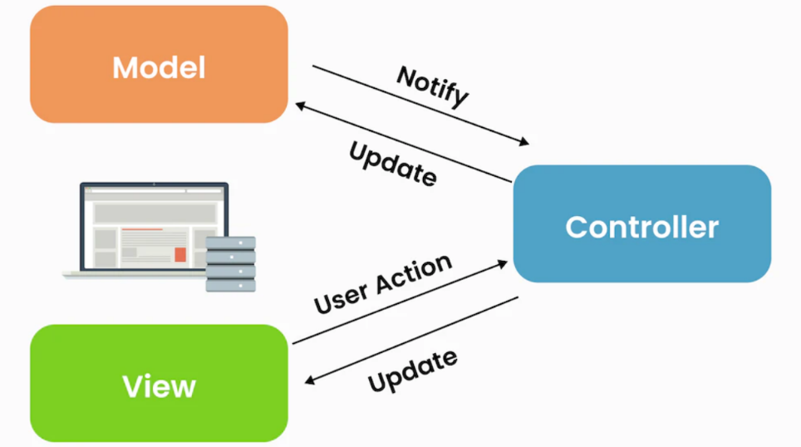

* Easy to be maintained.
* Easy for testing. Model can be tested independently and the same for others two.
* Easy to improve the Project.

### Repository Pattern

In the Project we applied the Repository Pattern which is the between layer of processing logic and data operation.

We choose this Pattern because of its advantages:

* **Separation of Concerns**: its separate data access logic from business logic, making the codebase cleaner and more manageable.
* **Maintainability**: Centralizing data access logic in repositories simplifies maintenance and update, as changes are confined to a single location.
* **Consistency**: Ensures a consistent data access strategy across the application, promoting code reuse and reducing duplication.

### Singleton Pattern

**Singleton pattern** is a design that ensures a class has only one instance throughout the application and provides a global point of access to that instance.

The key components:

1. **Private Static Instance**: A static variable to hold the single instance of the class.
2. **Private Constructor**: A constructor that is private to prevent direct instantiation from outside the class.
3. **Public Static method**: A method that provides access to the single instance, creating it if necessary.

We chose to use this pattern because of:

* **Reduced Memory Usage**: Minimizes memory consumption by avoiding the creation of multiple instances.
* **Consistency**: Guarantees that all parts of the application work with the same instance, ensuring consistency of state or configuration.
* **Global Access Point**: Provides a single, global point of access to the instance, which simplifies interactions with the object from different parts of the application.

## Activity Diagram

### Activity Diagram for Register new account

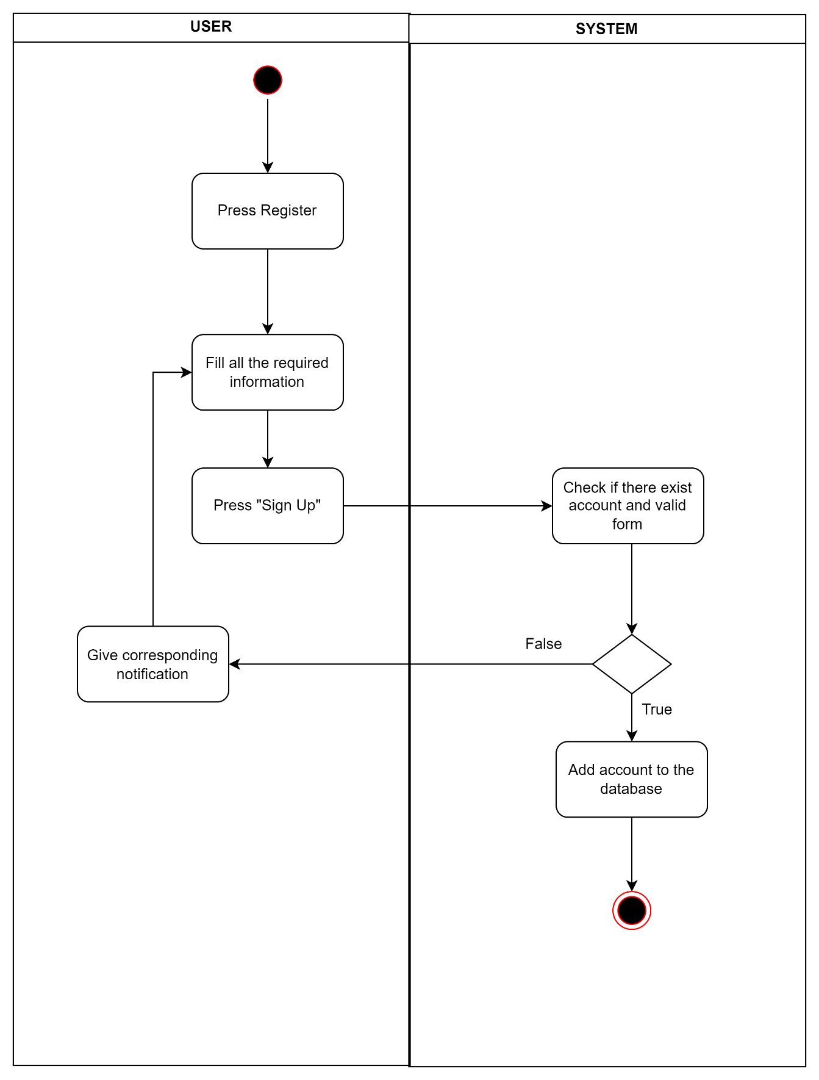

Figure . Activity Diagram for UC-01

### Activity Diagram for Log in

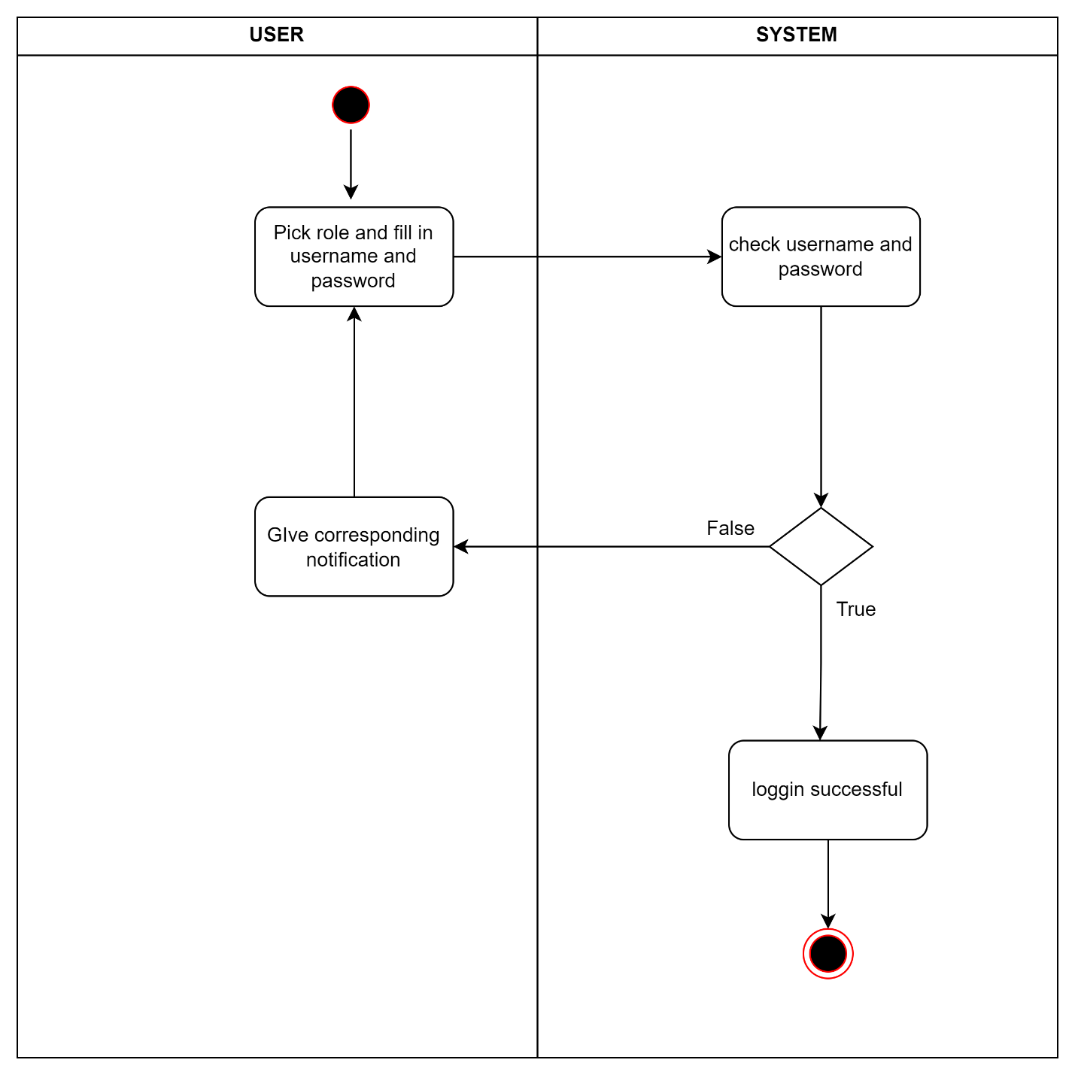

Figure . Activity Diagram for UC-02

### Activity Diagram for Reset password

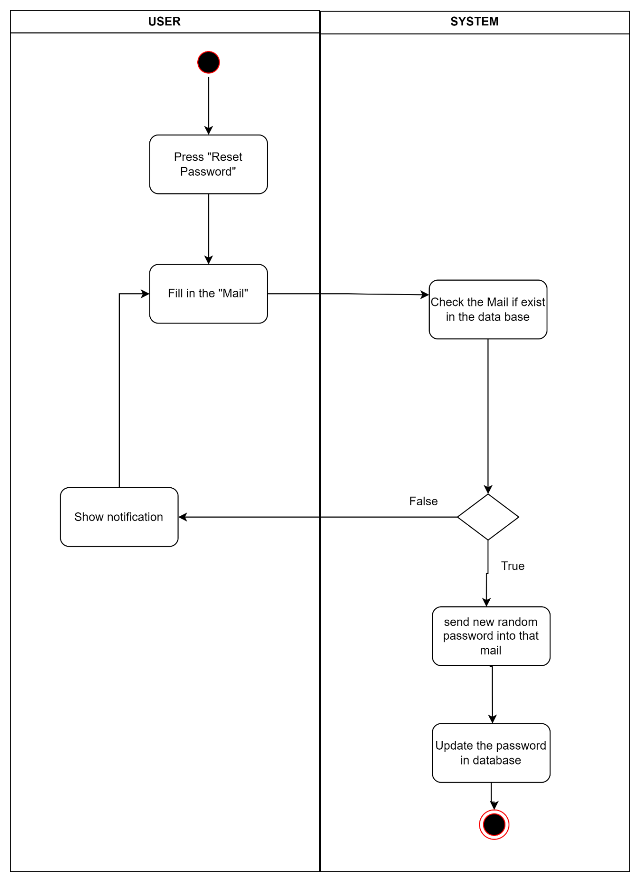

Figure . Activity Diagram for UC-03

### Activity Diagram for Change password

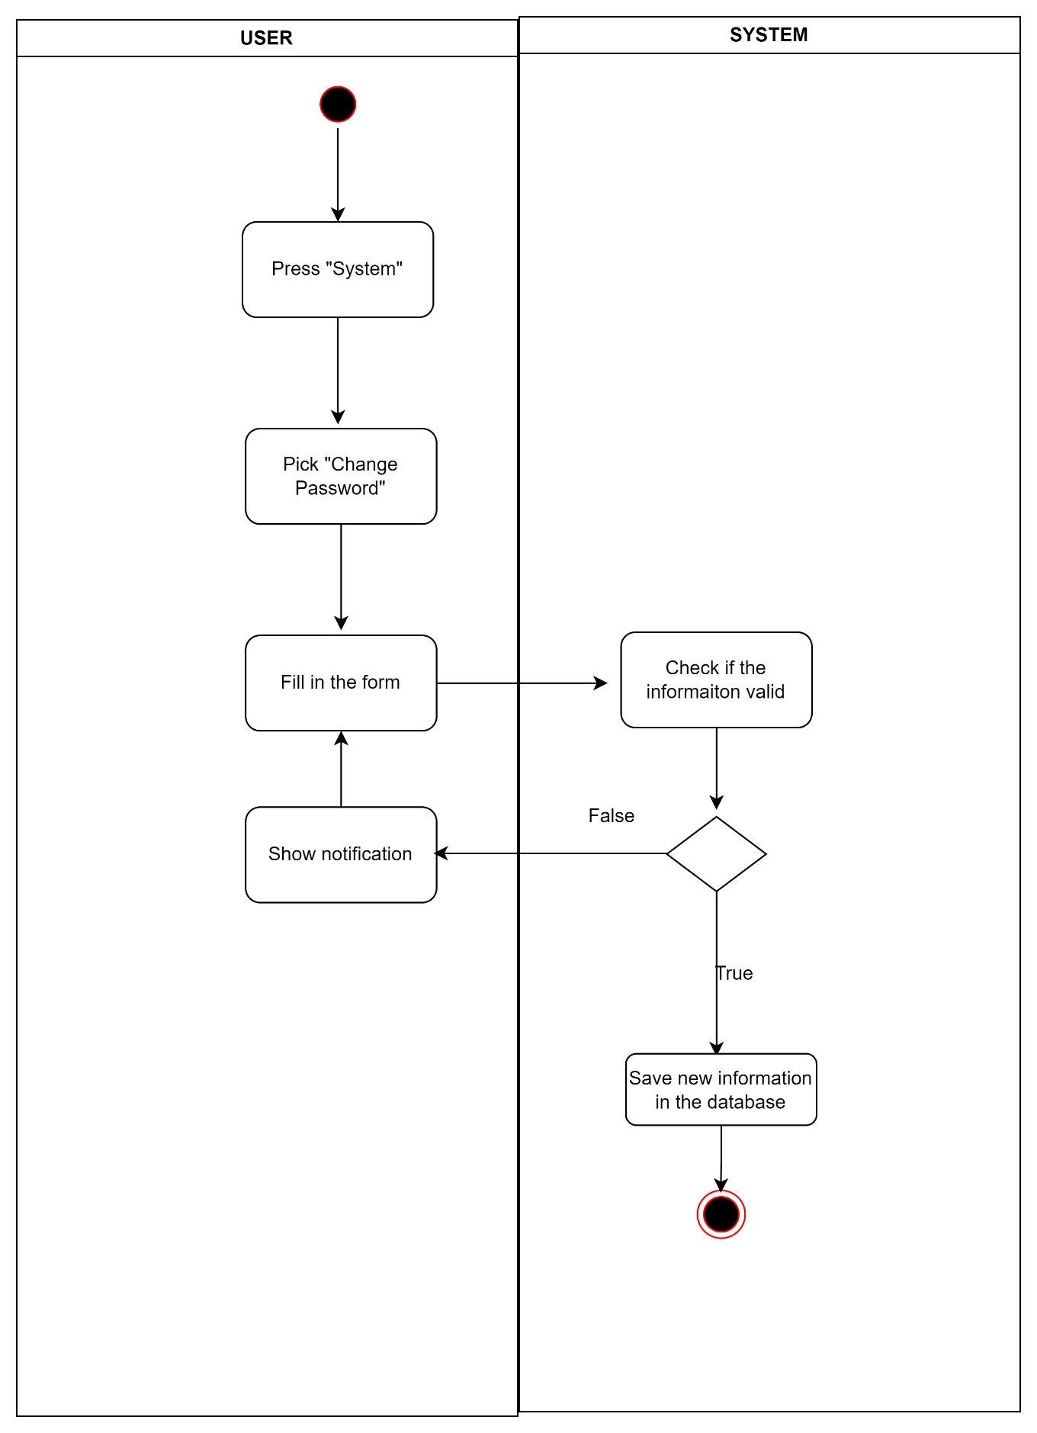

Figure . Activity Diagram for UC-04

### Activity Diagram for Log out

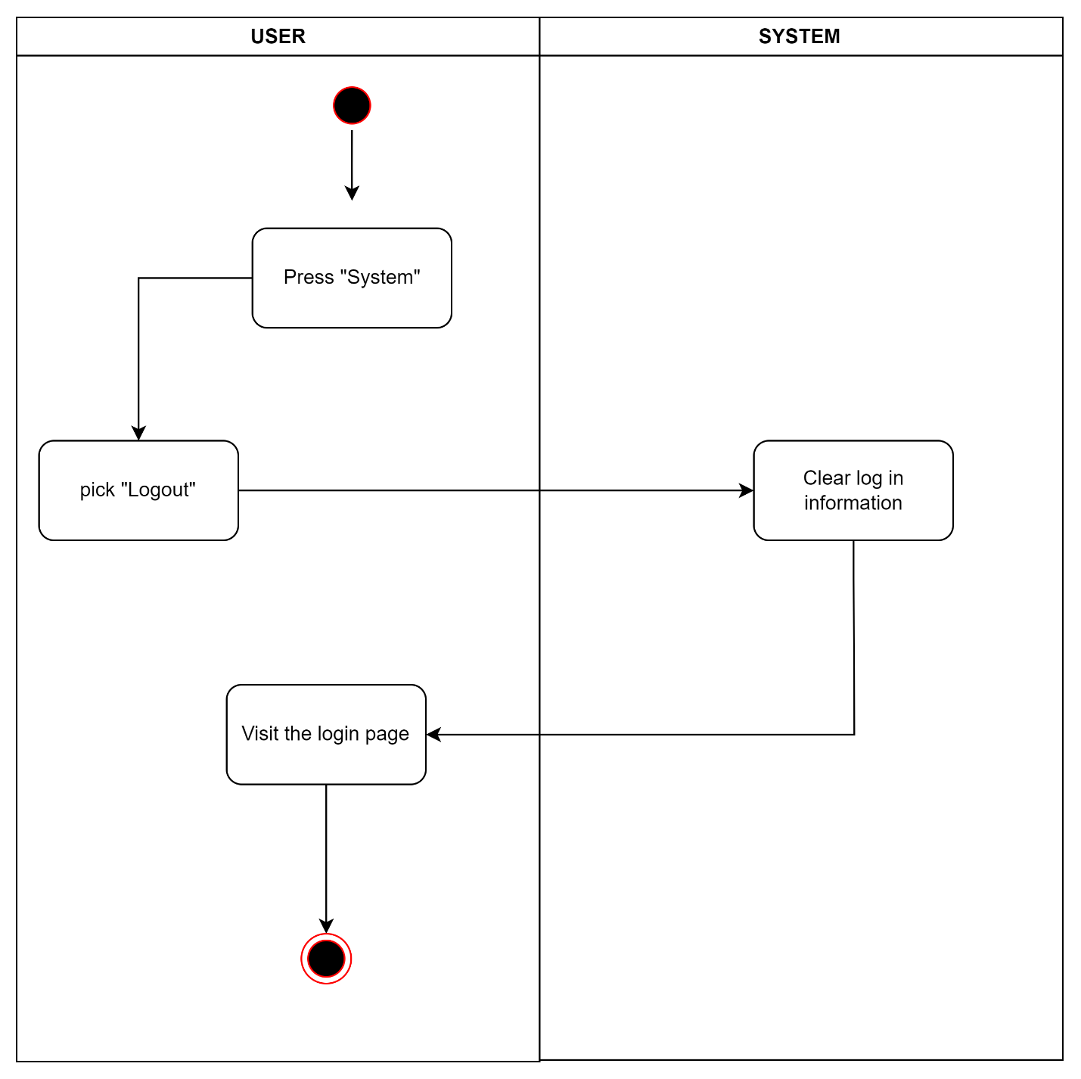

Figure . Activity Diagram for UC-05

### Activity Diagram for View profile

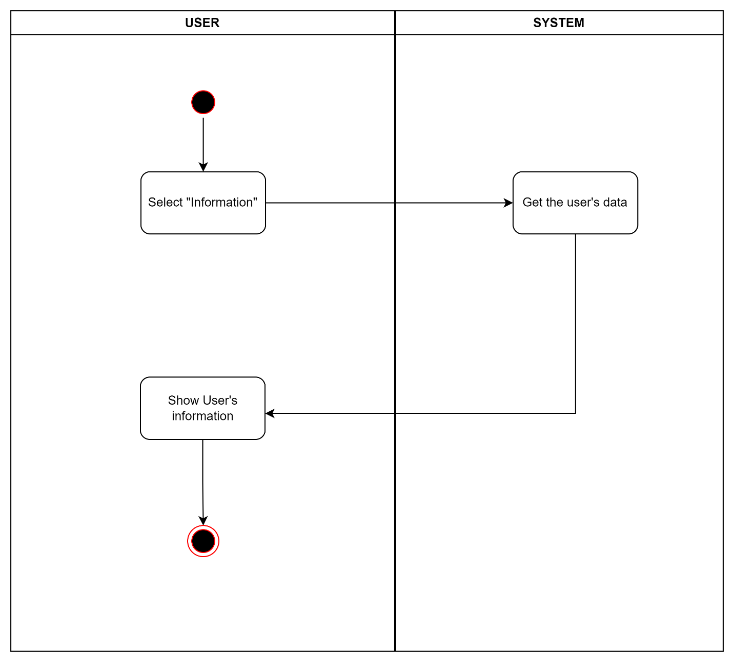

Figure . Activity Diagram for UC-06

### Activity Diagram for Edit profile details

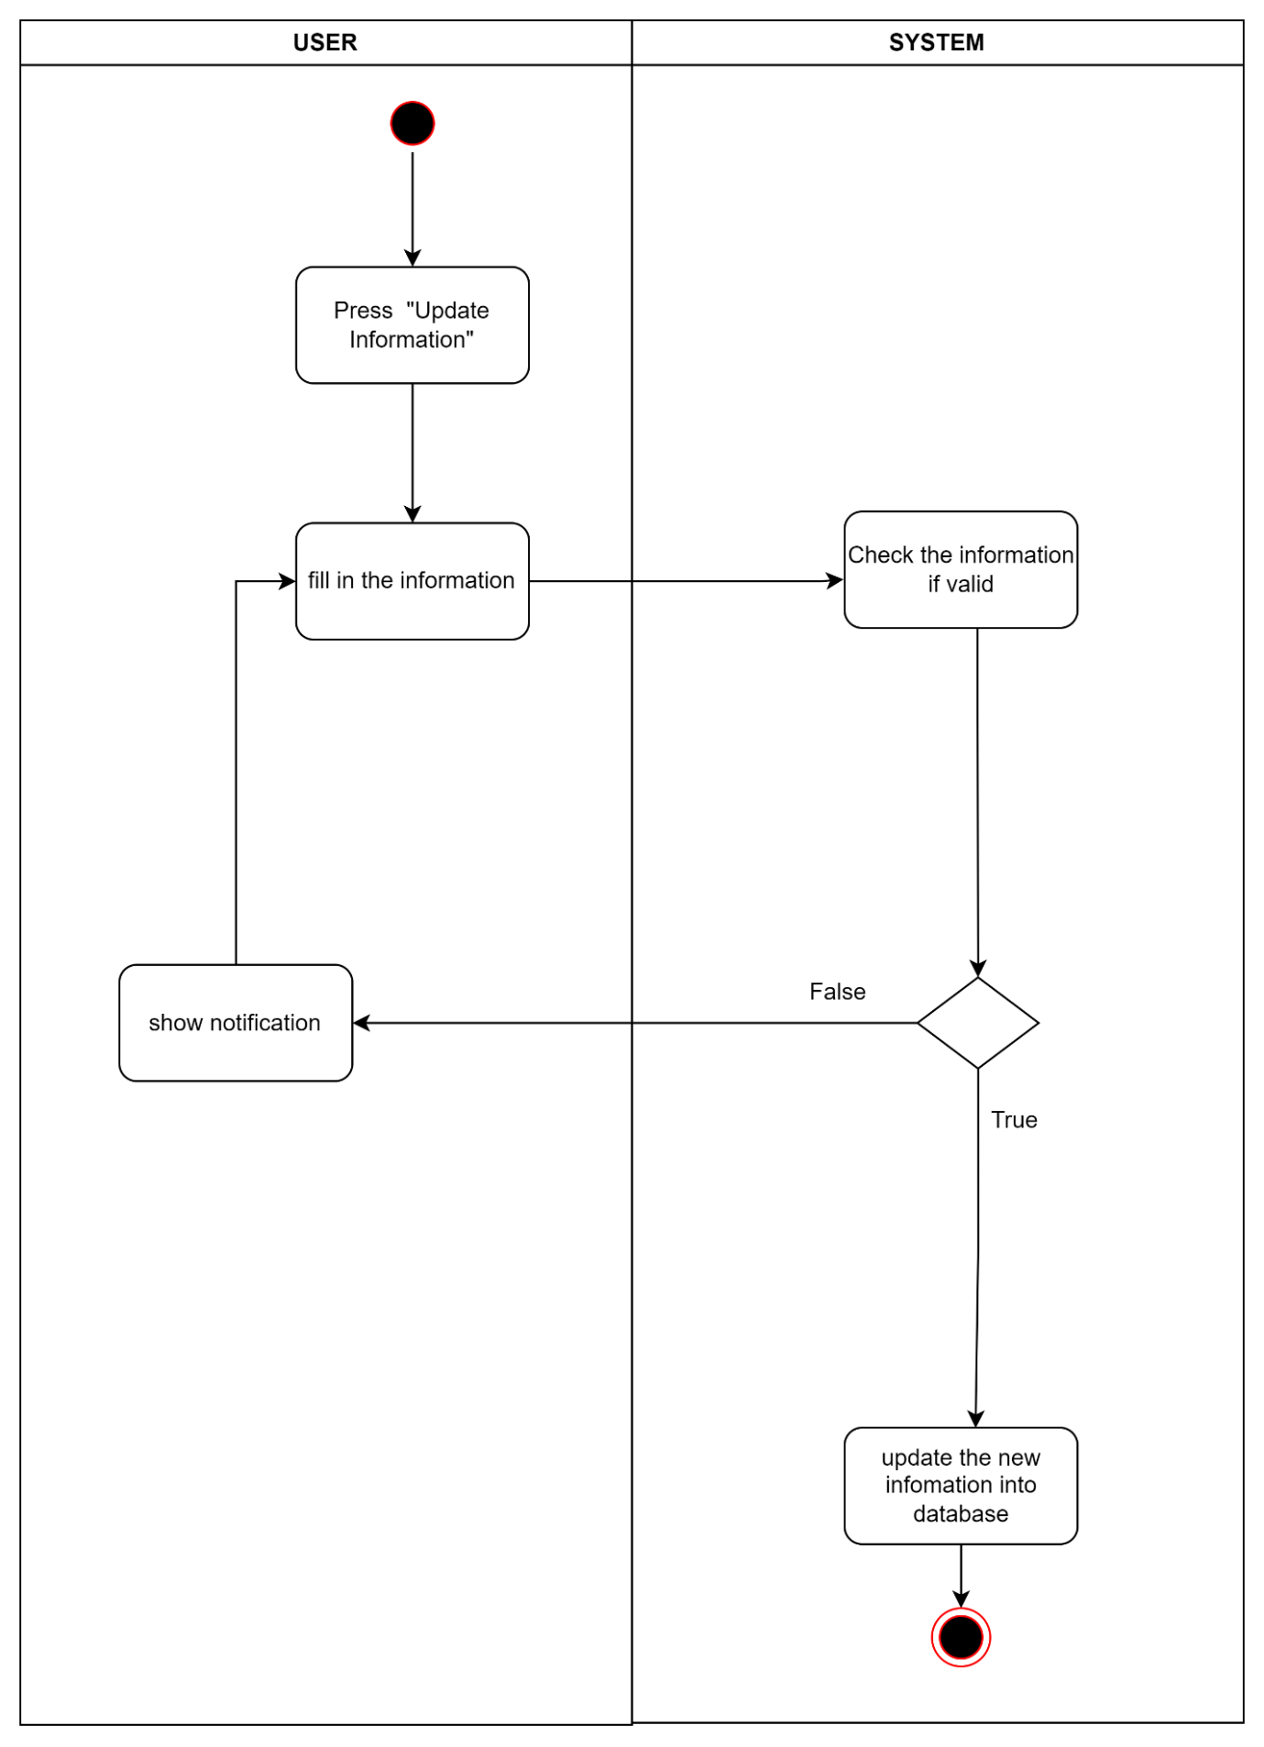

Figure . Activity Diagram for UC-06

### Activity Diagram for View notifications

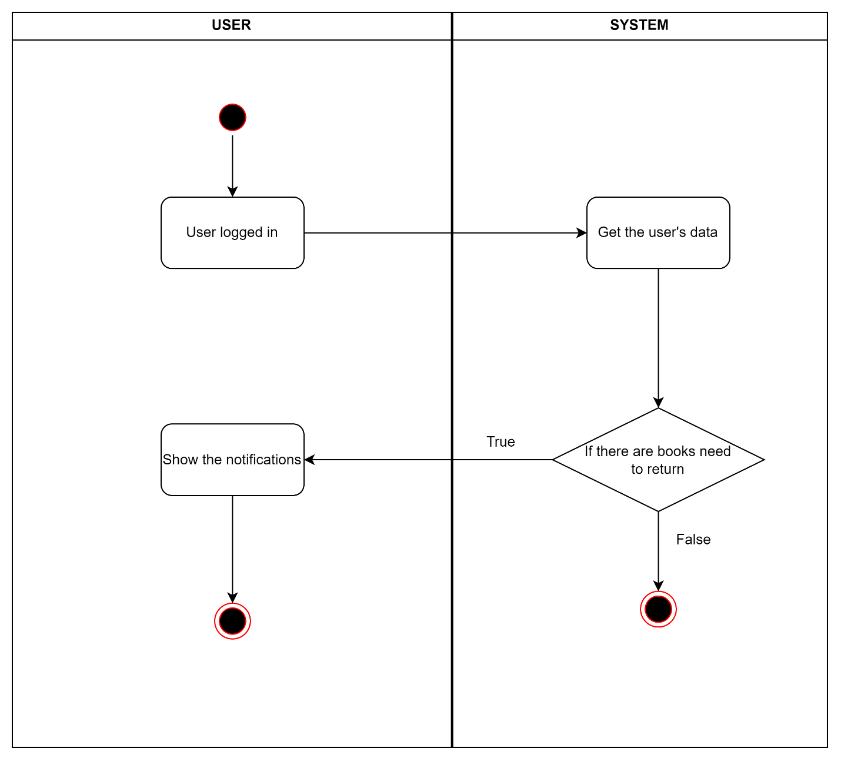

Figure . Activity Diagram for UC-08

### Activity Diagram for Ask for borrowing book

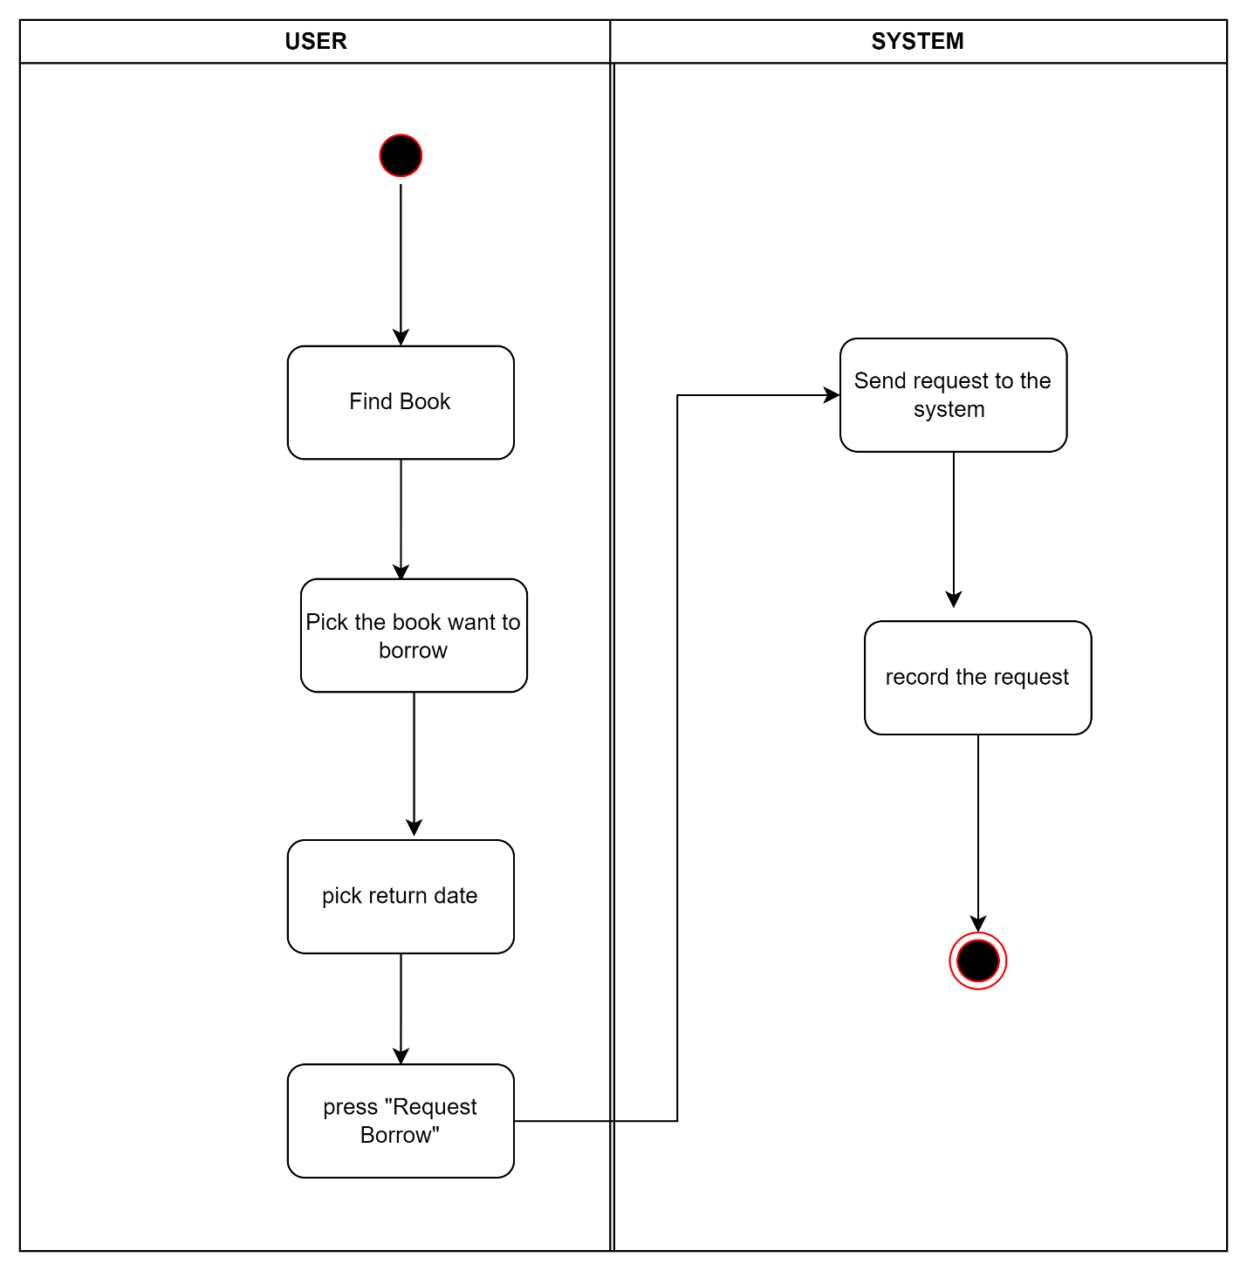

Figure . Activity Diagram for UC-09

### Activity Diagram for View all personal requests

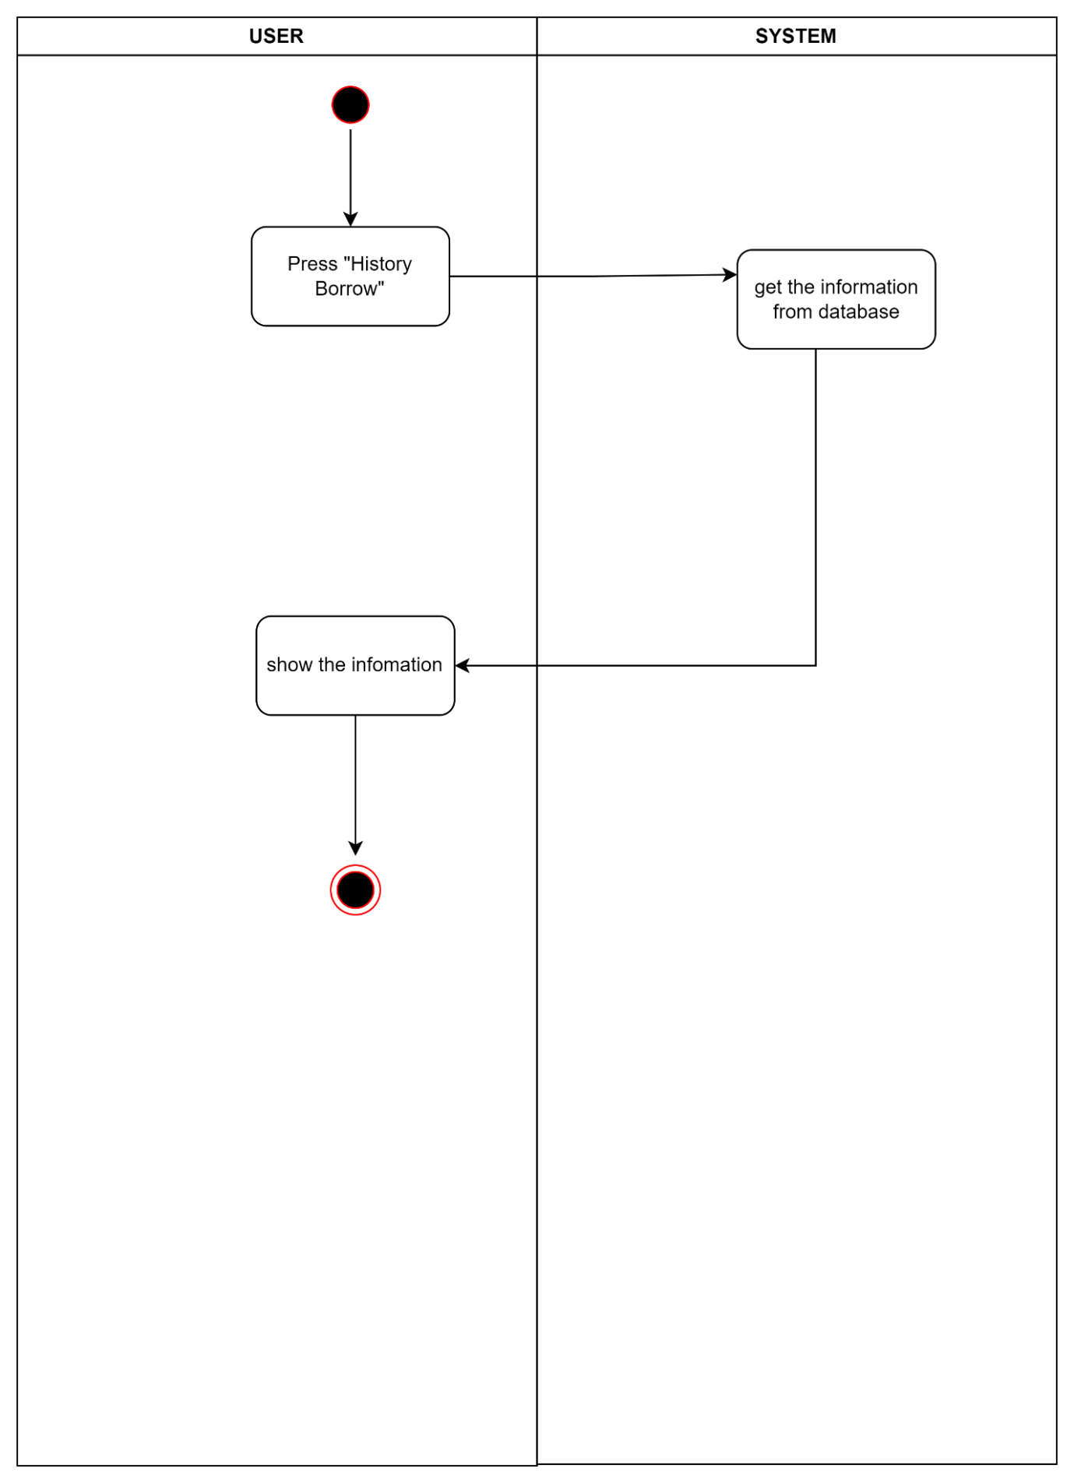

Figure . Activity Diagram for UC-10

### Activity Diagram for Search personal requests

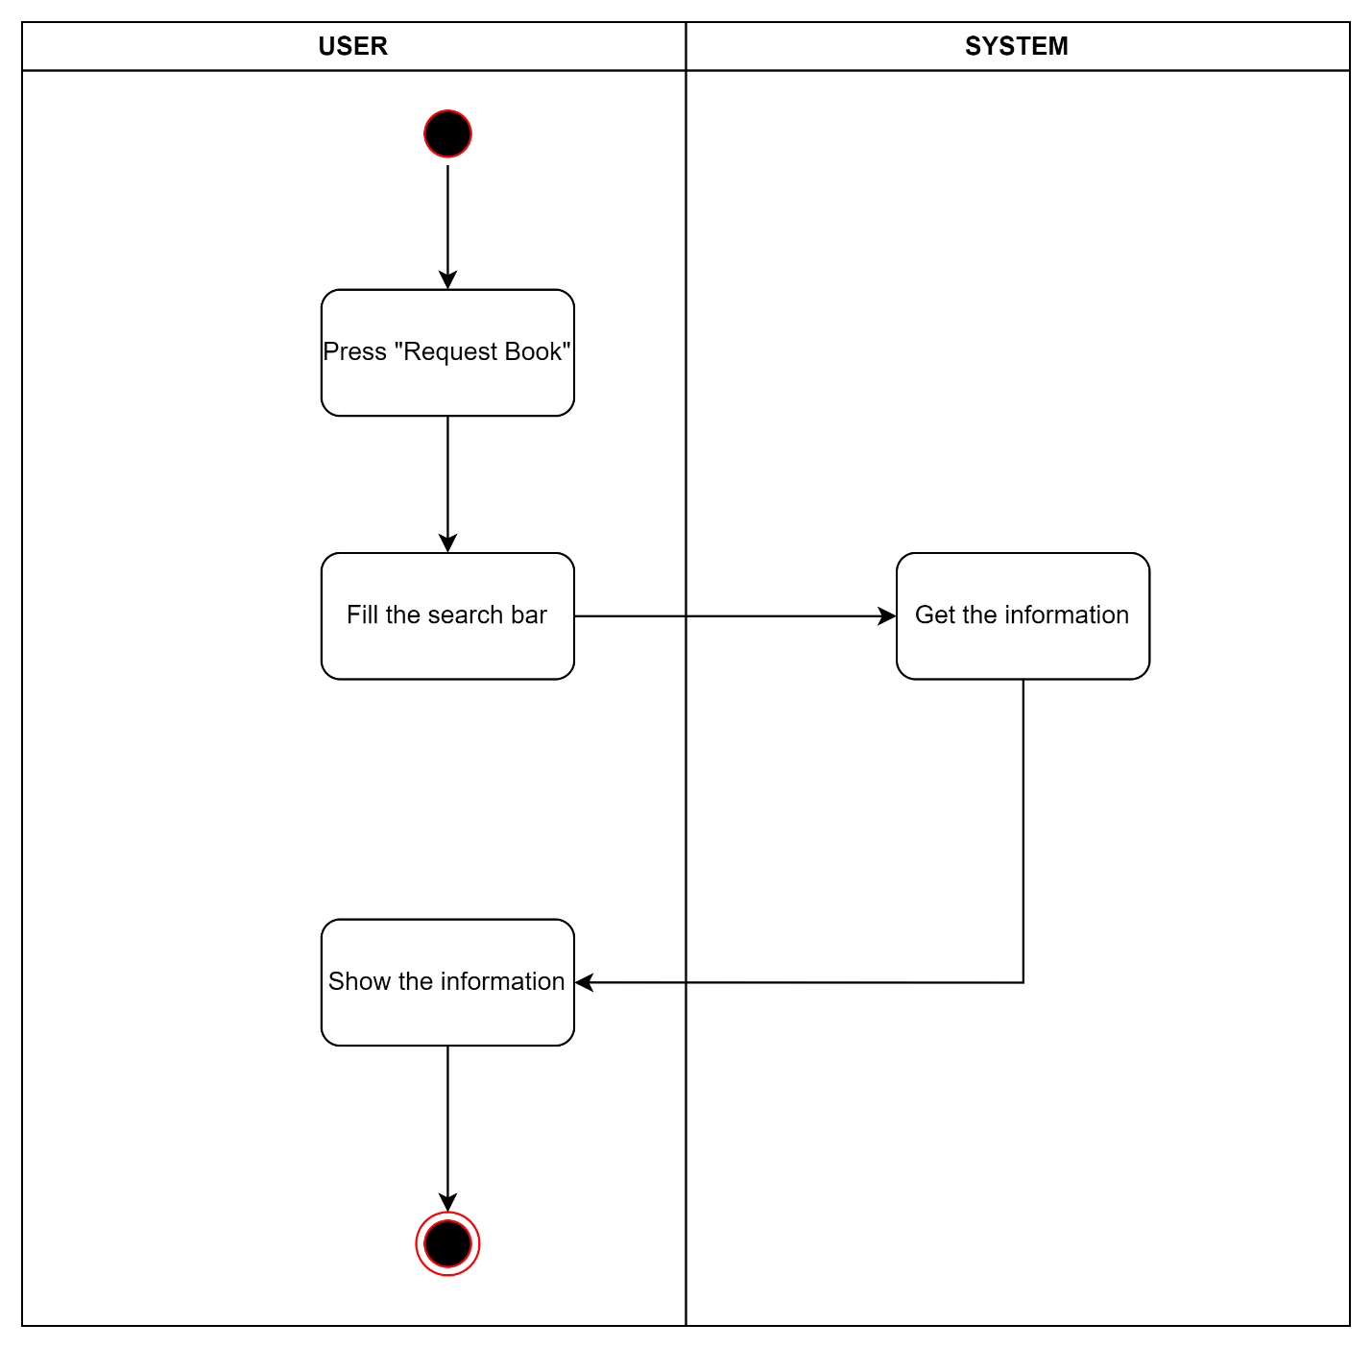

Figure . Activity Diagram for UC-11

### Activity Diagram for Cancel personal requests

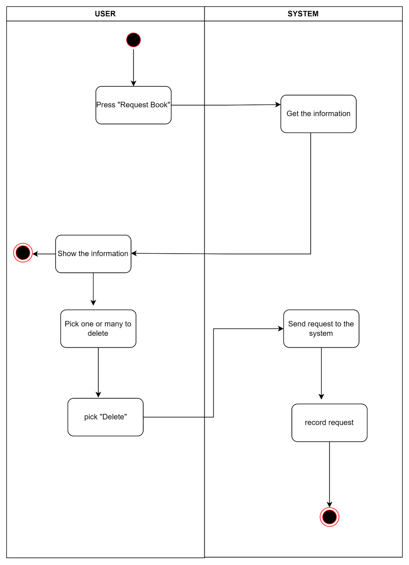

Figure . Activity Diagram for UC-12

### Activity Diagram for Add new book

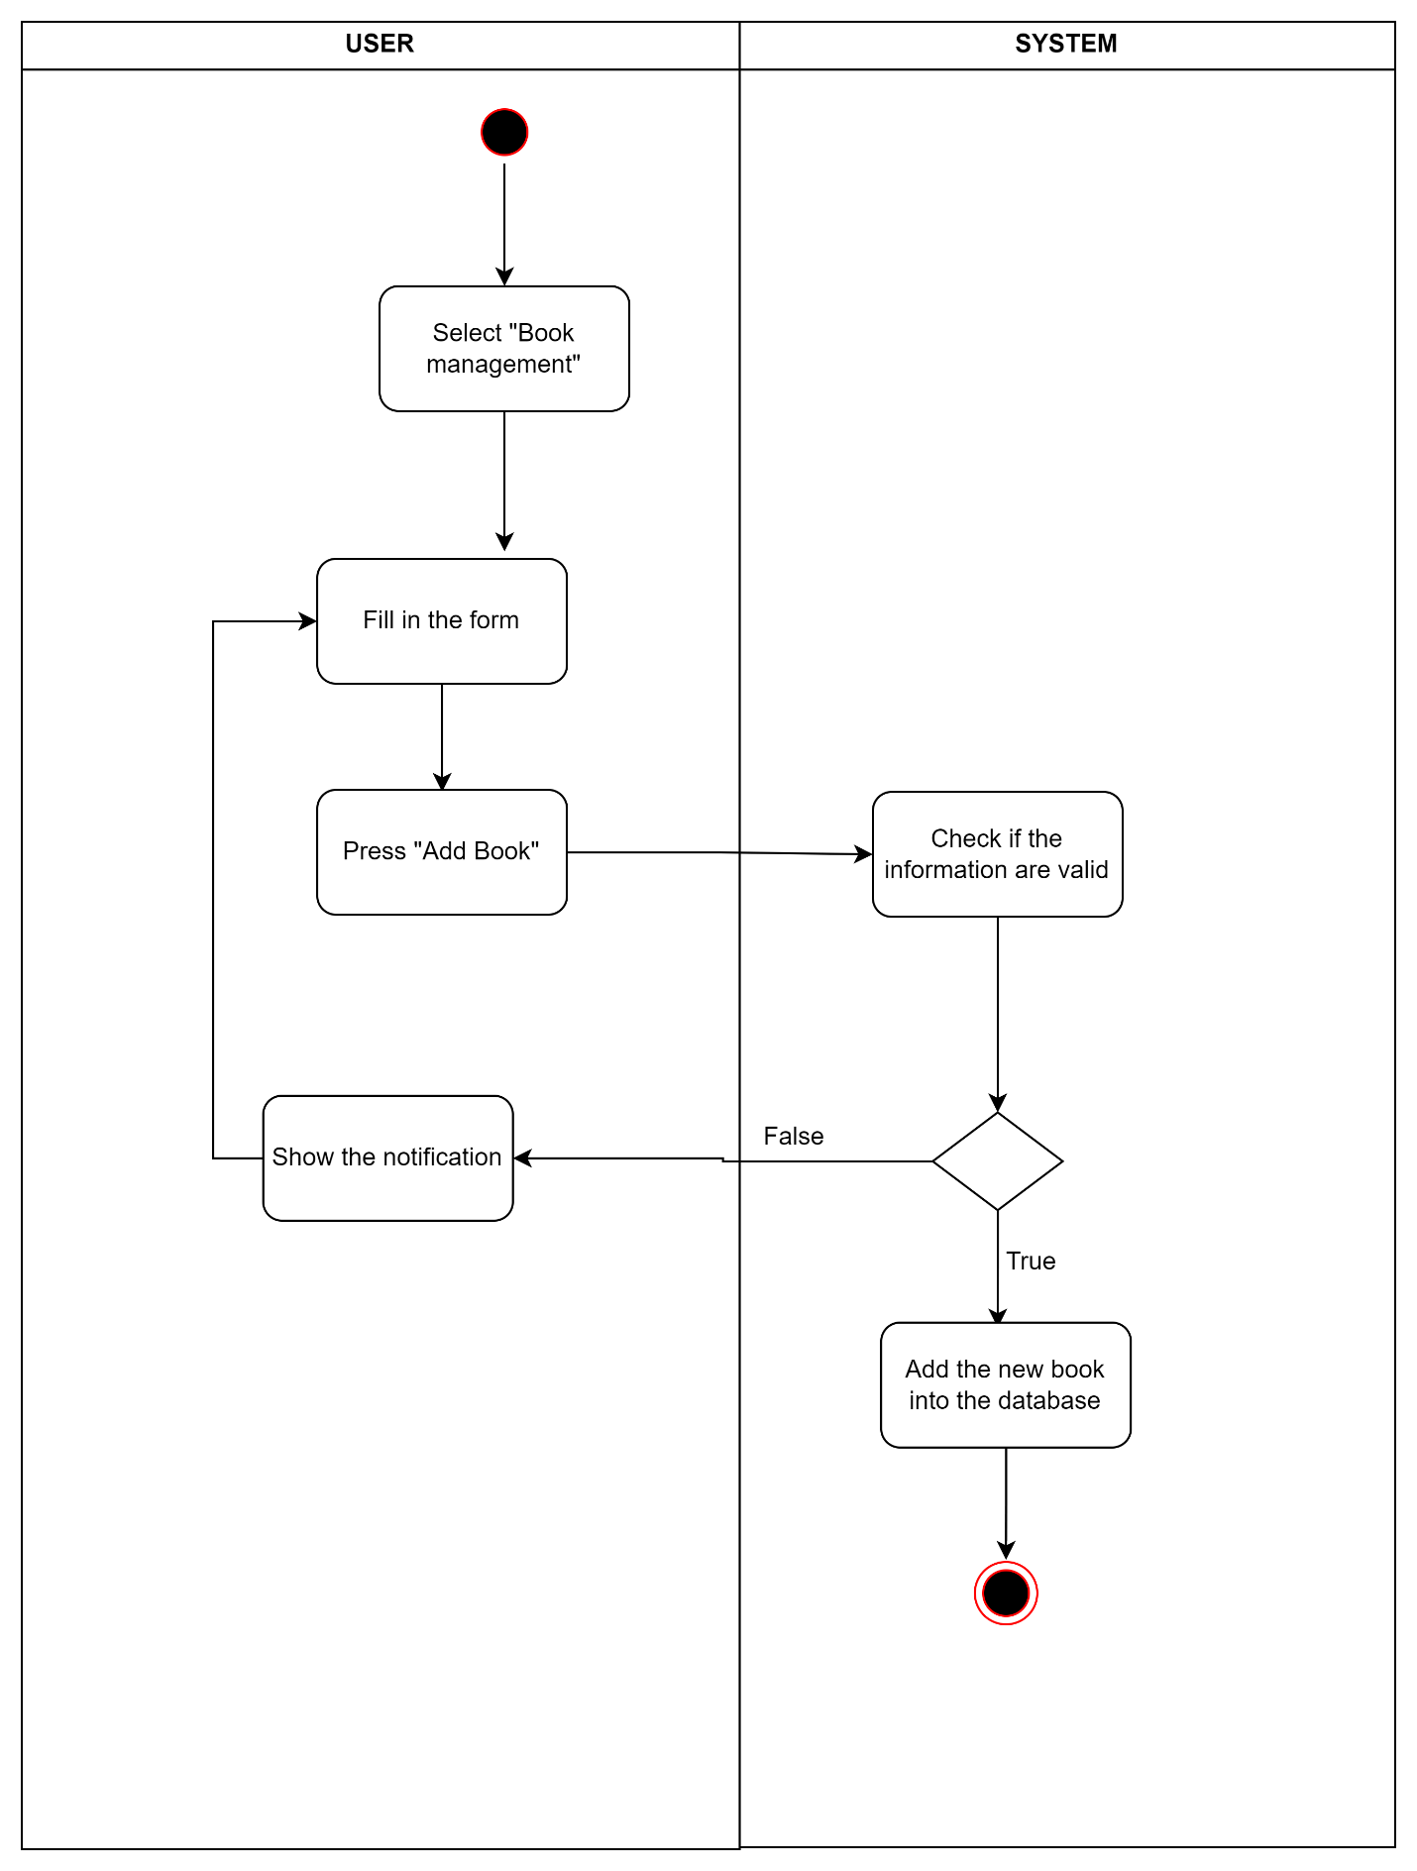

Figure . Activity Diagram for UC-13

### Activity Diagram for Remove book

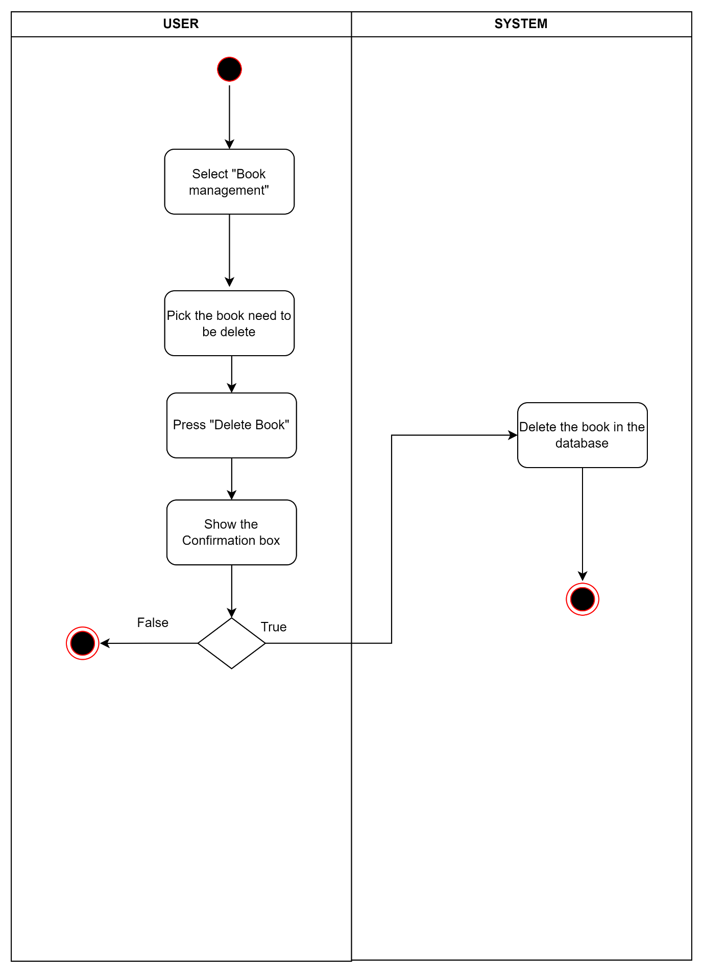

Figure . Activity Diagram for UC-14

### Activity Diagram for Update book details

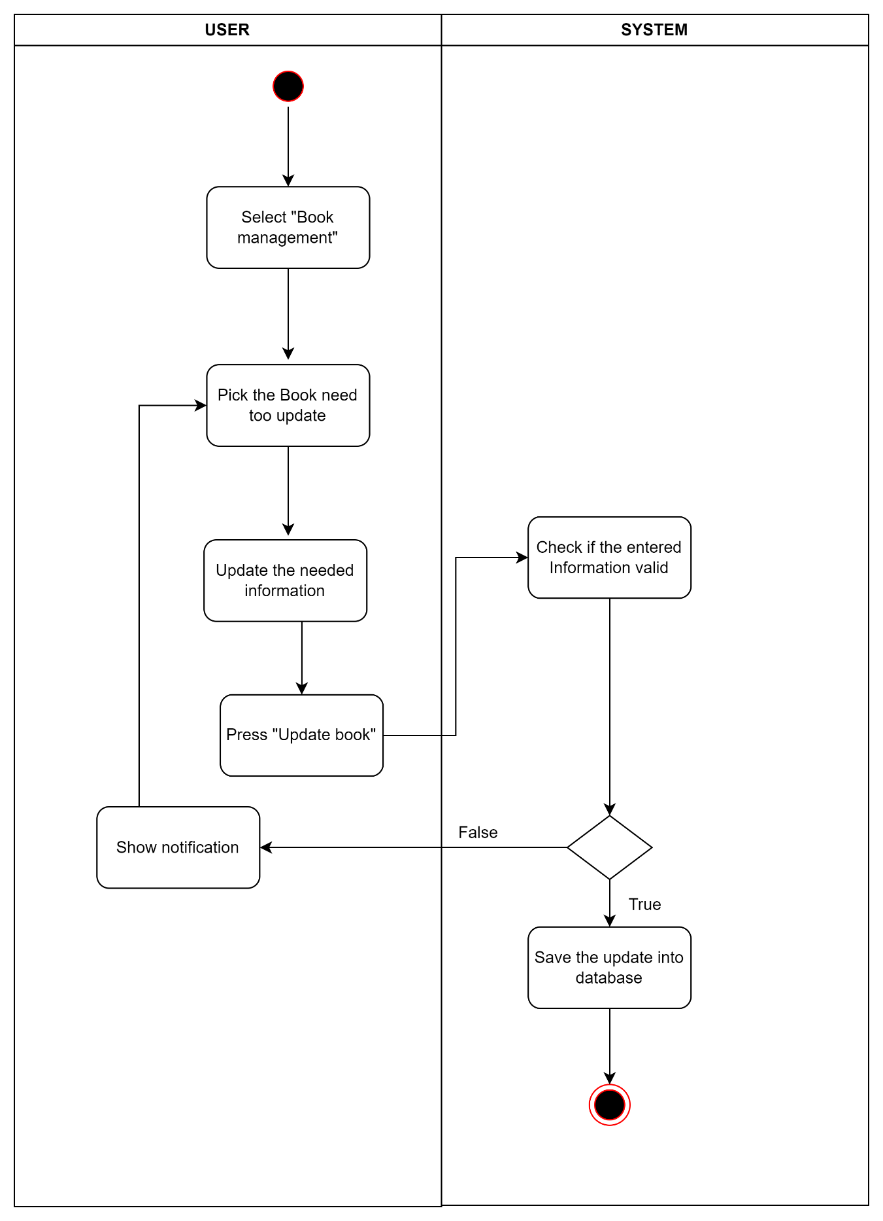

Figure . Activity Diagram for UC-15

### Activity Diagram for Search book

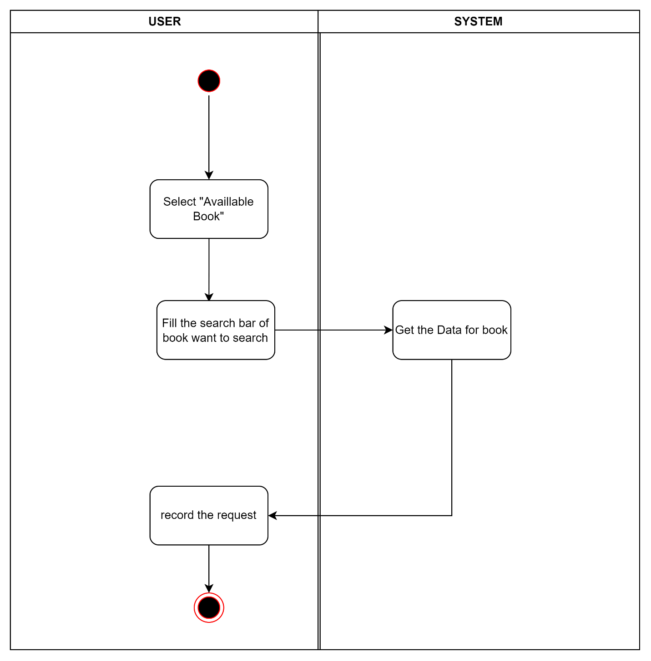

Figure . Activity Diagram for UC-16

### Activity Diagram for Add reader

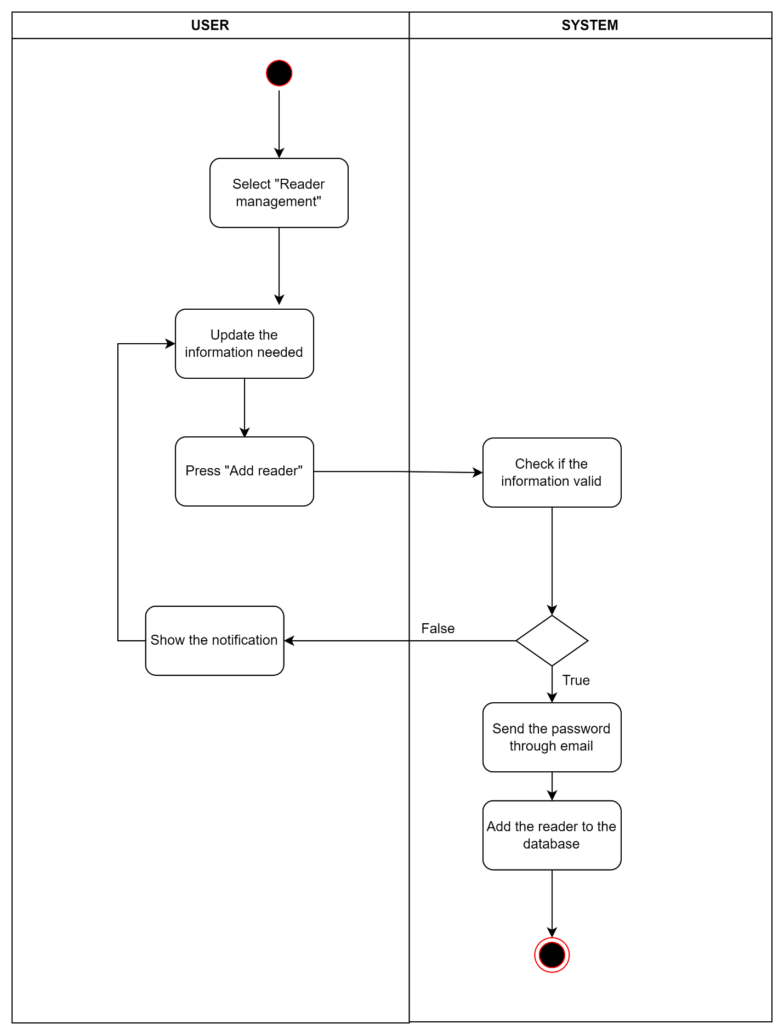

Figure . Activity Diagram for UC-17

### Activity Diagram for Remove reader

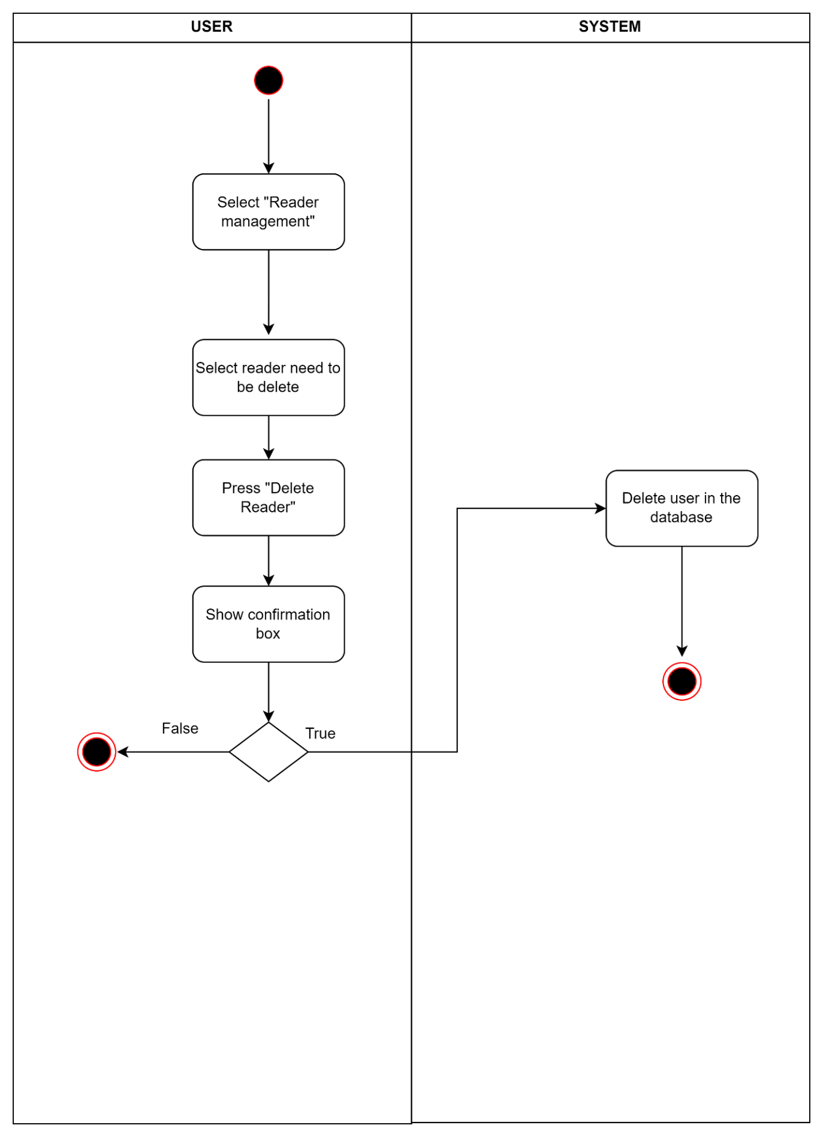

Figure . Activity Diagram for UC-18

### Activity Diagram for Update reader

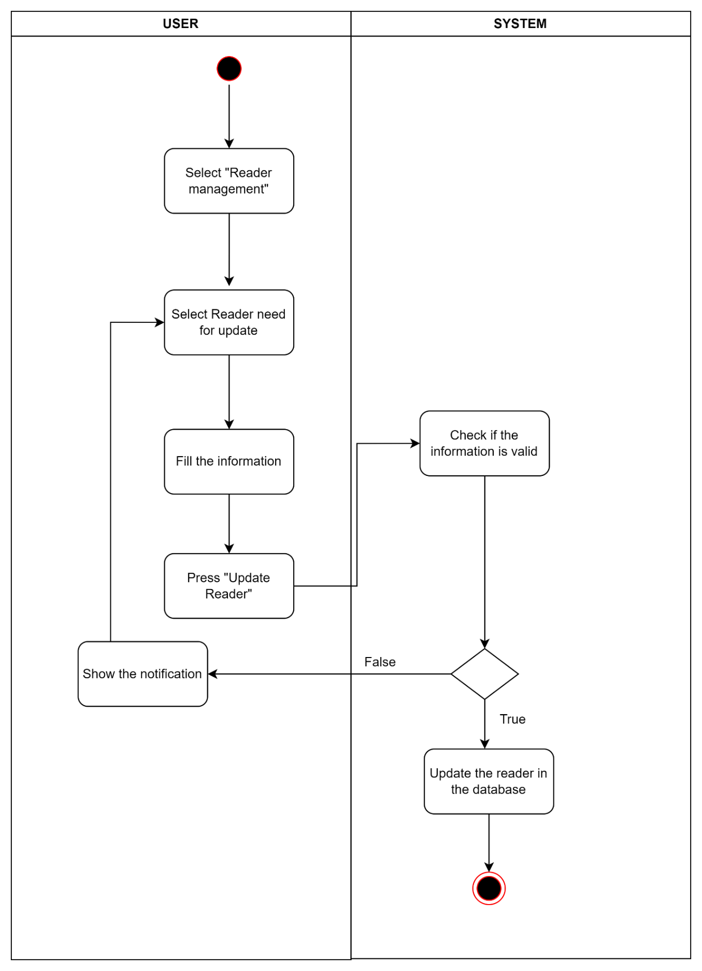

Figure . Activity Diagram for UC-19

### Activity Diagram for Search reader

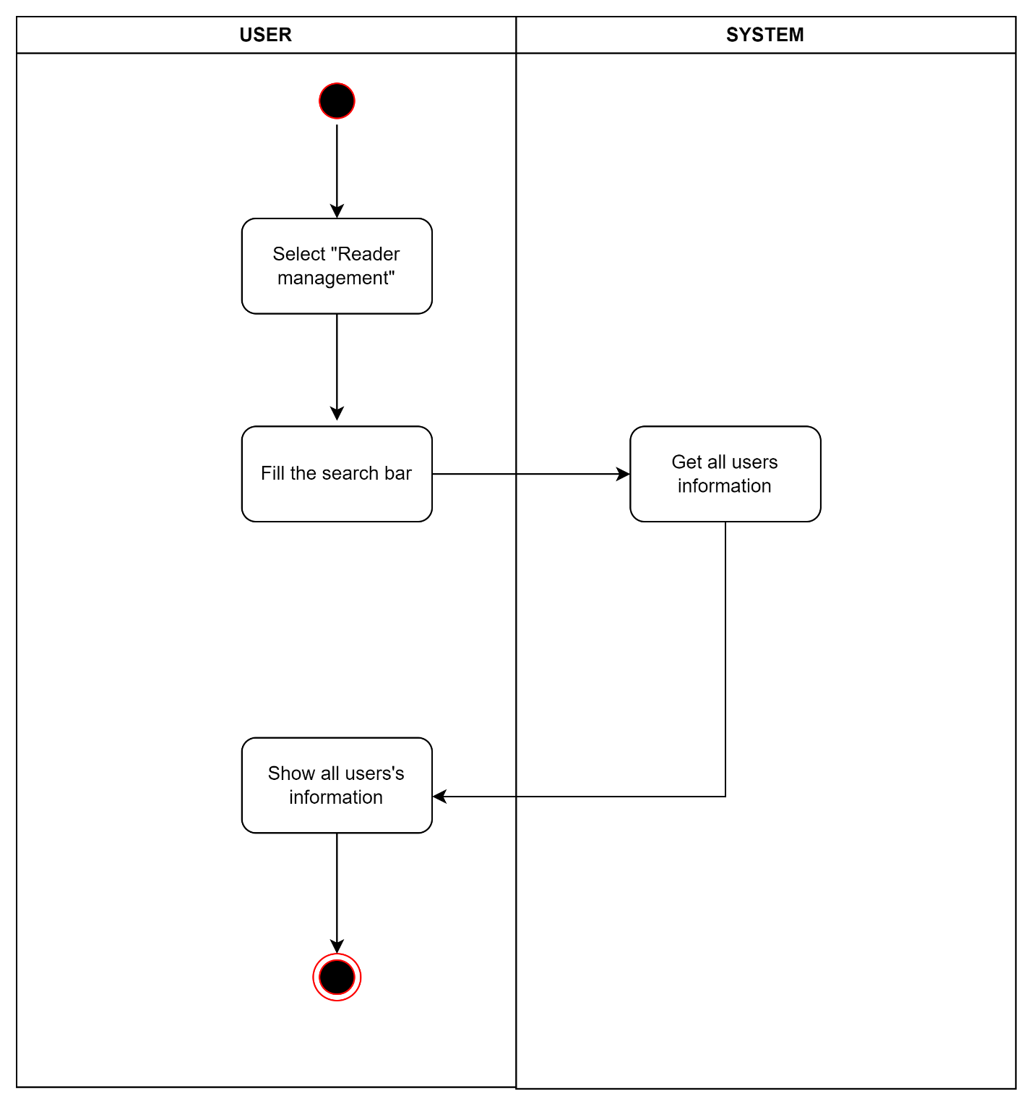

Figure . Activity Diagram for UC-20

### Activity Diagram for Ban reader

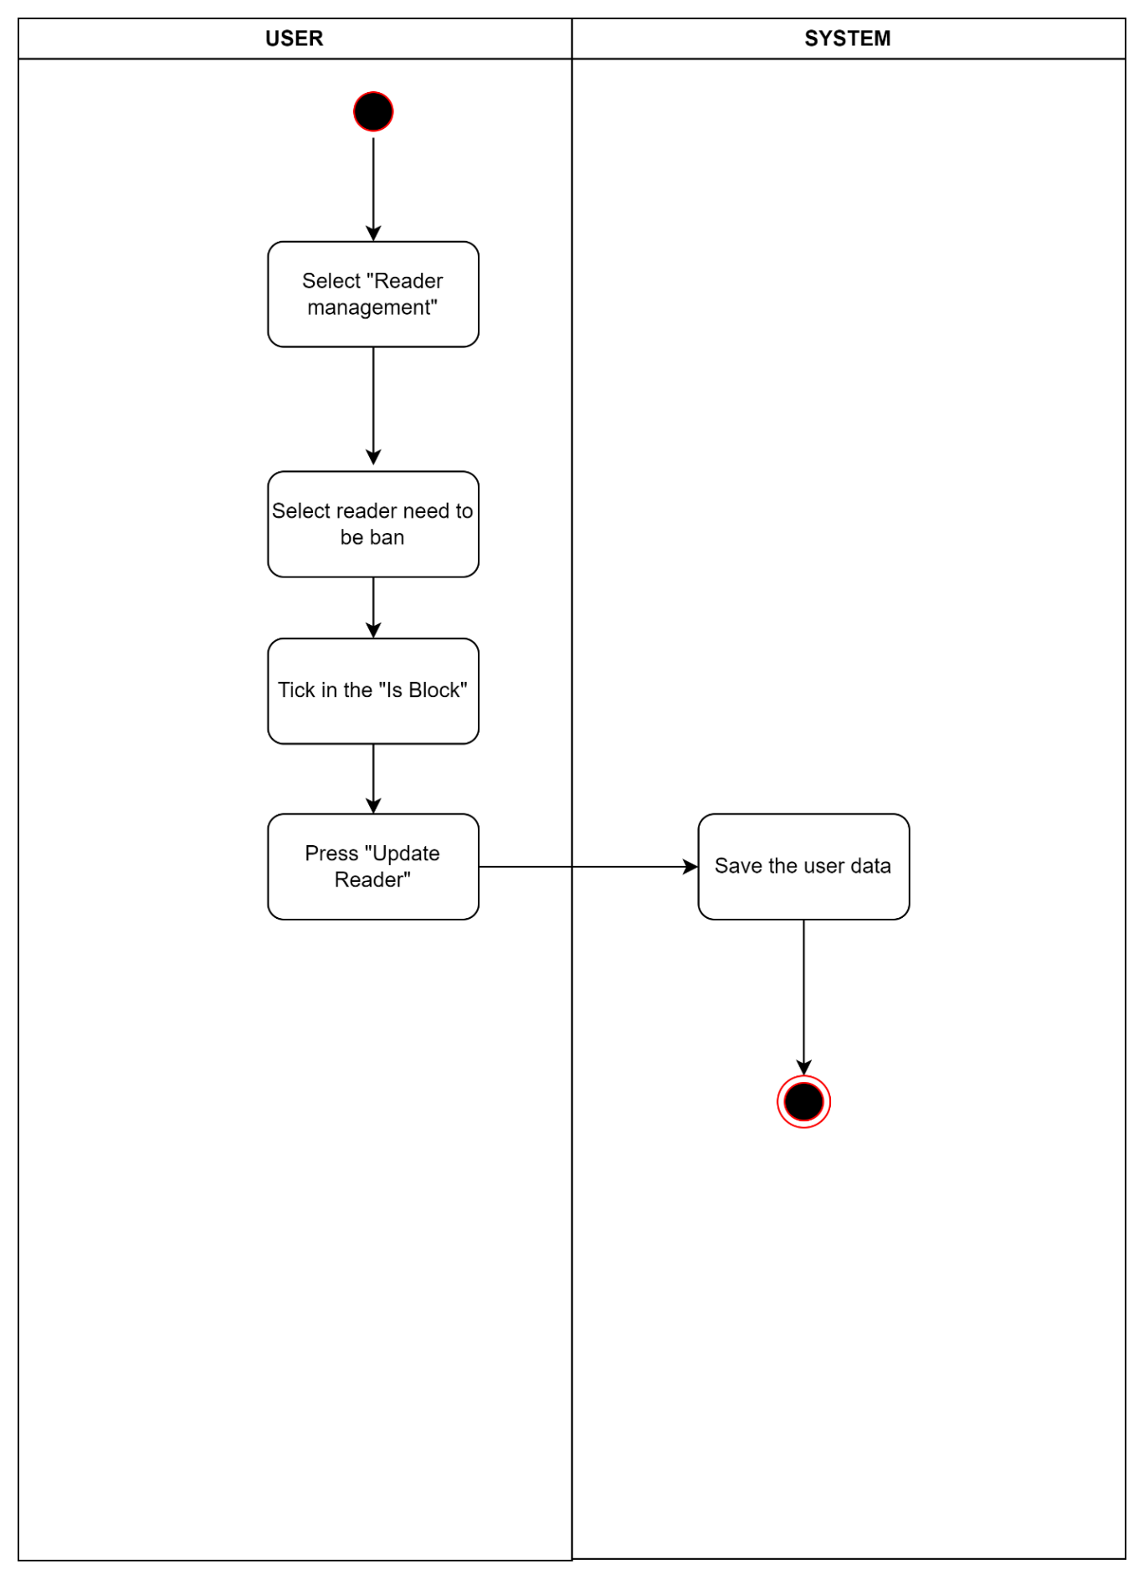

Figure . Activity Diagram for UC-21

### Activity Diagram for Unban reader

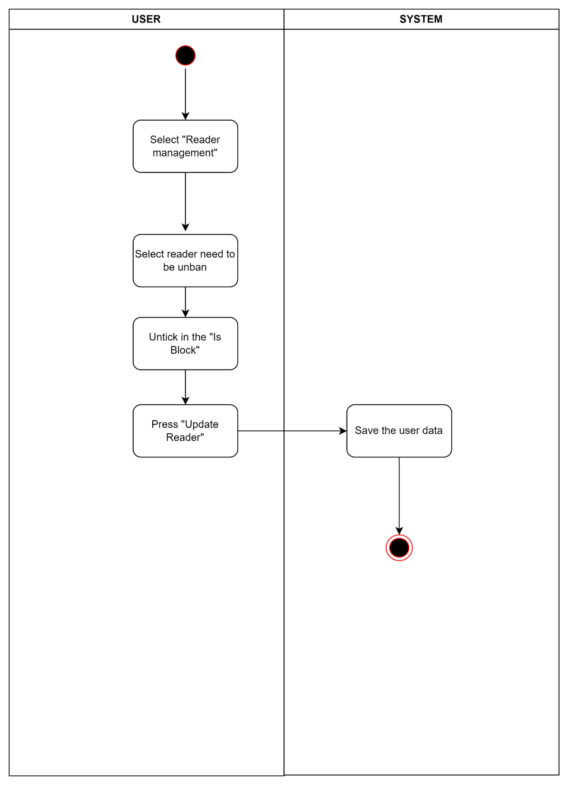

Figure . Activity Diagram for UC-22

### Activity Diagram for View history of borrowing and returning book

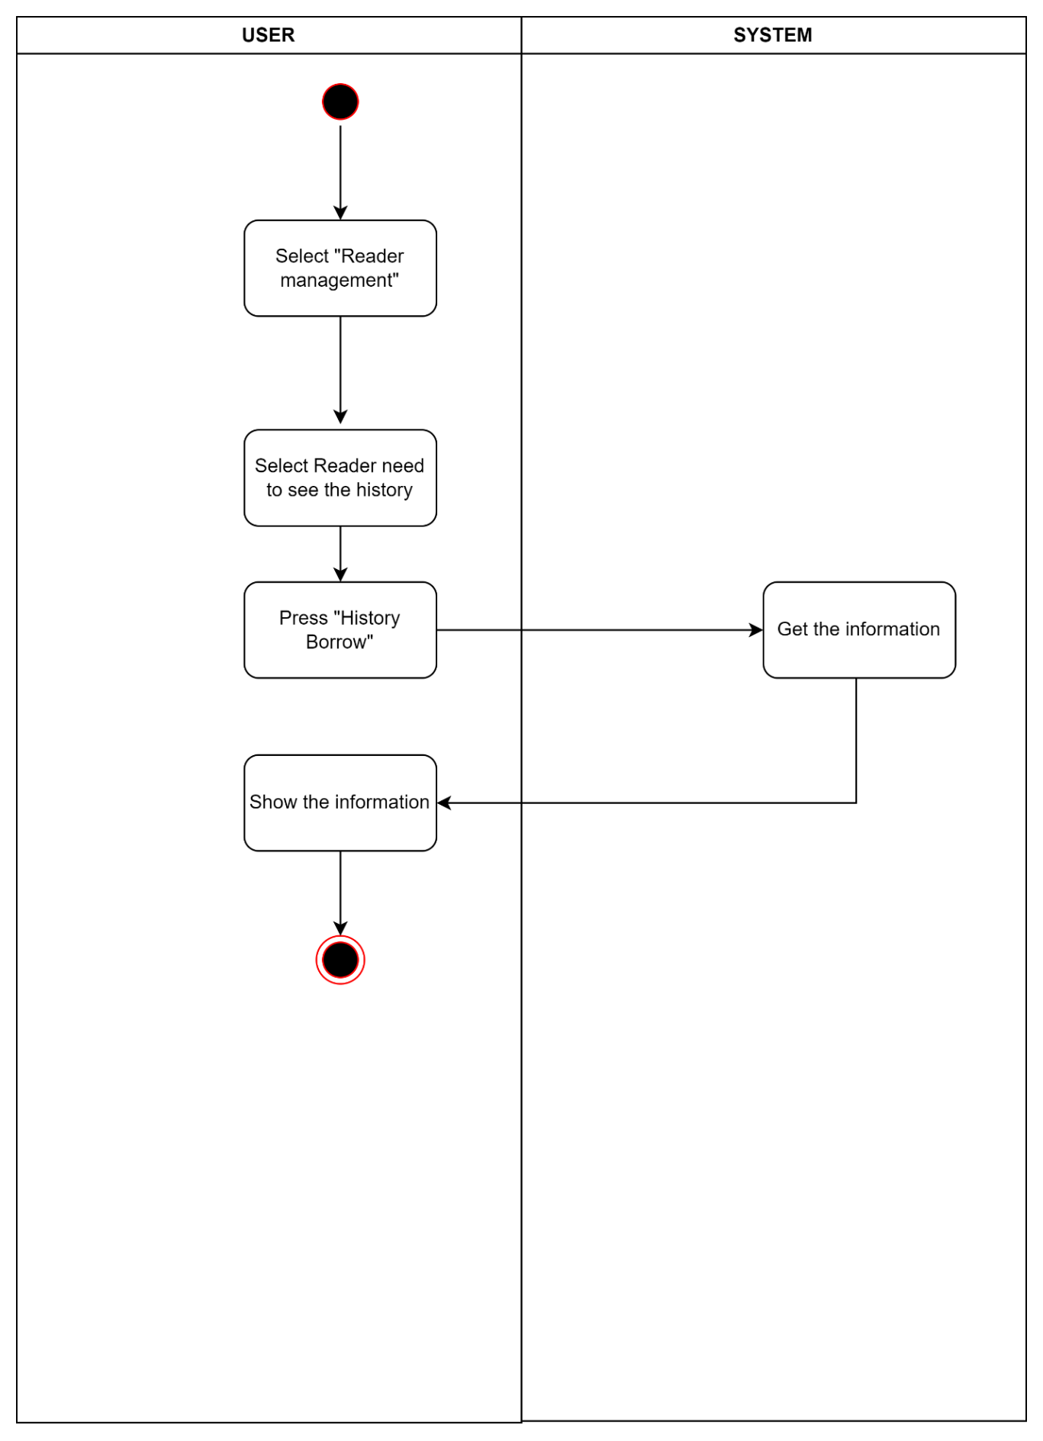

Figure . Activity Diagram for UC-23

### Activity Diagram for Issue book

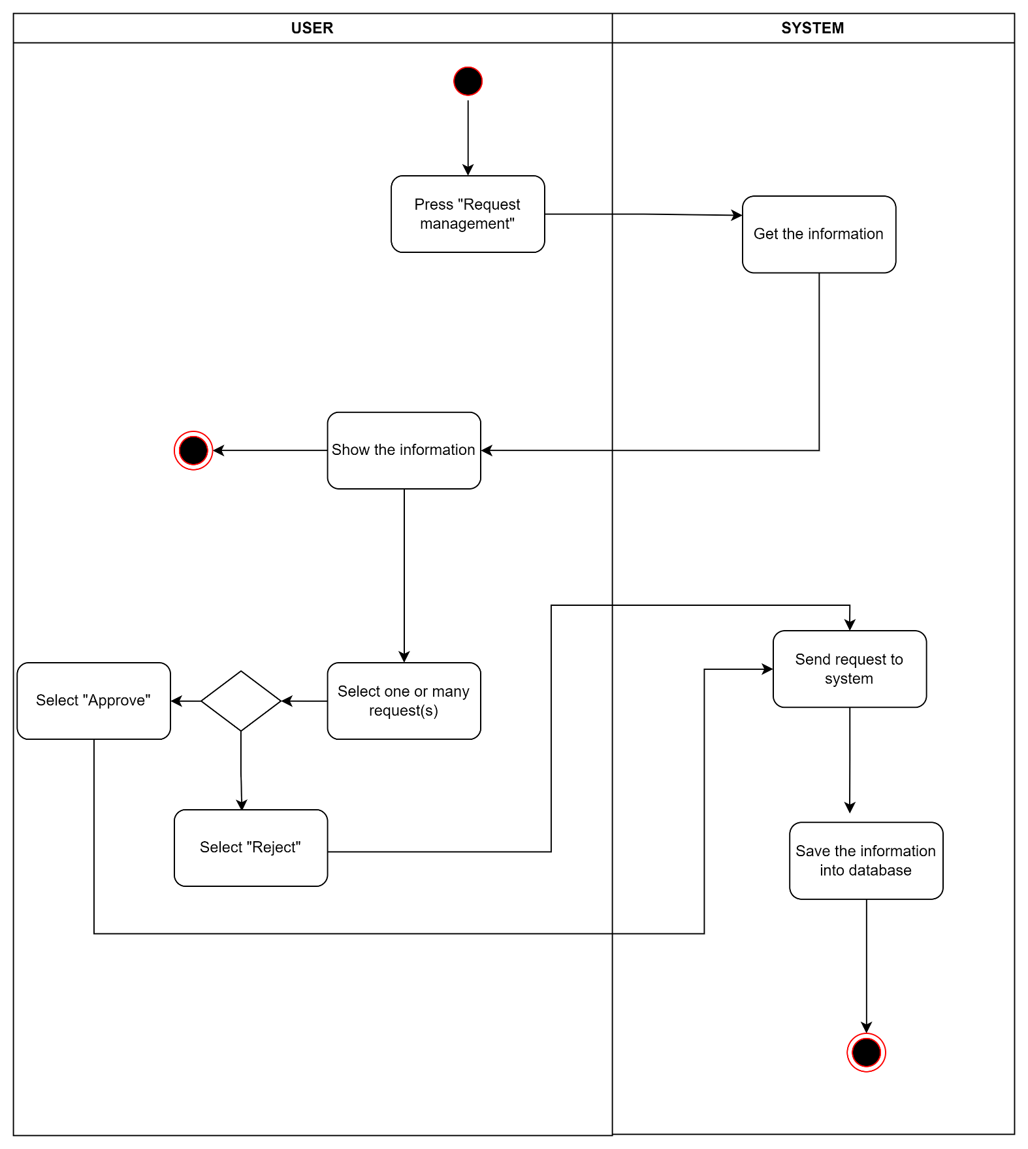

Figure . Activity Diagram for UC-24

### Activity Diagram for View requests to borrow book from reader

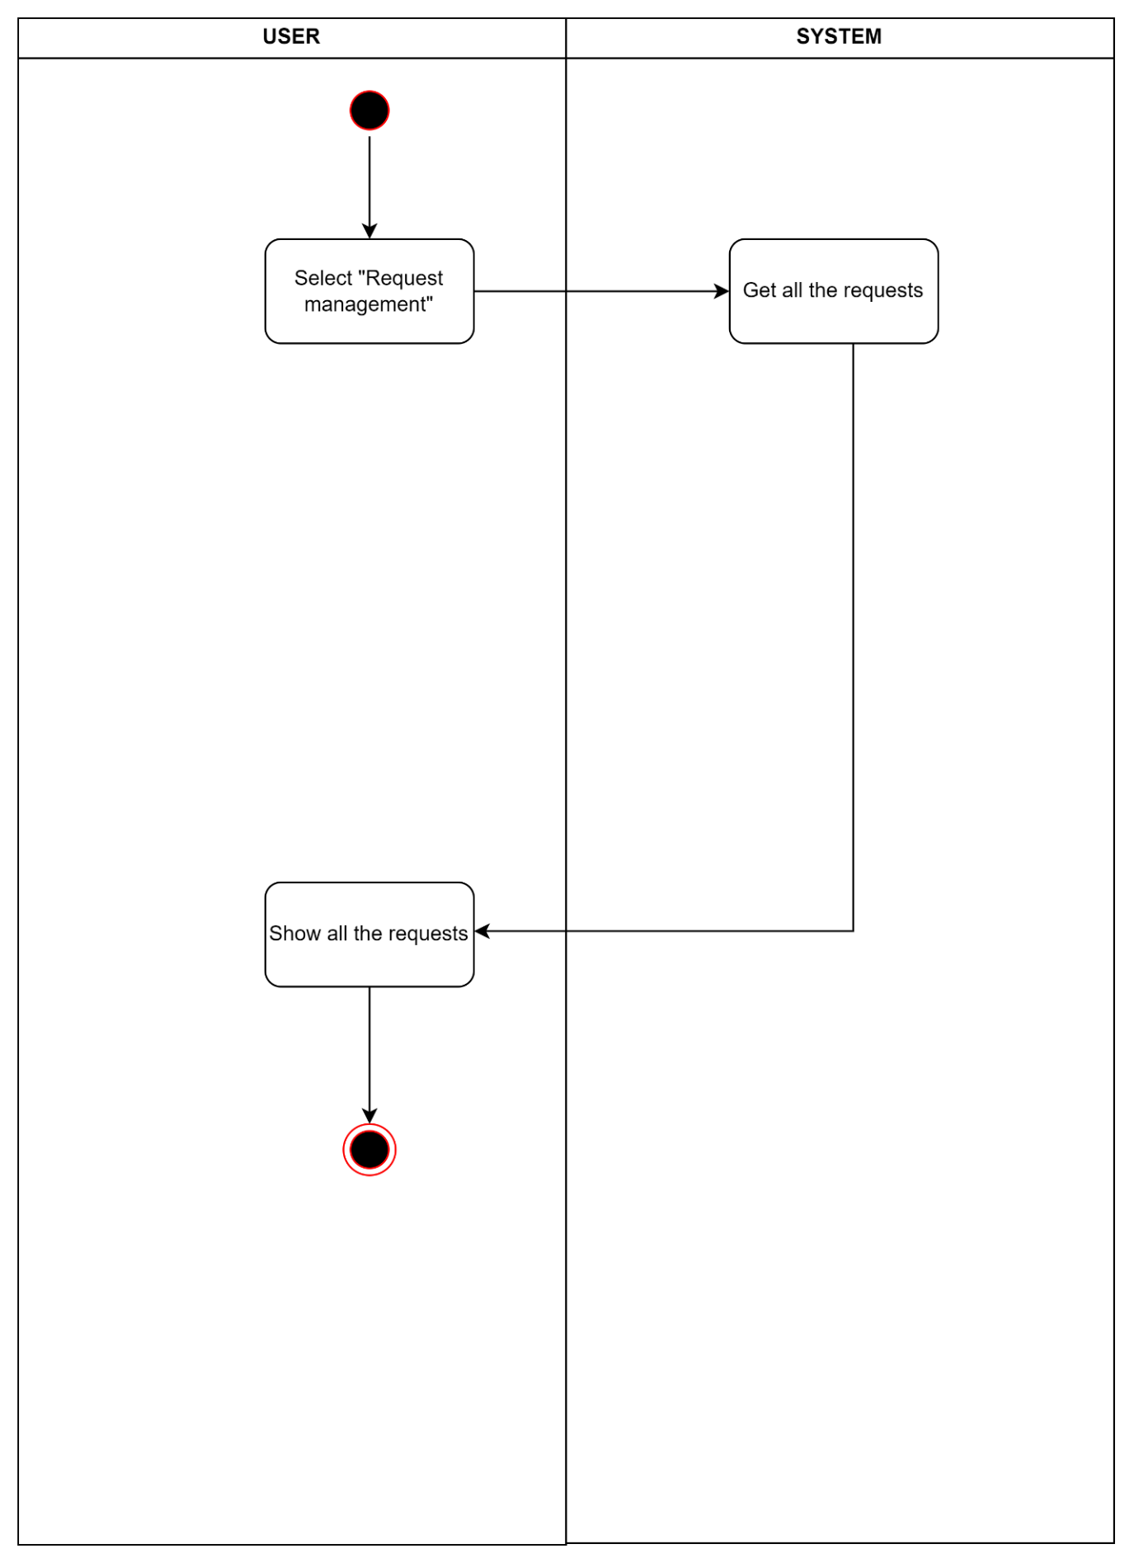

Figure . Activity Diagram for UC-25

### Activity Diagram for Search requests to borrow book from reader

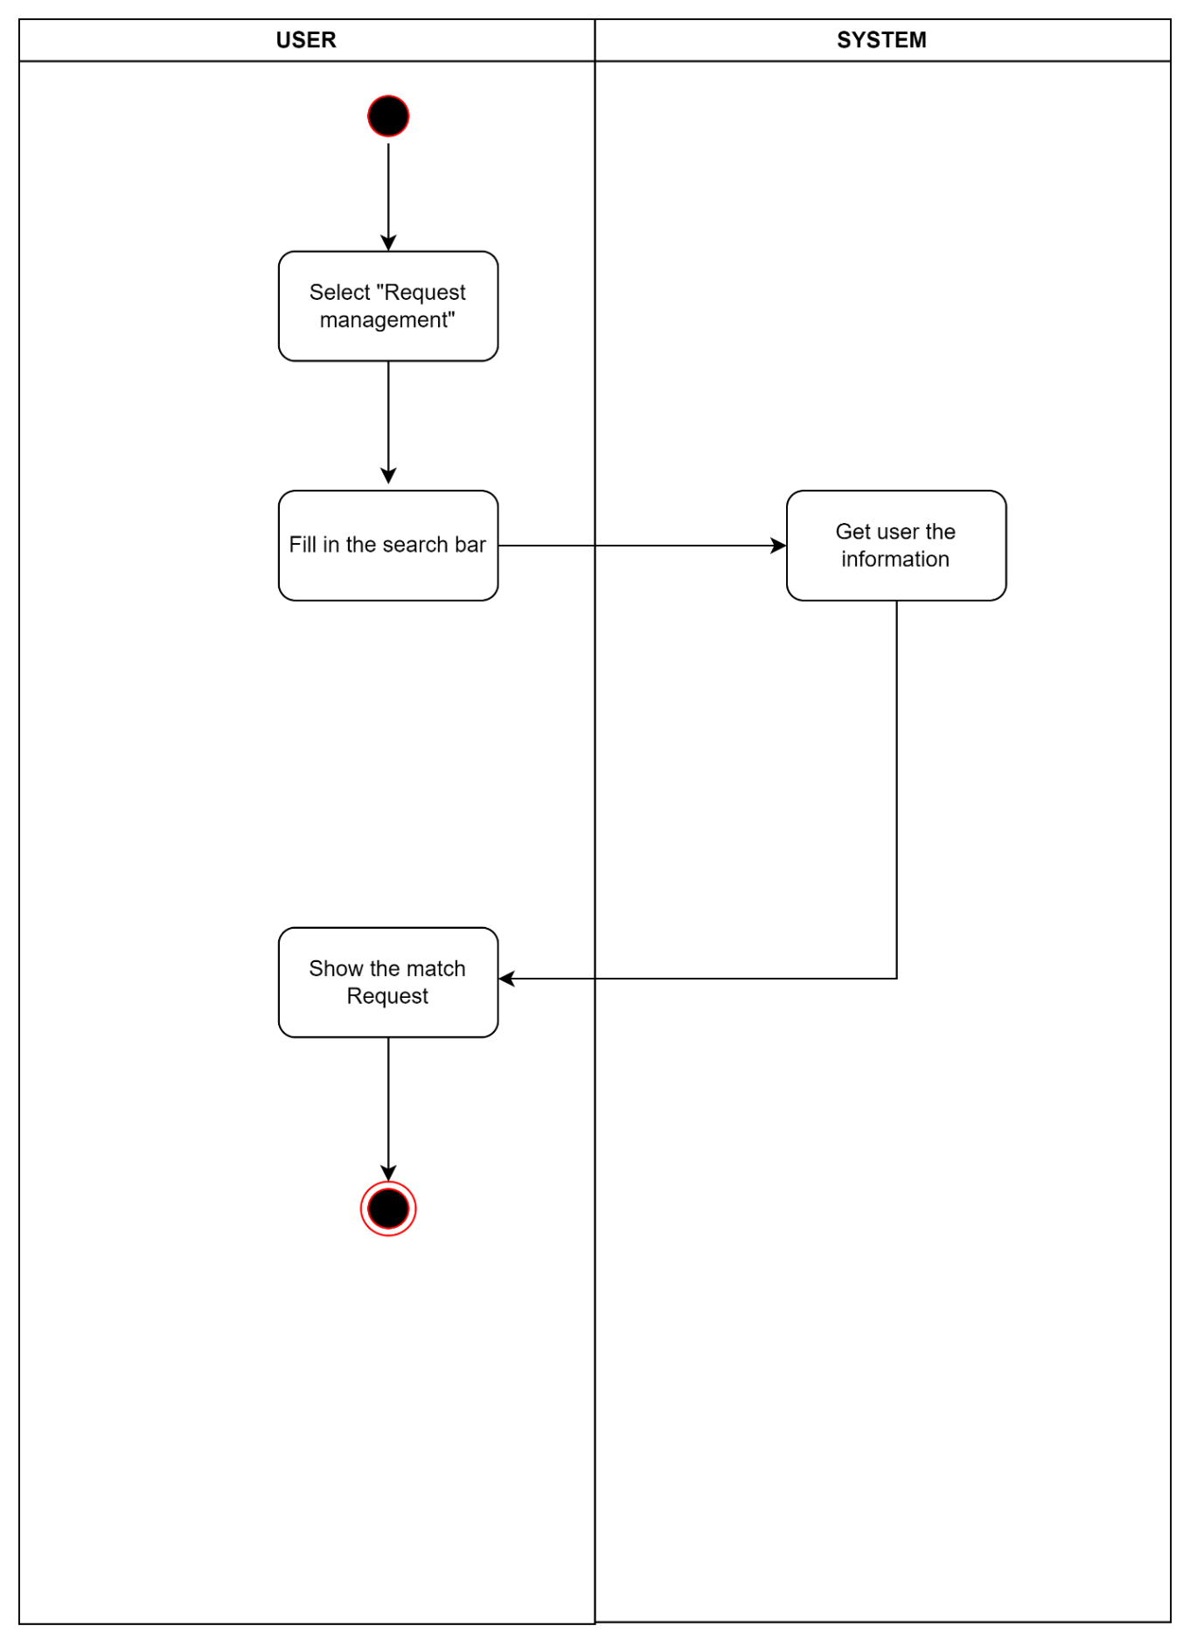

Figure . Activity Diagram for UC-26

### Activity Diagram for Return book

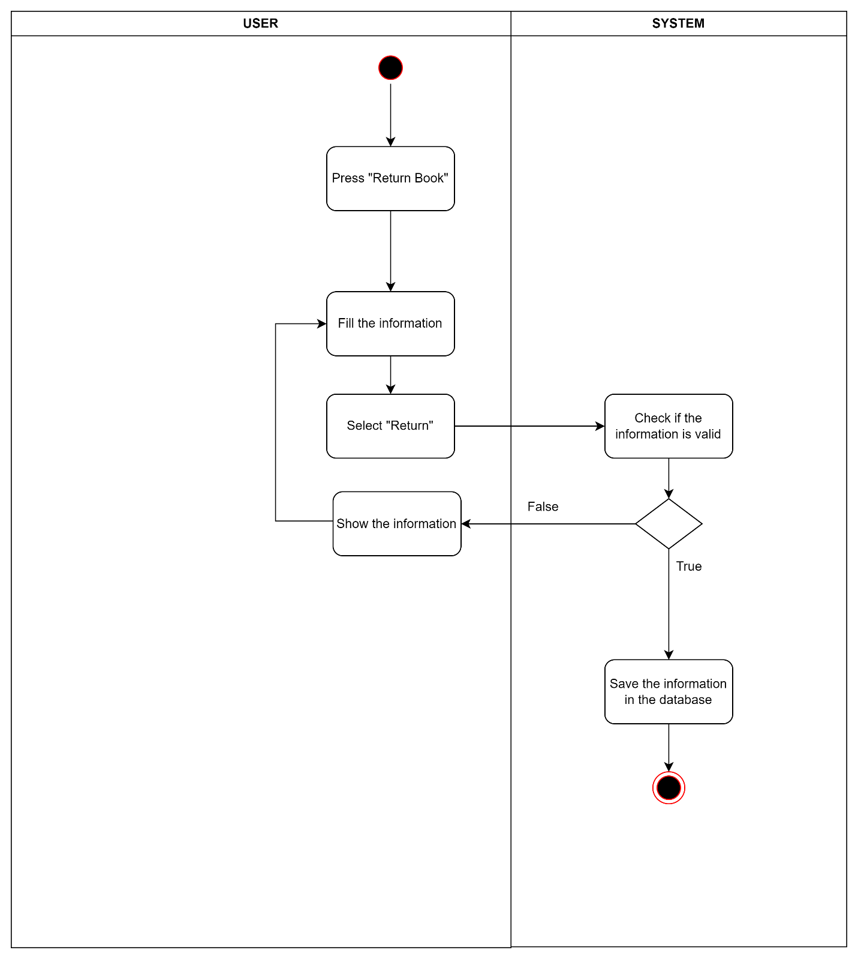

Figure . Activity Diagram for UC-27

### Activity Diagram for View reports and statistics

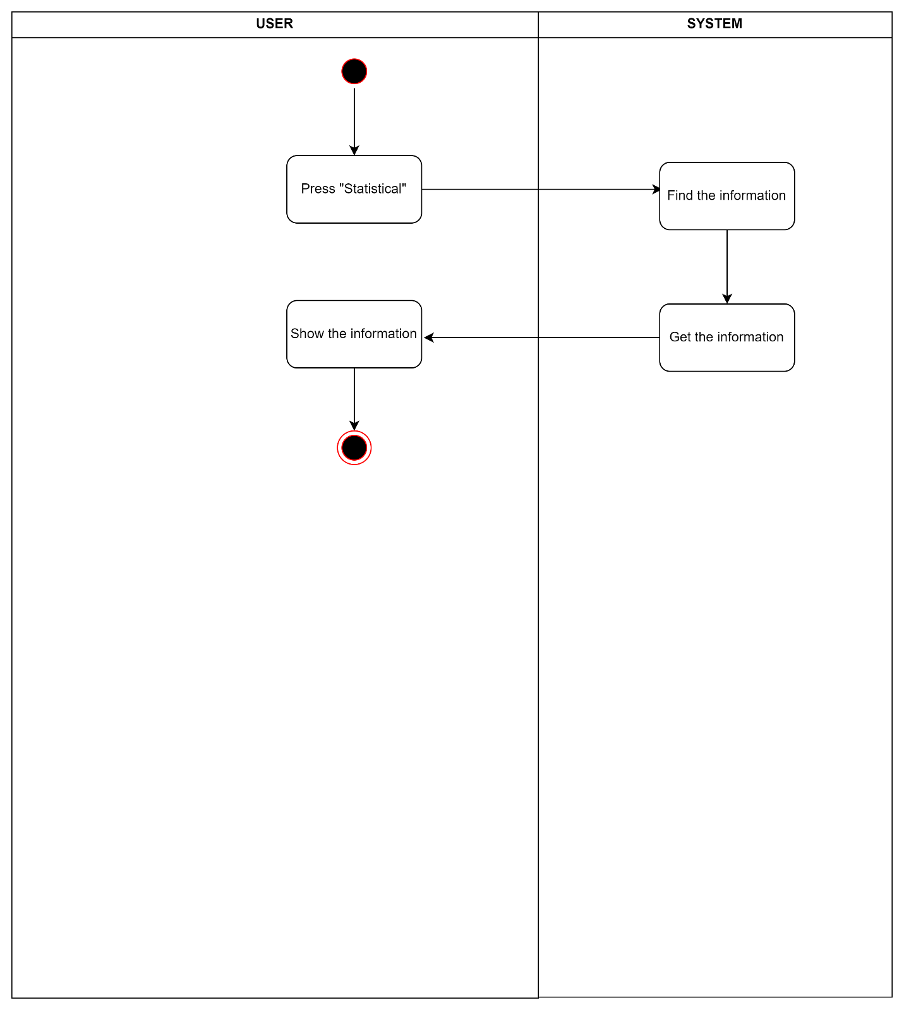

Figure . Activity Diagram for UC-28

## Sequence Diagram

### Sequence Diagram for Create new account (Sign Up)

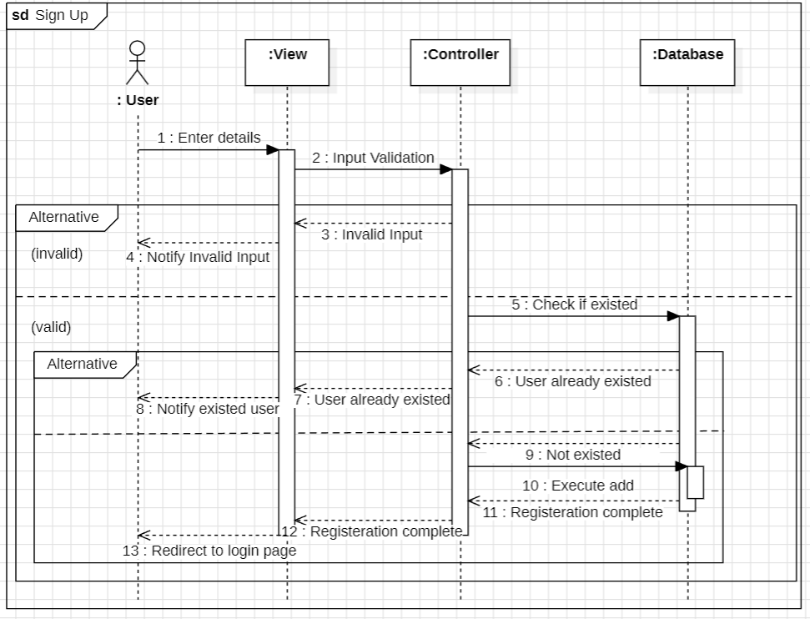

Figure . Sequence Diagram for Create New Account (Sign Up)

### Sequence Diagram for Login

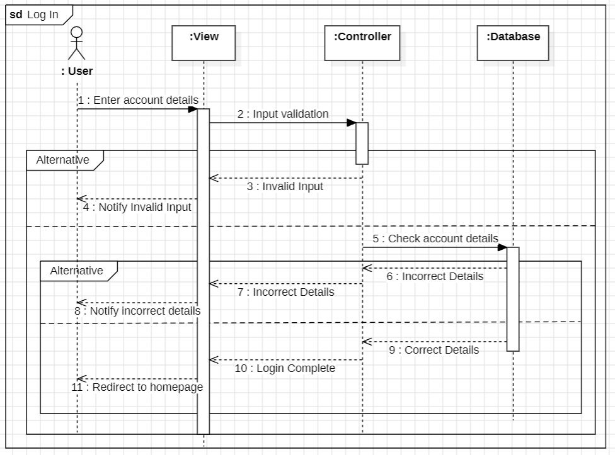

Figure . Sequence Diagram for Log in

### Sequence Diagram for Reset Password

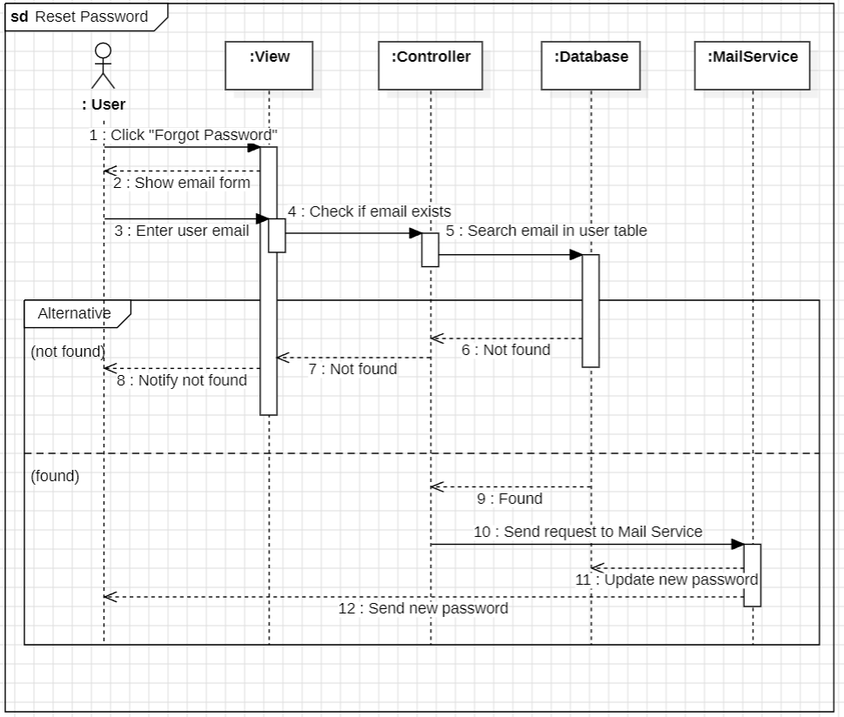

Figure . Sequence Diagram for Reset Password

### Sequence Diagram for Log Out

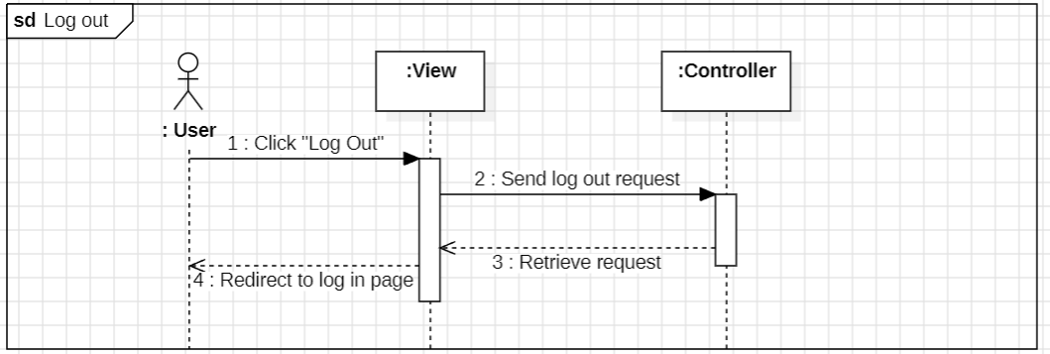

Figure . Sequence Diagram for Log Out

### Sequence Diagram for View Profile Details

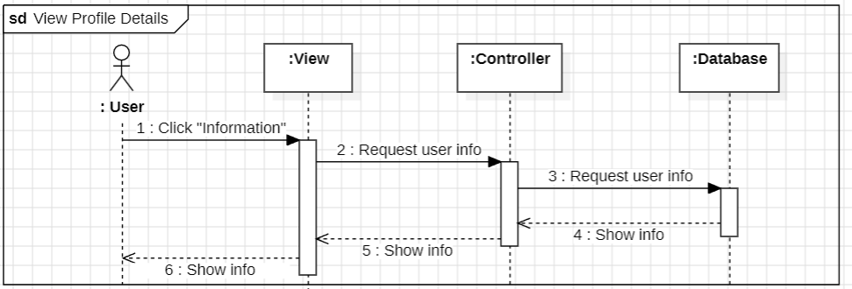

Figure . Sequence Diagram for View Profile Details

### Sequence Diagram for Edit Profile Details

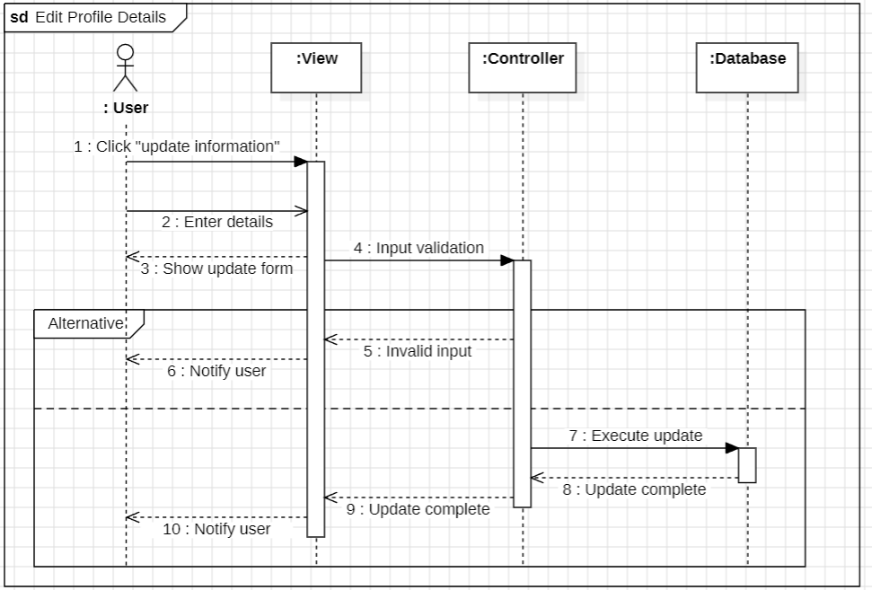

Figure . Sequence Diagram for Update Profile Details

### Sequence Diagram for Borrow Book

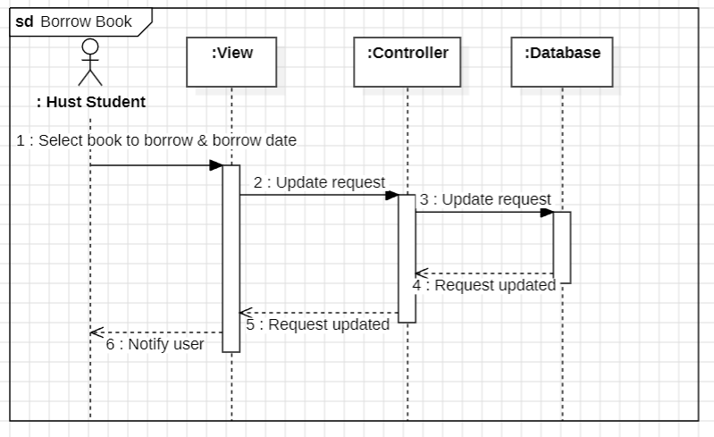

Figure . Sequence Diagram for Borrow Book

### Sequence Diagram for View Personal Request

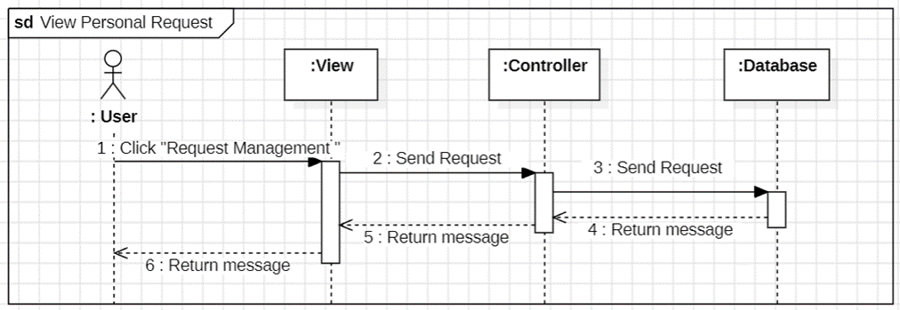

Figure . Sequence Diagram for View Personal Request

### Sequence Diagram for Search Personal Request

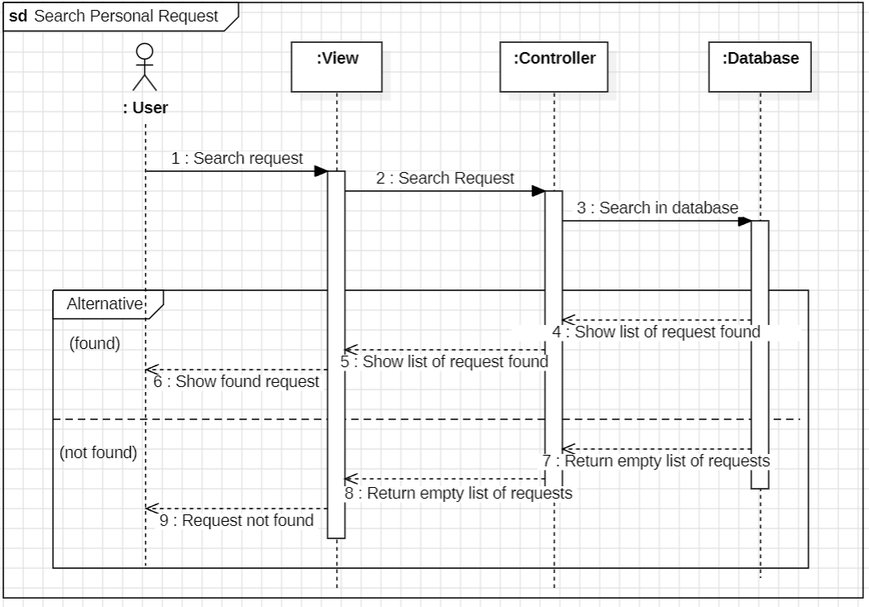

Figure . Sequence Diagram for Seach Personal Request

### Sequence Diagram for Cancel Personal Request

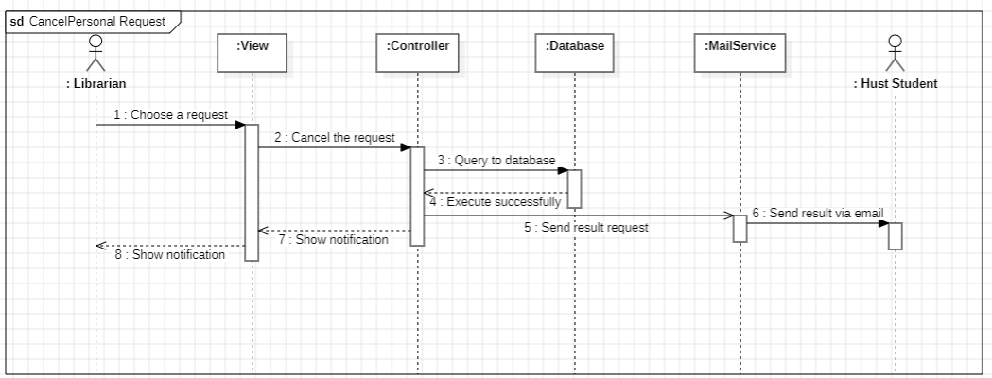

Figure . Sequence Diagram for Cancel Personal Request

### Sequence Diagram for Add Book

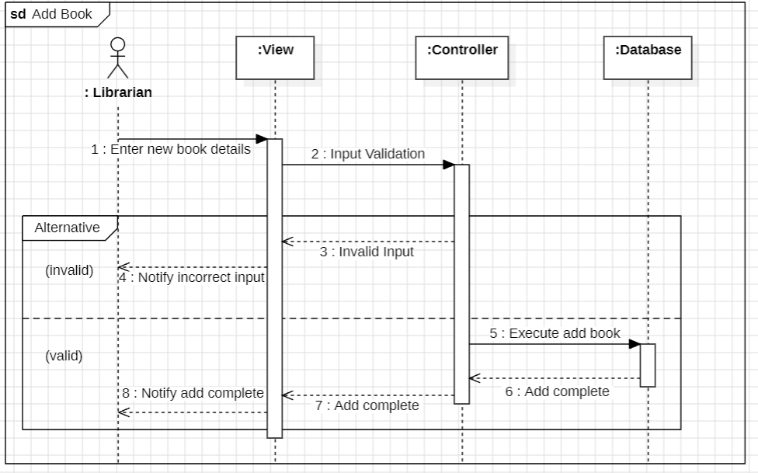

Figure . Sequence Diagram for Add Book

### Sequence Diagram for Search Book

Figure . Sequence Diagram for Search Book

### Sequence Diagram for Update Book Details

Figure . Sequence Diagram for Update Book Details

### Sequence Diagram for Add Reader

Figure . Sequence Diagram for Add Reader

### Sequence Diagram for Remove Reader

Figure . Sequence Diagram for Remove Reader

### Sequence Diagram for Update Reader Details

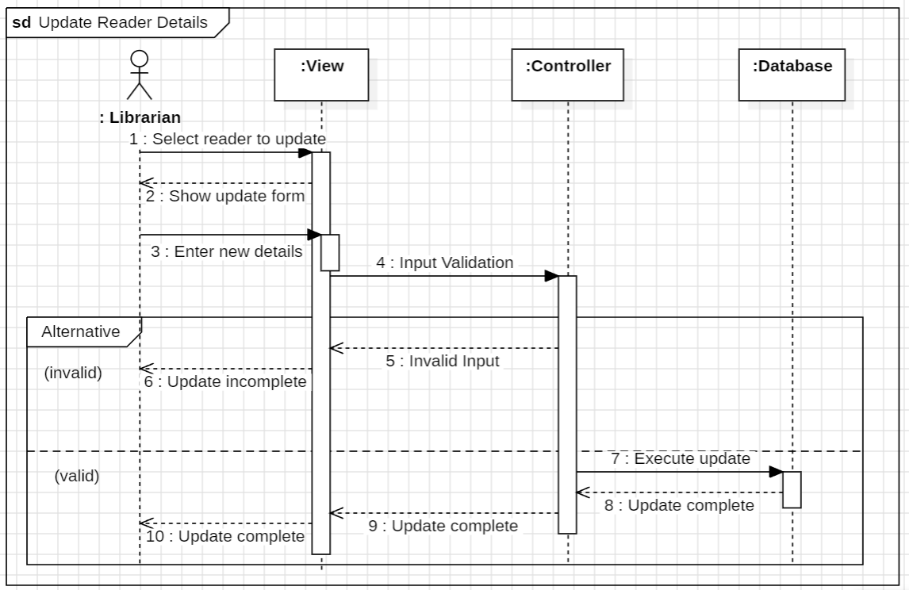

Figure . Sequence Diagram for Update Reader Details

### Sequence Diagram for Search Reader

Figure . Sequence Diagram for Search Reader

### Sequence Diagram for Ban/Unban Reader

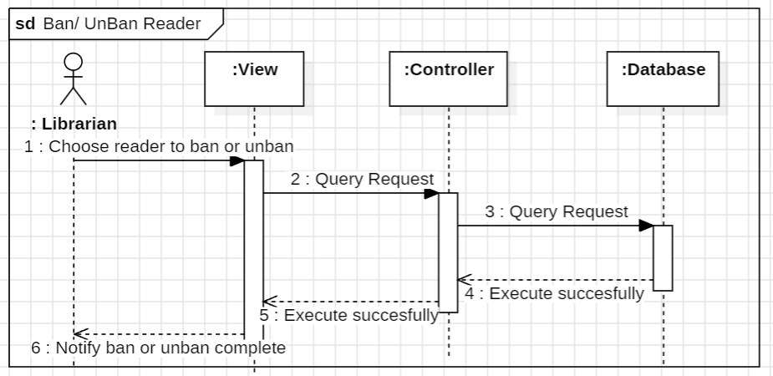

Figure . Sequence Diagram for Ban/Unban Reader

### Sequence Diagram for (Student) View History of Borrowing and Returning Book

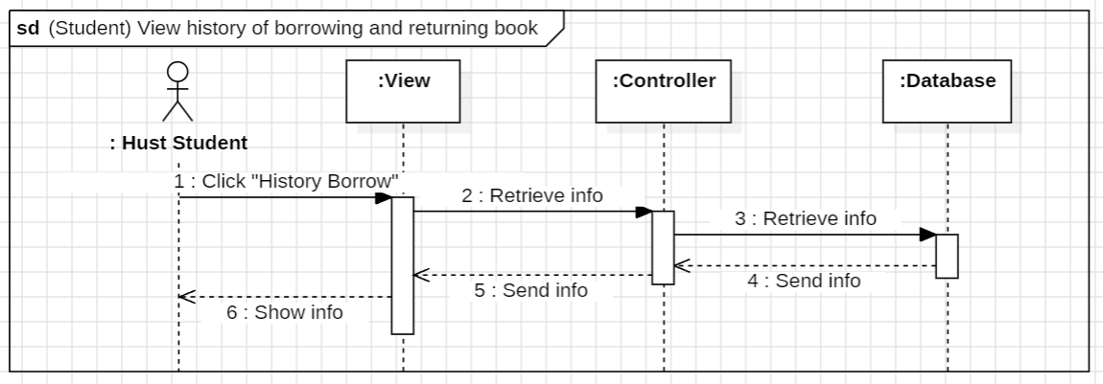

Figure . Sequence Diagram for (Student) View History of Borrowing and Returning Book

### Sequence Diagram for (Librarian) View History of Borrowing and Returning Book

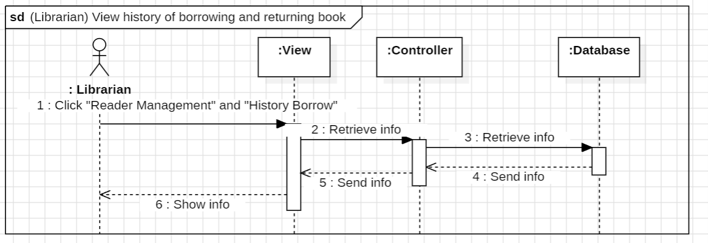

Figure . Sequence Diagram for (Librarian) View History of Borrowing and Returning Book

### Sequence Diagram for View Personal Request

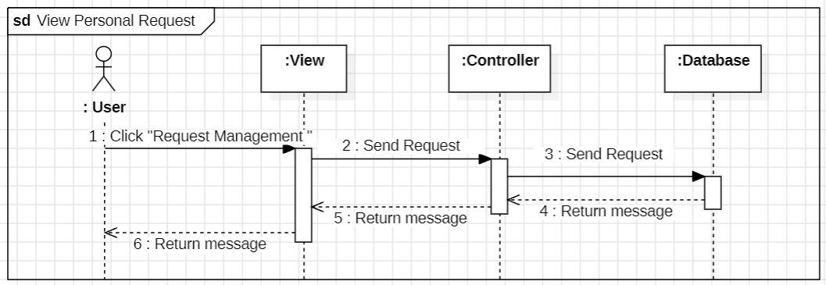

Figure . Sequence Diagram for View Personal Request

### Sequence Diagram for View Statistic

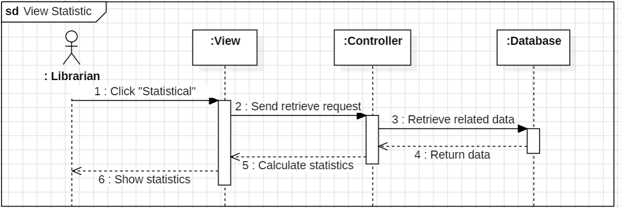

Figure . Sequence Diagram for View Statistic

## Database Design

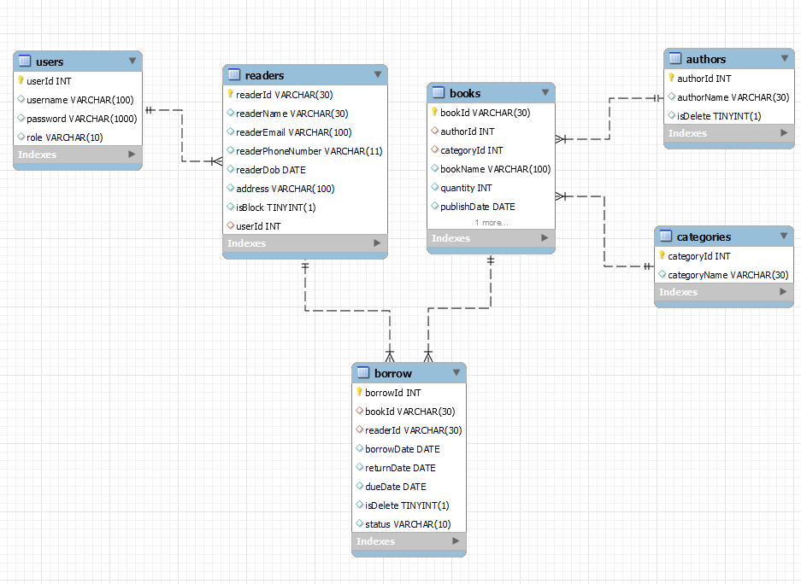

Figure . Database Diagram

### users

|  |  |  |
| --- | --- | --- |
| **Field Name** | **Data Type** | **Description** |
| userId | int | Account ID |
| username | varchar(100) | Username |
| password | varchar(1000) | Password |
| role | varchar(10) | Role of each user (Reader/Librarian) |

### readers

|  |  |  |
| --- | --- | --- |
| **Field Name** | **Data Type** | **Description** |
| readerId | varchar(30) | Identification Code for each reader |
| readerName | varchar(30) | Reader’s Name |
| readerEmail | varchar(30) | Reader’s Email |
| readerPhoneNumber | varchar(11) | Reader’s Phone Number |
| readerDob | date | Reader’s Date of Birth |
| address | varchar(100) | Reader’s Address |
| isBlock | tinyint(1) | Flag to indicate if the reader has been deleted. |
| userId | int | Account ID |

### books

|  |  |  |
| --- | --- | --- |
| **Field Name** | **Data Type** | **Description** |
| bookId | varchar(30) | The ID of each book |
| authorId | int | Author of each book |
| categoryId | int | Category of each book |
| bookName | varchar(100) | Title of each book |
| quantity | int | Quantity of each book |
| publishDate | date | Published Date of each book |
| isDelete | tinyint(1) | Flag to indicate if the book has been deleted. |

### categories

|  |  |  |
| --- | --- | --- |
| **Field Name** | **Data Type** | **Description** |
| categoryId | int | The ID for each category |
| categoryName | varchar(30) | Name of a category |

### authors

|  |  |  |
| --- | --- | --- |
| **Field Name** | **Data Type** | **Description** |
| authorId | int | The ID for each author |
| authorName | varchar(30) | Author’s Name |
| isDelete | tinyint(1) | Flag to indicate if the author has been deleted. |

### borrow

|  |  |  |
| --- | --- | --- |
| **Field Name** | **Data Type** | **Description** |
| borrowId | int | The ID for each request to borrow book from the reader |
| bookId | varchar(30) | The ID of the requested-to-borrow book |
| readerId | varchar(30) | The ID of the reader who sends a request to borrow books |
| borrowDate | date | The date that the reader asks to borrow the book |
| returnDate | date | The date that the reader returns the book |
| dueDate | date | The date that the reader promises to return the book |
| isDelete | tinyint (1) | Flag to indicate if the request has been deleted. |
| status | varchar(10) | Status of request (approved or rejected) |

## Package Diagram

Figure . Package Diagram

# Software Testing

## Overall Description

### Testing Levels

• Testing Level: System Test, User Acceptance Test

• Testing Types: Functional Testing, user Interface Testing

### Test Plan

|  |  |  |  |
| --- | --- | --- | --- |
| **Type of Test** | **State of Test** | | |
| **Unit** | **System** | **Acceptance** |
| **Functional Testing** |  | **x** |  |
| **User interface testing** |  | **x** |  |

### **Test Scope**

The scope of the Library Management Software Project encompasses the design, development, and deployment of a comprehensive system to manage all library operations. This includes modules for cataloging books, tracking inventory, managing member accounts, handling loans and returns, and generating reports. The project will integrate a user-friendly interface for both library staff and patrons, ensuring ease of use and accessibility. Additionally, the software will be scalable to accommodate future growth and adaptable to various types of libraries. The project will also include the testing and quality assurance phases to ensure the software's reliability and functionality before full deployment.

### Test item

Reader features:

|  |  |  |
| --- | --- | --- |
| **Feature** | **Parent Component** | **Overview** |
| Log in | Log in UI | The user logs in to the system by a reader account |
| Create new account | Log in UI | The user creates a new reader account |
| Get new password | Log in UI | The user gets a new password for existing account via email |
| Update information | Information UI | The user updating information of themselves |
| Search book | Available book UI | The user uses name to search all available books |
| Requesting to borrow a book | Available book UI | The user makes a request to the admin for borrowing a book |
| View the history of borrowed books | History borrow UI | The user views their history of borrowing |
| View current book borrow request | Request borrow UI |  |

Librarian features:

|  |  |  |
| --- | --- | --- |
| Log in | Log in UI | The librarian logs in to the system with the librarian account |
| Update information | Information UI | The librarian update information about themselves |
| Add book | Book management UI | The librarian adds new books to the system |
| Update book | Book management UI | The librarian updates the book new information to the system |
| Delete book | Book management UI | The librarian deletes a book from the system |
| Add reader | Reader management UI | The librarian adds a reader to the system |
| Delete reader | Reader management UI | The librarian deletes a reader from the system |
| Update reader | Reader management UI | The librarian changes a reader's information in the system |
| Ban reader | Reader management UI | The librarian bans a reader from logging in the system |
| Approve borrowing request | Request management UI | The librarian approves a reader’s borrowing books request |
| View statistical information | Statistical UI | The librarian view statistics in the system generated by users |

### Testing Risk Register

|  |  |  |  |  |  |  |  |  |  |  |  |
| --- | --- | --- | --- | --- | --- | --- | --- | --- | --- | --- | --- |
| |  | | --- | |  |   Risk ID No. | Summary | Probability of Occurrence | | Customer Impact | | Trigger | Mitigation Action | | Contingency Action | |
| R001 | Inexperienced users interact with new tools | | Medium | High | Users and testers struggle with unfamiliar testing tools | | | Provide training sessions and hands-on practice | | Assign experienced mentors to assist the team with tool usage | |
| R002 | Legacy modules documented | | Low | High | Difficulty understanding and testing legacy code | | | Allocate time for code review and documentation improvement | | Collaborate with original developers or maintainers to resolve issues | |

### Test Approach (Strategy)

* Type of Testing
  + Unit Testing: Will be conducted by the developers on individual components such as UI elements and database interactions. The focus will be on verifying the correctness of each component.
  + Integration Testing: Ensures that the JavaFX UI correctly interacts with the MySQL database. This phase will be crucial to verify data flow and the integrity of database transactions.
  + System Testing: Comprehensive testing of the entire system, covering all user interactions and data operations, to ensure that the software meets all specified requirements.
  + User Acceptance Testing (UAT): Involves library staff and key members to ensure the system meets practical needs and usability standards.
* Testing Prioritization
  + Must-Have Features: Core functionalities like user log in, book management, and borrow/return processes will be tested first.
  + Should-Have Features: Features like user management and advanced search will follow once core functionalities are stable.
  + Could-Have Features: Lower-priority features such as user interface themes or non-critical settings will be tested last.
* Remote Testing and Non-Functional Testing
  + Remote Testing: No remote testing is anticipated for this project as the team is localized.
  + Non-Functional Testing: Basic performance tests, such as load and compatibility testing, will be run towards the end of the testing cycle to ensure the software performs well under expected conditions.
* Test Tools
  + Database Management Tools: MySQL Workbench for verifying database integrity and executing test queries.
  + Communication Tools: Microsoft Teams for team collaboration and updates.
* Test Data
  + **Test Data Sample**: Test data will be provided by the test team with support from the developers for complex scenarios. Data will be anonymized if sourced from live systems.
  + **Automatic Test Data Generators**: Simple scripts may be developed to reset the database to a known state before each testing cycle.
* Test Environment
  + **Software Setup**: The environment includes the JavaFX application, MySQL database, and necessary Java development tools.
  + **Hardware Requirements**: Standard development machines capable of running the JavaFX UI and MySQL will be used. No special hardware is anticipated.
  + **Technical Publications**: Documentation will be available for all team members, including system architecture, data models, and test cases.

### Management and Metrics

* Metrics Collection:
  + **Test Coverage**: Percentage of requirements covered by test cases.
  + **Defect Density**: Number of defects found per module.
  + **Defect Resolution Time**: Average time taken to resolve defects.

### Test Estimation

* Test Planning: Estimated at 10% of the overall testing effort, involving the creation of test plans and test cases.
* Test Execution: Estimated at 60% of the testing effort, covering the execution of test cases across all phases.
* Test Reporting: Estimated at 90% of the effort, focusing on documenting test results, creating reports, and communicating with other members of the teams.

These estimates were agreed upon through a team consensus, with input from developers, testers, and the project manager. They feed into the overall project schedule.

### Test Deliverables

|  |  |  |  |  |  |  |
| --- | --- | --- | --- | --- | --- | --- |
| ID | Test case name | Description | Steps | Expected  result | Actual result | Status |
| TC001 | Register a new reader account successfully | The user to create a new reader account. | 1. The user clicks on “Create new account”  2. The user fills out the given form correctly  3. The user clicks “sign up” | 1. The system displays the message “Sign up successfully”  2. A new account is created in the database | 🗸 | Pass |
| TC002 | Register a new reader account with not enough info | The user to create a new reader account. | 1. The user clicks on “Create new account”  2. The user fills out the given form with missing field(s)  3. The user clicks “sign up” | 1. The system displays the message “All fields are required”  2. The system prevents the click of “sign up” if DOB field is not filled | 🗸 | Pass |
| TC003 | Register a new reader account with not existing info | The user to create a new reader account. | 1. The user clicks on “Create new account”  2. The user fills out the given form with existing information available in the database in that field(s)  3. The user clicks “sign up” | The system displays the message “Username already existed”, “Email already existed “or “Phone Number already existed “. The system then prompts the user to re-enter the form. | 🗸 | Pass |
| TC004 | Logs in to an existing account successfully | The user (librarian and reader) logs in to an existing account successfully | 1. The user chose their role  2. The user fills out the correct username and password  3. The user clicks “login” | The system directs the user to their respective dashboard based on their role. | 🗸 | Pass |
| TC005 | Logs in to an existing account failed | The user (librarian and reader) logs in to an existing account failed | 1. The user chose their role  2. The user fills out the wrong username and password  3. The user clicks “login” | The system displays an error message indicating the credentials are invalid and prompts the user to try again. | 🗸 | Pass |
| TC006 | Reset password successfully | The user reset the password of a created account via email in the log in UI. | 1. The user clicks on “Forgot your password?”  2. The user enters their email"  3. Click “submit” | The system sends a new 8-characters-long password to this email | 🗸 | Pass |
| TC006 | Reset password successfully | The user reset the password of a created account via email in the log-in UI. | 1. The user clicks on “Forgot your password?”  2. The user enters their email"  3. Click “submit” | The system sends a new 8-characters-long password to this email | 🗸 | Pass |
| TC007 | Reset password failed | The user reset the password of a created account via email in the log-in UI. | 1. The user clicks on “Forgot your password?”  2. The user enters a wrong email  3. Click “submit” | The system displays an error message and prompts the user to enter valid email. | 🗸 | Pass |
| TC008 | Change password successfully | The user changes their password successfully | 1. The user clicks on “Change password”  2. Enter valid passwords | The user's password is successfully updated, and they can log in with the new password. | 🗸 | Pass |
| TC009 | Change password failed | The user enters the wrong current password | 1. The user clicks on “Change password”  2. Enter the wrong existing passwords | The user is shown message “Incorrect current password” | 🗸 | Pass |
| TC010 | Change password failed | The user enters an invalid new password | 1. The user clicks on “Change password”  2. Enter an invalid new password | The user is prompted to enter a valid password. | 🗸 | Pass |
| TC011 | Change password failed | The user re-enters new password failed | 1. The user clicks on “Change password”  2. Re-enter new password doesn’t match | The user shows the error message and prompts the user to re-enter the field “Re-entering new password” | 🗸 | Pass |
| TC012 | Log out | The user logs out | 1. The user selects the "Log Out" option from the “System” section | The system redirects the user to the login page or displays a log-out confirmation page. | 🗸 | Pass |
| TC013 | View profile | The user views their own profile | 1. The user selects the "Information" option on the homepage. | The system retrieves the user’s profile information from the database. Then the system displays the user’s profile details, including Full name, ID, Birth, Address, email, phone number | 🗸 | Pass |
| TC014 | Edit profile successfully | The user changes their own profile | 1. The user selects the "Information" option on the homepage.  2. The user clicks on “Update information”  3. The user edits necessary fields in the form  4. The user submits the form by clicking on “Save” | The system validates the input and updates the profile information in the database. | 🗸 | Pass |
| TC014 | Edit profile failed | The user changes their own profile failed | 1. The user selects the "Information" option on the homepage.  2. The user clicks on “Update information”  3. The user filled wrong information (e.g., incorrect email format)  4. The user submits the form by clicking on “Save” | The system displays an error message, and then asks the user to correct the input and resubmit. | 🗸 | Pass |
| TC015 | View notifications | The user views their own profile notifications | 1. The user successfully logs in to the system | The system displays necessary notifications | 🗸 | Pass |
| TC016 | Ask for borrowing book | The user asks for borrowing book | 1. The user clicks on “Available book” section  2. The user searches and selects the desired books.  3. The user enters the date to return the book  4. The user clicks on “Request borrow” | The borrowing request is successfully sent and awaits approval by the librarian. | 🗸 | Pass |
| TC017 | Ask for borrowing book failed | The user asks for borrowing book failed | 1. The user clicks on “Available book” section  2. The user searches and selects the desired books.  3. The user enters the date to return the book (invalid date)  4. The user clicks on “Request borrow” | The system displays an error message highlighting the issues and prompts the user to correct them. | 🗸 | Pass |
| TC018 | View all personal requests | The user views all personal requests | The student clicks on “Manage personal requests” on the homepage | The system displays the history of requests to borrow the book | 🗸 | Pass |
| TC019 | Search personal requests | The user searches a personal request | 1. The student clicks on “Manage personal requests” on the homepage  2. The student enters a keyword | The history of related requests is shown. | 🗸 | Pass |
| TC020 | Search personal requests failed | The user searches a personal request | 1. The student clicks on “Manage personal requests” on the homepage  2. The student enters a keyword | The system displays the messages “No request found”, and prompts the user to enter another keyword. | 🗸 | Pass |
| TC021 | Cancel personal requests | The user cancels personal requests | 1. The student clicks on “Manage personal requests” on the homepage  2. The student selects one or more than one desired request to cancel  3. The student clicks on “Cancel request”  4. The student clicks on “Ok” | The system removes information of the selected requests from the database | 🗸 | Pass |
| TC021 | Cancel personal requests | The user cancels personal requests | 1. The student clicks on “Manage personal requests” on the homepage  2. The student selects one or more than one desired request to cancel  3. The student clicks on “Cancel request”  4. The student clicks on “Ok” | The system removes information of the selected requests from the database | 🗸 | Pass |
| TC021 | Add new book | The librarian adds a new book | 1. The librarian clicks on “Book management” in the homepage  2. The librarian fills out the given form 3. The librarian clicks on “Add book” | The system validates the submitted form, and then the system informs “Added new book” | 🗸 | Pass |
| TC022 | Add new book failed | The librarian adds a new book failed | 1. The librarian clicks on “Book management” in the homepage  2. The librarian fills out the given form 3. The librarian clicks on “Add book” | The system displays an error message highlighting the issues and prompts the librarian to correct them. | 🗸 | Pass |
| TC023 | Remove book | The librarian removes a book | 1. The librarian clicks on “Book management” in the homepage  2. The librarian searches and selects for the book in the  3. The librarian clicks on “Remove book”.  4. The librarian confirms the removal. | The books are successfully removed from the system | 🗸 | Pass |
| TC024 | Update book details | The librarian updates a book detail | 1. The librarian clicks on “Book management” in the homepage  2. The librarian searches and selects for the book in the  3. The librarian updates the necessary fields by filling out the given form.  4. The librarian clicks on “Update book”  5. The librarian confirms updating the book by clicking on “Ok” | The system validates the submitted form, then the system updates the book details in the database, and then sends the message “Updated book”. | 🗸 | Pass |
| TC024 | Update book details failed | The librarian enters incomplete or invalid details while updating the book. | 1. The librarian clicks on “Book management” in the homepage  2. The librarian searches and selects for the book in the  3. The librarian updates the necessary fields by filling out the given form.  4. The librarian clicks on “Update book”  5. The librarian confirms updating the book by clicking on “Ok” | The system displays an error message highlighting the issues and prompts the librarian to correct them. | 🗸 | Pass |
| TC025 | Update book details failed | The librarian enters incomplete or invalid details while updating the book. | 1. The librarian clicks on “Book management” in the homepage  2. The librarian searches and selects for the book in the  3. The librarian updates the necessary fields by filling out the given form.  4. The librarian clicks on “Update book”  5. The librarian confirms updating the book by clicking on “Ok” | The system displays an error message highlighting the issues and prompts the librarian to correct them. | 🗸 | Pass |
| TC026 | Search book | Users (librarians, students) search for books within the library system. | 1. The librarian clicks on “Book management” / The student clicks on “Available book” in the home page in the homepage  2. The user enters the desired search criteria  3. The user submits the search request. | The system searches the library's database for books that match the criteria. If found, then the system shows the search results, including details like title, author, availability, etc. If not found, the system shows message “not found”. | 🗸 | Pass |
| TC027 | Search book failed | The user enters invalid or incomplete search criteria. | 1. The librarian clicks on “Book management” / The student clicks on “Available book” in the home page in the homepage  2. The user enters the desired search criteria  3. The user submits the search request. | The system prompts the user to correct the input and resubmit the search. | 🗸 | Pass |
| TC028 | Add reader | The librarian adds a new reader (Hust Student) to the system | 1. The librarian clicks on “Reader management”  2. The librarian uses the information of a new reader to fill out the given form.  3 The librarian clicks on “Add reader” | The system creates a new account for this new reader, based on the input Username (password is generated randomly)  The system shows message “Add reader” | 🗸 | Pass |
| TC029 | Add reader failed | The librarian entered information that already existed | 1. The librarian clicks on “Reader management”  2. The librarian uses the information of a new reader to fill out the given form.  3. The librarian clicks on “Add reader” | The system shows the message “The username existed”  The system shows the message “The email existed”  The system shows the message “The phone number existed” | 🗸 | Pass |
| TC030 | Remove reader | The librarian removes a reader (Hust Student) from the system | 1. The librarian clicks on “Reader management”  2. The librarian selects one reader to remove  3. The librarian clicks on “Remove reader”  4. The librarian clicks on “Ok” | The system removes everything about this reader from the database | 🗸 | Pass |
| TC031 | Update reader | The librarian updates the reader's details | 1. The librarian clicks on “Reader management”  2. The librarian selects a reader  3. The librarian edits necessary fields in the given form  4. The librarian clicks on “Update reader” | The system updates the database  The system shows the message “Updated reader” | 🗸 | Pass |
| TC032 | Update reader failed | The librarian updates the reader's details with invalid information | 1. The librarian clicks on “Reader management”  2. The librarian selects a reader  3. The librarian edits necessary fields in the given form  4. The librarian clicks on “Update reader” | The system shows the message “The username existed”  The system shows the message “The email existed”  The system shows the message “The phone number existed” | 🗸 | Pass |
| TC033 | Search reader | The librarian to search readers | 1. The librarian clicks on “Reader management”  2. The librarian enters a keyword to search for a reader's details” | The system shows all related readers  The system shows the message “No result found” | 🗸 | Pass |
| TC034 | Ban reader | The librarian bans a reader | 1. The librarian clicks on “Reader management”  2. The librarian selects one reader to ban  3. The librarian clicks on “Ban reader”  4. The librarian clicks on “Ok” | The system does not allow the account of this banned user to access the system anymore.  The system shows the message “Banned reader” | 🗸 | Pass |
| TC035 | Unban reader | The librarian unbans a reader | 1. The librarian clicks on “Reader management”  2. The librarian selects a banned reader to unban  3. The librarian clicks on “Ban reader”  4. The librarian clicks on “Ok” | The system does not allow the account of this banned user to access the system anymore.  The system shows the message “The reader is unbanned” | 🗸 | Pass |
| TC036 | View history of borrowing and returning books | The librarian to view the history of borrowing and returning books of readers | 1. The librarian clicks on “Reader management”  2. The librarian selects one reader to view his/her history of borrowing and returning book.  3. The librarian clicks on “History borrow” | The system shows the history of borrowing and returning books of the selected reader | 🗸 | Pass |
| TC036A | View history of borrowing and returning books | Students view their history of borrowing and returning books | 1. The student clicks on “History borrow” | The system shows the history of borrowing and returning books | 🗸 | Pass |
| TC037 | Issue book | The librarian issues books for corresponding readers, based on their requests to borrow books. | 1. The librarian clicks on “Issue book” on the homepage  2. The librarian selects one request  3. The librarian selects one request | The reader borrows the book successfully  The history of borrowing books is recorded  The system shows the message “Issued book successfully” | 🗸 | Pass |
| TC037 | Issue book | The librarian issues books for corresponding readers, based on their requests to borrow books. | 1. The librarian clicks on “Issue book” on the homepage  2. The librarian selects one request  3. The librarian clicks on “Approve” | The reader borrows the book successfully  The history of borrowing books is recorded  The system shows the message “Issued book successfully”  The system sends a confirmation message to the corresponding reader’s email. For example, “Book Name, ID, has been approved by the librarian. Please go to the librarian to take the book” | 🗸 | Pass |
| TC038 | Reject book | The librarian rejects books for corresponding readers, based on their requests to borrow books. | 1. The librarian clicks on “Issue book” on the homepage  2. The librarian selects one request  3. The librarian clicks on “Reject” | The system sends a rejection message to the corresponding reader’s email. For example, “Book Name, ID, has been rejected.” | 🗸 | Pass |
| TC039 | View requests to borrow book | The librarian views all requests to borrow books from the readers | 1. The librarian clicks on “Issue book” on the homepage | The system shows all requests to borrow books from readers | 🗸 | Pass |
| TC040 | Seach requests to borrow book | The librarian searches a request to borrow books from the readers | 1. The librarian clicks on “Issue book” on the homepage  2. The librarian enters a keyword to search for the desired requests | The system shows all related requests  The system shows the message “No corresponding request found”, and then prompts the librarian to enter another keyword. | 🗸 | Pass |
| TC040 | Seach requests to borrow book | The librarian searches a request to borrow books from the readers | 1. The librarian clicks on “Issue book” on the homepage  2. The librarian enters a keyword to search for the desired requests | The system shows all related requests  The system shows the message “No corresponding request found”, and then prompts the librarian to enter another keyword. | 🗸 | Pass |
| TC041 | Return book | The librarian returns a book | 1. The librarian clicks on “Return book” on the homepage  2. The librarian enters information about the book returned, and the information of the reader who returns the book.  3. The librarian clicks on “Return book” | The system verifies information of the book returned, and the information of the reader who returns the book. | 🗸 | Pass |
| TC041 | Return book failed | The information of the returner and the information of the book returned do not match | 1. The librarian clicks on “Return book” on the homepage  2. The librarian enters information about the book returned, and the information of the reader who returns the book.  3. The librarian clicks on “Return book” | The system shows the message “Returned book and Returner do not match”, then the system prompts the librarian to enter again. | 🗸 | Pass |
| TC042 | View statistic | Librarian views statistics including the number of readers, available books, books currently borrowed, overdue readers, and return-book-on-time readers. | The librarian clicks on “View statistics” option in the homepage | The system displays the following statistics  1. The system shows the number of available books  2. The system shows the number of books currently borrowed  3.The system shows the number of overdue readers  4.The system shows the number of return-book-on-time readers | 🗸 | Pass |

## User Guides

### Deliverables Package

|  |  |  |
| --- | --- | --- |
| **No** | **Items** | **Sub - items** |
| **1** | Code Packages | Source codes and dependency |
| **2** | Database |  |
| **3** | Documentation | Report CS3332.docx |

### Software Requirements

|  |  |  |
| --- | --- | --- |
| **Component** | **Name and version** | **Description** |
| Operating System | Windows 7 SP1/8.1/10 |  |
| DBMS | MySQL latest version | Used to manage database |
| Dependency | Java | The app is Java-based |
| Apache Maven | The app uses Maven to manage build |
| IDE | Any IDE can be used |

### Installation Guide

The installation in this manual is going to be on Visual Code Studio

Note that the same step is applied to other IDE

**Step 1: Download and open files**

**Step 2: Compiling**

- Maven/library/Lifecycle/clean execute button (triangle one on the right)

- Wait for “build success” prompt

- Maven/library/Lifecycle/compile execute button (triangle one on the right)

- Wait for “build success” prompt

**- Step 3: Connect to the SQL database**

- Open MySQL workbench

- Establish connection of your account

- KTPM/src/java/com/utils/DbConnect.Java

- Change the username to your username (default is “root”)

- Change the passwords to your passwords

**- Step 4: Run the app**

**-** Run the app using run feature in KTPM/src/java/com/main.java or directly by the IDE (VS Code): Run java

# Evaluation and Results

## Evaluation of Library Management Software

Evaluating the library management software is a key step to ensure it meets all the set requirements and goals. The main criteria used for evaluation include:

### Easy of Use

The library management software has a user-friendly and intuitive interface, making it easy for users to access and use. Library staff training goes smoothly thanks to detailed guides and support features within the software. Users can quickly and easily perform tasks like searching for books, borrowing, and returning them.

### Effectiveness

The software optimizes the library management process by automating many daily tasks. Tasks like data entry, updating book information, and managing user accounts are done quickly and accurately. This not only reduces the workload for library staff but also significantly improves work performance. In particular, the time to process user requests is greatly reduced, leading to higher satisfaction.

### Flexibility

The software allows customization and expansion of features to meet the specific needs of each library. Its ability to integrate with other management systems, such as student management or digital document management systems, enhances compatibility and application. This allows the library to easily adapt to changes in needs and job requirements.

## Results of Implementing Library Management Software

Implementing the library management software has brought positive and noticeable results, improving the quality and efficiency of library operations. Specific results include:

### Improved Management Efficiency

The software helps systematize and professionalize the library management process. With centralized management and automation of processes, library staff can easily track and update book and document information. This reduces errors and saves time and effort for staff, allowing them to focus on other important tasks.

### Reporting and Performance Analysis

The software provides detailed reports on library activities, including statistics on borrowed, returned books, and document status. These reports help management track performance and make strategic decisions to improve service quality. Additionally, data analysis helps the library identify user trends and needs, allowing for reasonable adjustments to policies and operations.

## Summary

In summary, the implementation of the library management software has provided clear benefits, enhancing management efficiency and service quality. The initial goals have been achieved and even exceeded expectations, highlighting the value and importance of applying technology in library management. The software not only improves internal operations but also enhances the user experience, contributing to the overall development of the library.

# References

**Jamhuri, A.** (2023, August 21). *Model-view-controller architecture in programming*. LinkedIn. <https://www.linkedin.com/pulse/model-view-controller-architecture-programming-aditira-jamhuri/>

**Viblo.** (n.d.). *Repository pattern là gì? Sử dụng repository pattern trong Laravel*. Viblo. <https://viblo.asia/p/repository-pattern-la-gi-su-dung-repository-pattern-trong-laravel-gDVK2jqwKLj>